# Native Revegetation Strategy and Invasive Plant Control at the Improved College M Trail

##### Elliot French, Lauren Livengood, Chris Slater, Trevor Stewart

## Abstract

Invasive plant species threaten biodiversity and ecological health at the College M Trail. Noxious weeds and other invasive plants blanket the landscape at the M Trail, outcompeting native vegetation, such as wildflowers. Steps must be taken to restore and preserve native vegetation at the College M Trail. The following proposal outlines how Montana State University and other stakeholders can manage the College M Trail to better support plant communities at the M trail to restore the area to its beautiful, natural ecosystem.

## Introduction

The “M” trail is an iconic feature of the Bozeman community, offering both recreation and panoramic views of the Gallatin Valley. However, the increased popularity of the trail has led to higher foot and vehicle traffic, resulting in ecosystem degradation around the trailhead, including the surrounding roadside and parking lot areas. One of the most visible and impactful forms of degredation for wildlife and ecosystem functioning is the loss of native species and invasions of non-native species. As the M Trail undergoes restoration and management changes, the native plant community and presence of invasive plant species must be addressed. This project proposal aims to restore these degraded areas after construction through revegetation using native plant species, which will help stabilize soil, promote biodiversity, and enhance ecological resilience as the site undergoes construction of the proposed renovations while addressing non-native invasions.

Invasive, non-native plant species pose a significant threat to the biodiversity and ecological health of the trailhead area. Without proper management, invasives, like spotted knapweed or cheatgrass, often outcompete native plants, reduce habitat quality, and hinder the establishment of desired vegetation. As part of the long-term restoration plan, we recommend an integrated weed management strategy to control invasive species and ensure native plants can establish themselves successfully.

Effective monitoring is crucial for the success of restoration efforts, particularly in environments like the Bridger M Trail, where invasive species and disturbances such as fire can significantly affect plant biodiversity. To ensure the survival of native species and the stability of their habitats, a comprehensive, adaptive management strategy will be implemented. This plan includes regular watering and invasive species removal during the first growing season, alongside supplemental planting and erosion control as needed. A detailed monitoring schedule will assess plant health, soil stability, and invasive species presence over a 3–5 year period. By collaborating with students from Montana State University for photographic monitoring, we aim to engage citizen science and enhance educational opportunities, while simultaneously collecting valuable data on species diversity and ecosystem changes.

Through public education programs, integrated weed management plan utilizing goats, invasive species surveying, and site-specific methods for native plant revegetation, this project proposal outlines a comprehensive management strategy to improve the ecological condition of the “M” trailhead and parking lot areas as the site undergoes reconstruction.

## Survey and Public Education

To improve our prevention and detection ability, public education and rapid response needs to be at the forefront of our efforts. Prevention and early detection are the first steps of invasive management and can be the most efficient and cost-effective method. Despite this, these strategies are difficult to implement since most of the nonnative vegetation has already established, and trail users are typically ill equipped with plant identification knowledge.

The importance of detection and quick response is becoming more recognized for its capability of reducing invasive species impacts. Awareness of the role of early detection and rapid response is increasing, along with the understanding of its potential to mitigate the impact of invasive species. This growing recognition highlights the effectiveness of proactive measures in managing and alleviating the burden posed by non-native organisms in various ecosystems. A recent bipartisan infrastructure law provides $4 million for developing an Early Detection and Rapid Response (EDRR) framework, working as a failsafe when prevention is rendered useless. $1 million of the money was put towards a rapid response fund for aquatic invasive species that can drive out native wildlife and plants, spread diseases, and damage infrastructure. The additional money will be distributed each year from 2024 to 2026 to advance a national EDDR framework. Detecting invasions early in the plants’ lifespan is essential for cost effective control. Creating a framework specifically designed for early detection will save the U.S. Forest Service money and reduce the pressure of invasive plants in their area.

One species that poses serious threats in Montana is cheatgrass, which is labeled as a priority 3 noxious weed (Montana State University Extension, 2019). This means that it is a regulated plant, which has the potential for significant negative effects on the ecosystem. Cheatgrass can spread quickly, outcompeting native plants for resources and changing fire regimes in the area. Another plant abundant at the M trail is field bindweed, which is considered a priority 2b noxious weed. This criteria is for weeds that are abundant in Montana and management will need immediate eradication. Field bindweed causes a variety of issues; it can physically outcompete native vegetation due to its tangling nature, making it hard to eradicate. It can also be toxic to certain wildlife due to alkaloids that cause digestive problems to its consumers (UNL Beef, 2020). A third invasive species causing problems at the M trail is spotted knapweed because of its ability to outcompete native vegetation. It has spiny leaves which can be uncomfortable to touch for recreators and reduces the forage for wildlife. As well as increasing erosion and sedimentation (Lacey 1990), spotted knapweed is among one of the most problematic nonnative species found in Montana.

To control invasive species like the ones mentioned above, prevention is a critical step to managing these plants. Non-native vegetation gets introduced to new areas through several pathways. They can be spread through human activities such as contaminated cargo shipments by land, air, or sea. Seeds or other plant parts attach to vehicles and clothing allowing them to travel with the host. Construction projects move lots of soil, potentially containing seeds that get moved with the soil. Cutting switchbacks and passing on the sides of the trail are ways that seeds are released and spread, making the problem worse.

Additional signage along the trail can help inform people about the negative effects of nonnative vegetation and teach them how to prevent introductions to the M trail. These signs could also include information on the identification of invasive species to help the public make decisions about their recreation. Trail management is also a vital step of preventing the introduction of invasive plants. Regular cleaning of trail maintenance equipment can get rid of seeds that can be transported to different areas, creating other invasions. The addition of a boot cleaner with strong bristles to be used before and after using the trail can remove invasive seeds that travel via human transportation. Finally, collaboration with the United States Forest Service and their invasive management programs can be effective since they have the most jurisdiction on the M trail. They could implement penalties for violations such as removing and introducing plants to the M trail. The application of these prevention methods can help stop potential future invasions, despite so many species of invasive plants already being established on the M trail.

The next phase of invasive management is early detection. Identifying what plants exist in the ecosystem can give researchers direction on what strategies to implement. The U.S. Forest Service offers databases that can aid in identifying and proactively managing invasive plants. The extra signs previously mentioned can contain pictures of targeted invasive species or even have them identifying plants on the trail. An important aspect of detection is regular monitoring, by both professionals and citizens. Volunteers can be chosen from the trailhead to participate in monitoring programs that give us data on plant cover. This information gives us insight into how the vegetation type is changing over time and reacting to our control strategies. Modern technology is allowing for easier invasive species mapping and reporting. The Early Detection and Distribution Mapping System (EDDMapS) can simplify the reporting process, alert land managers to new reports, and generate maps for reported species. This program is developed by Budwood at the University of Georgia, which began as a grand funded project in 1994. Their services include a Bugwood image database with forestry and weed images for educational applications. They also employ several iOS and Android applications for pest management (VegDr) and geographical mapping (IveGot1, Wild Spotter). Remote sensing and Geographic Information Systems (GIS) are also valuable tools for mapping invasive pressure. Remote sensing uses aerial imagery to detect changes in vegetation patterns. It can provide data for the abundance of invasive species, their distance from other vegetation types, and the environmental impacts of invasives on the local landscape. GIS uses remote sensing to create distribution maps for various plants which can identify high risk areas for invasion. These maps can aid in predictive modeling where other factors like climate data and habitat suitability are considered to identify areas where future invasions can occur. This gives land managers time to prepare the site and prevent invasives from coming in. The use of technology in detection methods is essential to provide healthy data for the distribution of invasive species at the M trail.

For the prevention and early detection programs to be effective, a rapid response program needs to be implemented so when an invasion is spotted during the surveying process, it can be properly documented. Certain applications on smartphones can help track and locate invasions reported by individuals. The iMapInvasives network, for example, is a tool that allows anyone to document invasive species sightings. These apps have GPS location tracking, photo uploading capability, species identification guides, and the option for offline data collection for areas with poor cell service. Creating a protocol for hikers when they encounter an infestation of invasives can provide a standardized approach for responding to invasions. It can also encourage a rapid response since a defined protocol will make it easier for the invasions to be documented. The quicker a potential invasion is reported, the more likely it can be dealt with. A potential protocol could look like the following:

1. Initial observation
   1. Hikers who spot an invasive plant can use reporting applications like iMapInvasives or EFFMapS to take clear photos of the plant and note the location using GPS coordinates
2. Reporting
   1. The apps will automatically inform the Bozeman Ranger District office of the sighting
3. Preliminary assessment
   1. A trained staff member should visit the site within 24-48 hours of detection to verify the report and collect a sample of the invasive weed
4. Species verification
   1. Once the plant is returned to the Ranger office, an expert will verify the identity of the weed
5. Notification
   1. If deemed a proper invasion, the USFS, Montana Department of Agriculture, or other conservation groups will be notified
6. Rapid assessment
   1. Professionals will conduct a quick assessment to determine the scale of the invasion and the priority of the species, allowing them to evaluate the potential impact and spread risk
7. Action plan
   1. From there, land managers can create an appropriate plan for eradication and determine the most applicable treatment

## Control Plan

### Targeted Grazing: An overview

With invasive plant species, particularly cheatgrass (*Bromus tectorum*) and spotted knapweed (*Centaurea stoebe*), spreading rapidly across the Montana landscape, incorporating novel management strategies is vital to the protection of the native landscape. With the presence of cheatgrass and spotted knapweed at the M Trail, we recommend a targeted grazing plan using goats to manage these plants. Targeted grazing is a management approach that utilizes specific livestock at particular times of the year to attack specific vegetation. Focusing on landscape vegetation, targeted grazing addresses the land rather than livestock production, unlike traditional grazing (Launchbaugh et al., 2006). Targeted grazing incorporates an alternative approach to land management by considering ecosystem processes and interactions. With this approach, land managers can use targeted grazing to remove a particular plant species in a natural way.

No single targeted grazing approach can be applied across all landscapes, requiring specific knowledge of the targeted site and plant. Considering this, a targeted grazing plan should damage the target species without damaging native vegetation while integrating other control methods, such as herbicide and revegetatioin (Launchbaugh et al., 2006). Additionally, livestock choice is paramount in targeted grazing. Choosing the right animal depends on the targeted vegetation and landscape. Cows have large, broad mouths that harvest grasses while the narrow mouths of goats are ideal for herbaceous, leafy weeds and grasses (Launchbaugh et al., 2006). Goats are common targeted grazers because they can easily digest tannins and other toxic plant compounds due to their large livers (Launchbaugh et al., 2006). While cattle may be better suited for grazing grass, the steep terrain of the M trail may be difficult for cattle to navigate. The agility of goats allows them to graze on steep terrain with ease where they will gladly target and consume cheatgrass and other noxious weeds (Mosley, 2018).

### Goats and Noxious Weeds

Noxious weeds and other invasive plant species have proven to be difficult to remove. Common practices, like herbicides, may not always be suitable and can have adverse environmental effects. Pesticides, including herbicides, can accumulate in water sources and soil, which can lead to environmental and human health issues (Syafrudin et al., 2021). Herbicides, such as Roundup, are the primary method for controlling cheatgrass and noxious weeds, but this method can get expensive quickly, especially in a location like the M where application is tricky. Targeted grazing offers an alternative approach to invasive plant control by avoiding the use of herbicides.

When managed properly, targeted grazers—such as goats—can remove invasive plants in a way that mimics ecological processes. Grazing introduces a disturbance that invasive plants are unfamiliar with and may be unprepared for, leading to their removal from the landscape. At the M trail, noxious weeds blanket the trails and mountainside, preventing the growth of natural vegetation. When introduced at the right time, goats will consume the heads of cheatgrass and the leaves and stems of other noxious weeds, eliminating them from the landscape.

### Management Plan

In an approach that limits herbicide use, the targeted grazing by goats can be a sustainable method in removing cheatgrass and spotted knapweed [(Hopper, 2014)](https://www.zotero.org/google-docs/?broken=0sPtgO). At the M Trail, the most effective grazing plan introduces goats in spring, before the cheatgrass turns purple, allowing the goats to consume the cheatgrass before it reaches seed reproductive maturity (Mosley, 2018). A secondary grazing period two weeks after the preliminary period prevents any remaining cheatgrass from regrowing and producing more seeds (Mosley, 2018). Targeting cheatgrass in the early spring prevents the grass from photosynthesizing and growing through the summer months (Hopper, 2018). For the best results, this grazing plan should be implemented for a minimum of two years with additional grazing being applied as needed in the following years. After the first two to three seasons, cheatgrass biomass should be greatly reduced and further grazing may not be required.

Previous studies show that grazing of spotted knapweed is most effective during the blooming phase in the summer (Thrift et al., 2008). However, the rosette phase of spotted knapweed occurs in early spring and can still be grazed (Williams & Prather, 2006). By grazing at the rosette stage, spotted knapweed and cheatgrass can be grazed at the same time.

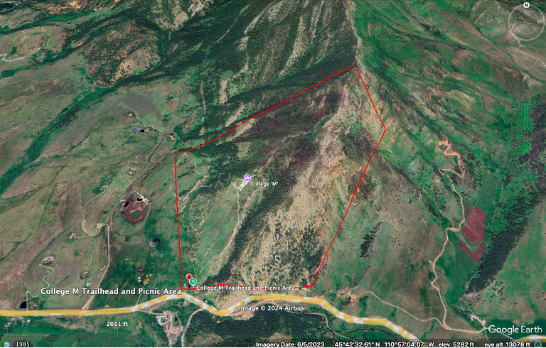

*Figure 1: The area that needs grazing is roughly 300 acres (Google Earth Pro, Montana Fish, Wildlife, and Park).*

Figure 1 shows the approximate 300 acres at the M trail will require grazing A herd of 300 alpine goats could graze 30 acres per day, requiring 10 days of grazing. Herd control can be managed in multiple ways. Temporary and moveable fencing is a common method to keep goats in a desired area. Sheep dogs and goatherds are also effective in controlling the movement of goats as goats will follow a trusted leader. For the health of the goats, they will remain in a fenced, electrified paddock at night at the M during the grazing periods.

While the primary purpose of goat grazing is to remove invasive plant species, herd grazing can benefit soil health. Organic waste from the goats is trampled into the soil, returning important nutrients back to the soil. Improving the soil health will support native plant revegetation following grazing.

### A Legacy in Targeted Grazing

With noxious weeds invading the iconic College M Trail, Montana State University can prove itself to be a leader in sustainable landscape management. With noxious weeds invading across the country, land managers and students from around the country can follow and learn from Montana State’s initiative at the M Trail. As a land grant university with a heavy focus in agriculture, targeted grazing at the M can showcase the strengths of the university.

## Native Revegetation Strategy

### Objective

The objective of this project is to implement a native revegetation plan along the expanded parking lot and roadside of the M trailhead reconstruction. The increased traffic and construction activities will likely have detrimental effects on soil compaction and erosion, degrading the surrounding landscape and threatening the ecological health of the area. Additionally, the lack of native vegetation in disturbed areas has diminished habitat availability for local wildlife and increased the potential for invasive species establishment.

To address these challenges, this project aims to implement a native revegetation plan along the expanded parking lot and roadside. By planting native vegetation, we seek to stabilize the soil, reduce compaction impacts, create habitat for local wildlife, and restore ecological function to the site, all while maintaining the aesthetic and functional value of the area for visitors.

Native species are already adapted to our local climate, soil, and precipitation patterns, which makes them more likely to thrive without intensive care. This resilience will be particularly important in the arid environment around the M trailhead, where water resources are limited for large portions of the year. Native plants are crucial for supporting the local biodiversity and providing food and habitat for birds, pollinators, and other wildlife. By using native species, we can help restore the ecological balance disrupted by human activity.

Revegetation Goals:

1. Restore Native Vegetation: Reintroduce native plant species after construction along the expanded parking lot and roadside to reestablish natural habitat and promote biodiversity.
2. Prevent Soil Erosion: Stabilize the disturbed soils around the trailhead and parking lot areas using biodegradable materials initially followed by the establishment of plants that have deep root systems to reduce runoff and soil loss.
3. Enhance Visitor Experience: Create an ecologically sustainable and visually appealing landscape that blends wildflowers, shrubs, grasses, and trees with the natural surroundings of the Bridger Mountains.
4. Promote Long-Term Sustainability: Ensure the continued health of the restored areas by selecting native species that are adapted to the local climate and soil conditions, requiring minimal maintenance. Prevent the invasion of noxious weeds and other non-native species that could harm the local environment.

### Implementation

**Soil Preparation:** The first phase of revegetation should involve light tilling and loosening the compacted soil to improve its structure and permeability. Soil amendments, such as organic compost or new topsoil, may be important to add to promote plant establishment. During construction of the parking lot, specific care and protective measures should also be taken to prevent contamination of the surrounding water and soil.

**Planting:** As much as possible, transplants and plant ‘plugs’ of various sizes should be used to help increase the rate and success of establishment. In areas where that is not as feasible, seed mixes containing specifically chosen native species will be broadcast across the target areas. Planting will occur during the late spring or early fall to maximize the likelihood of successful establishment for a lot of native plant seeds which require a cold season period to germinate. Plant protections such as wire mesh cages around the larger tree and shrub transplants will be built to protect the young plants from grazing animals such as deer and elk.

**Erosion Control:** Temporary erosion control measures, such as straw bales or erosion blankets made of organic materials such as cotton or burlap should be installed along the roadside to prevent runoff while the plants are becoming established. Using biodegradable geotextiles or mycorrhizal inoculants in the soil can help strengthen soil structure, improve water retention, and aid root establishment, particularly in steep or highly compacted areas.

### Ecosystem Services and Biodiversity Enhancement:

A well-designed revegetation project provides numerous ecosystem services and enhances local biodiversity, creating a resilient natural environment that benefits both wildlife and human visitors. This proposal for the M trailhead includes several strategies aimed at maximizing these services, such as supporting pollinators, creating microhabitats, and implementing protective buffer zones in ecologically sensitive areas. Each approach is tailored to complement the native ecosystem, promote ecological health, and foster an environment where a wide range of species can thrive.

One key aspect of the project is the creation of pollinator habitats, which will support various pollinating species throughout the growing season. Pollinators, including bees, butterflies, and certain bird species, are critical to maintaining biodiversity and ensuring the reproduction of many plant species. To support these essential creatures, we recommend that the M is revegetated with plant species with staggered bloom times, ensuring that pollinators have access to nectar-rich flowers from early spring to late fall. For instance, incorporating native asters and wildflowers can provide a steady source of nectar and pollen. Early-blooming plants, such as golden currant and spring beauty, will cater to pollinators emerging in spring, while later-blooming species, such as yarrow and showy goldeneye, will sustain pollinators through the end of the season. These plants also require minimal maintenance, as they are adapted to the local climate, further enhancing the project's sustainability.

Beyond pollinator support, the inclusion of habitat features for a broader range of wildlife will enhance biodiversity and encourage natural ecological interactions promoted by native species. By strategically placing features such as rock piles, logs, and birdhouses, the project will create shelters for small mammals, reptiles, and bird species. These microhabitats offer shelter from predators, nesting sites, and temperature regulation, which are particularly valuable in an area as ecologically diverse as the Bridger Mountains. The habitat elements will be carefully placed to ensure they blend seamlessly with the surrounding landscape, maintaining the aesthetic integrity of the trail area while providing essential resources for wildlife. For example, rock piles can serve as basking spots for reptiles and hiding spots for small mammals, while logs provide habitat for decomposers, fostering nutrient cycling within the soil. Birdhouses, when positioned away from heavy foot traffic, can encourage nesting for species that thrive in the area, such as chickadees and wrens.

Additionally, establishing buffer zones around sensitive areas, including erosion-prone slopes and riparian zones, will protect this ecosystem from disturbance. Buffer zones act as transitional spaces between high-traffic or impacted areas and delicate habitats, reducing the flow of water, sediment, and pollutants into vulnerable regions. In these designated zones, more intensive revegetation efforts will focus on establishing deep-rooted native plants that can stabilize the soil and prevent erosion. For example, species such as blue bunch wheatgrass and slender wheatgrass, which have extensive root systems, can be used in buffer zones to fortify soil stability and reduce runoff during rainfall events. In riparian areas, sedges and rushes are well-suited to withstand intermittent flooding and play a critical role in water filtration. These plants not only prevent soil loss but also improve water quality by capturing sediment and absorbing pollutants before they can enter waterways.

### Suggested Native Plant Species:

A diverse selection of native grasses, wildflowers, shrubs, and trees will be essential for plant community establishment, stabilizing soil, promoting biodiversity, and enhancing aesthetics. Here are a few potential species to include, categorized by their ecological roles and suitability for the project site:

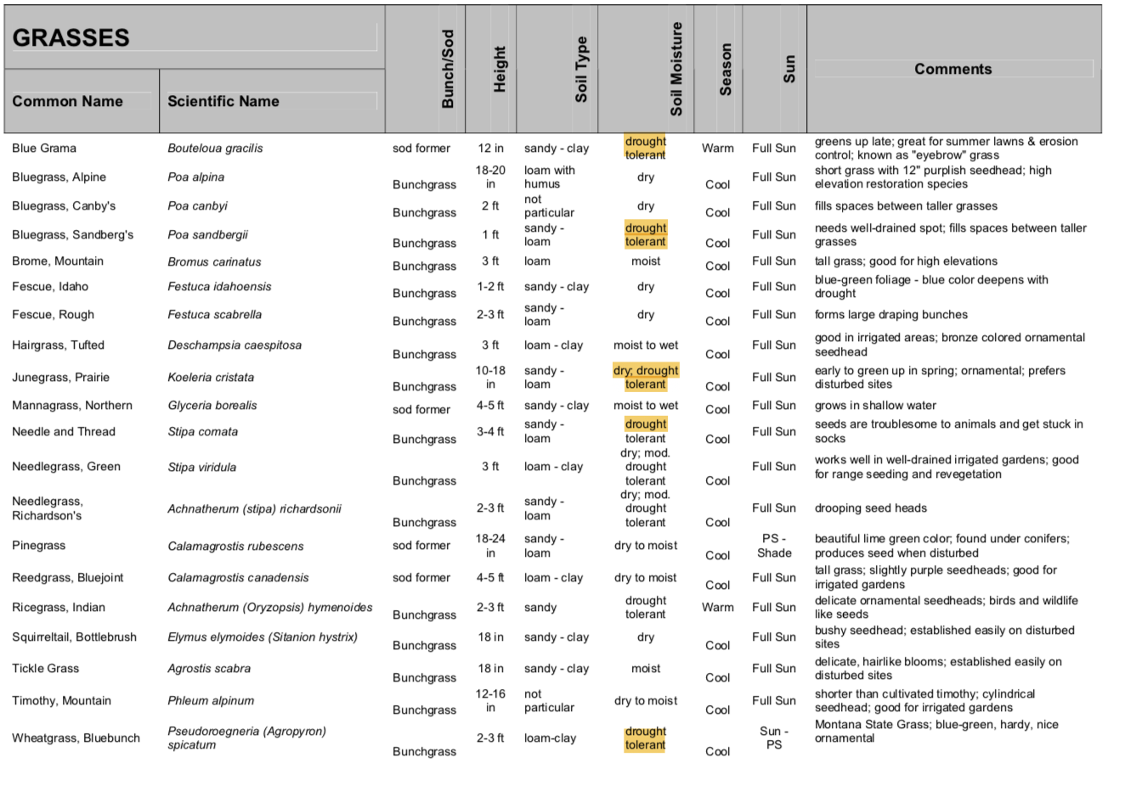

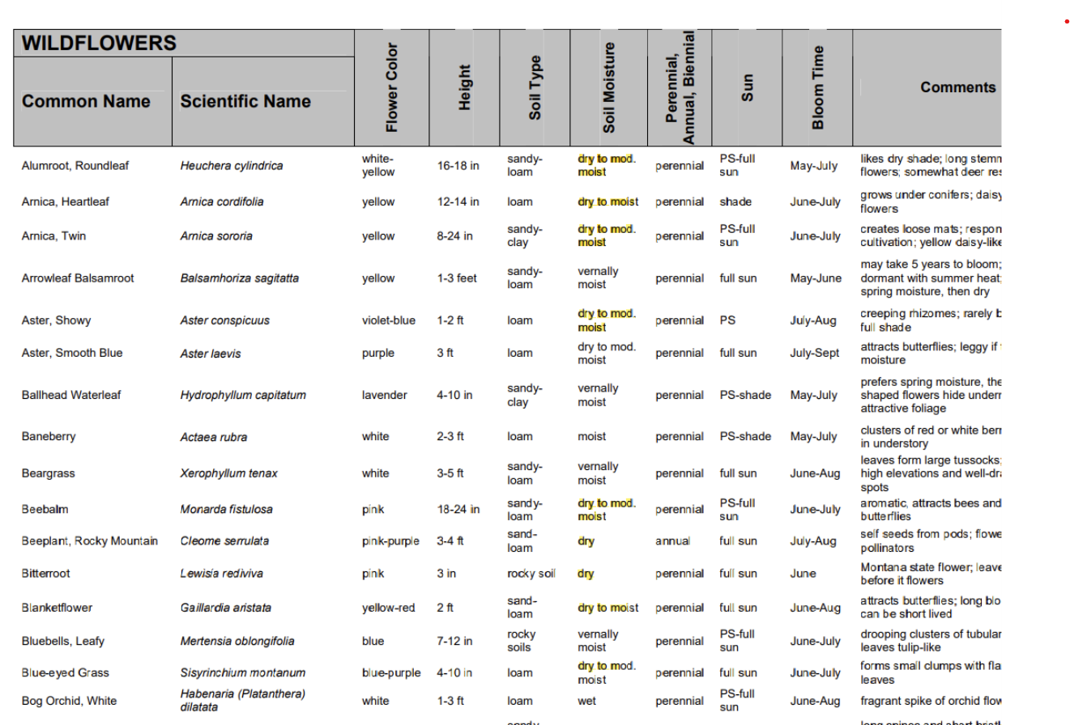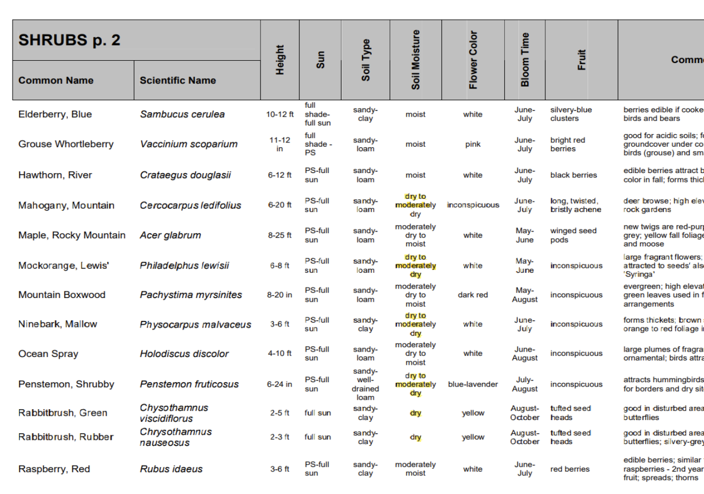

**Sourcing the seeds and plants:**

As the project of improving the facilities for the popular M-trailhead is aiming to benefit the community, one important consideration of the revegetation strategy would be coordinating with local nurseries to source the plants and seeds. Many local nurseries and seed companies can support this project. Here are a few local companies that specialize in native Montana plants.

* Native Ideal Seeds:
  + <https://nativeideals.com/seed-catalog/seed-mixes/low-maintenance/>
* Great Bear Native Plants:
  + <https://www.greatbearnativeplants.com/retail-ready-1>

### Anticipated Challenges and Mitigation:

**Water Scarcity:**

The limited water availability in this semi-arid region, compounded by drought-prone conditions, is one of the most significant challenges to the successful establishment of native vegetation. To ensure plant survival, especially during the establishment phase, drought-tolerant species will be selected for revegetation in areas where natural water supply is limited, such as the sloped sections of the trail. Native grasses and shrubs with deep root systems, like bluebunch wheatgrass and sagebrush, can effectively withstand periods of low moisture and establish stable plant communities that require minimal water after initial growth.

However, areas near the parking lot where runoff naturally accumulates offer an opportunity to introduce species that require slightly more water. In these spots, native plants with moderate water needs, such as golden currant and yarrow, can be used to maximize vegetation without exceeding natural water resources. Limited irrigation may be necessary during the first growing season to support root development and improve establishment rates. Gradually, as the plants establish themselves, irrigation will be reduced and eventually phased out, making the project more sustainable in the long term. Improving soil conditions around the site, by adding organic compost, will increase soil water retention and reduce water stress for the plants, ensuring they remain healthy and resilient even in drier periods.

**Soil Compaction and Continued Disturbance:**

The M trailhead is a highly trafficked area, and despite the planned improvements to the parking lot and footpath, soil compaction will remain a persistent challenge due to repeated foot traffic. Compacted soils reduce water infiltration, limit root growth, and make it challenging for plants to establish and thrive. To address this, soil amendments, such as organic matter and compost, will be incorporated into the soil to improve its structure and aeration. Erosion controls, including coir logs and jute mats, will be installed in highly trafficked areas and on slopes to stabilize the soil and protect it from further degradation.

To further mitigate soil compaction and protect sensitive revegetated zones, the project will establish designated paths and place barriers around newly planted areas. Low, natural fencing or rock boundaries can effectively guide visitors away from fragile vegetation while maintaining an aesthetically pleasing, natural look. Additionally, woody shrubs and other dense plantings around the edges of the paths will help to create natural barriers, discouraging visitors from veering off designated trails. Clear signage indicating marked trails will reinforce responsible use and help prevent additional damage to newly restored areas, increasing the chances of long-term revegetation success.

### Community Engagement and Research Opportunities:

Continuing the long-time communal traditions of this trail, the success of the M trailhead revegetation project will benefit greatly from active community engagement and the creation of educational and research opportunities. By involving local community members and establishing research initiatives, the project can foster a stronger sense of stewardship and provide a platform for long-term environmental education. This approach not only enhances the immediate outcomes of the restoration efforts but also supports a culture of sustainability and conservation within the local community.

**Visitor Education and Engagement**

A crucial element of this project will be educating visitors on the significance of native plant restoration and sustainable trail practices. Informational signage placed at key points along the trail and parking area will serve as an effective medium for raising awareness. Signage could include educational material on the importance of native plants for soil stability, water conservation, and wildlife habitat. Informative graphics and concise messages can emphasize the role of native species in resisting erosion, the adverse effects of invasive plants on biodiversity, and the importance of staying on marked trails to protect sensitive habitats. Educational signage would seek to promote responsible behavior but also enhance visitor appreciation for the revegetation efforts. This knowledge can help visitors understand how seemingly small actions, like staying on trails or respecting plant growth areas, contribute to the health and resilience of the ecosystem. By engaging visitors in the project's goals, the signage can help cultivate a community culture that respects and values conservation.

**Community Involvement Programs and Research Opportunities:**

Engaging local organizations and educational institutions, particularly Montana State University (MSU), in hands-on restoration activities can foster a deep sense of community involvement. Organizing volunteer days for initial planting and ongoing maintenance activities, such as weeding and invasive species removal, would allow community members to participate actively in the project. MSU’s student organizations, environmental clubs, and local conservation groups could take part in regular volunteer efforts, creating an opportunity for students to apply their environmental knowledge practically and build a personal connection to the local ecosystem. These volunteer activities can provide a valuable learning experience, as participants can witness the direct impact of restoration work and take pride in contributing to the project.

The M trail revegetation project presents a unique opportunity for scientific research and data collection, which could significantly enrich understanding of restoration ecology and native plant resilience. By partnering with MSU and other local universities, the project can serve as a living laboratory for longitudinal studies that track changes in soil health, vegetation cover, and local biodiversity over time.

Such studies could be integrated into the university's ecology, land resources, or environmental science courses, offering students an invaluable opportunity to apply academic knowledge in a real-world context.

By merging community involvement with academic research, the M trail project becomes more than just an ecological restoration effort, it transforms into a collaborative endeavor that fosters a deeper understanding of environmental stewardship. This holistic approach will not only restore the trail area but will also inspire ongoing commitment to conservation among community members and create a legacy of environmental stewardship and sustainability in the Bozeman area.

### Monitoring Maintenance and Monitoring of Revegetation:

Biweekly watering and monitoring will be conducted during the first growing season to ensure plant survival. Invasive species should be removed by hand periodically to prevent competition with the slower-growing native plants. Adjustments, such as supplemental planting or additional erosion controls, will be made as necessary. Establishing a schedule for monitoring plant health, soil stability, and invasive species presence with regular site visits for 3–5 years post-planting would help identify needs for replanting or soil amendments.

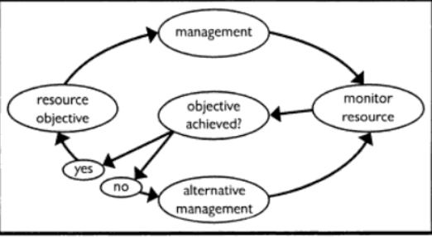

*Figure 2: Flow chart of Adaptive management (Gray and Shimshack, 2011)*

### Photographic V.S Environmental Monitoring Techniques

Photographic monitoring involves taking photos with handheld cameras in the field and then analyzing the data later in the lab. This approach reduces the time required in the field for conducting plant surveys and can encourage citizen science (Dongen et al., 2017). By partnering with a Montana State University Environmental Science class, specific areas of infestation and remediation could be photographed at the same time each year, allowing for annual comparisons by students. This partnership would provide students with a unique opportunity to enhance their plant identification skills and gain experience working on a restoration project. Additionally, signs along the trail could encourage hikers to take and submit photos to the project, which would allow researchers to examine both seasonal and annual variability.

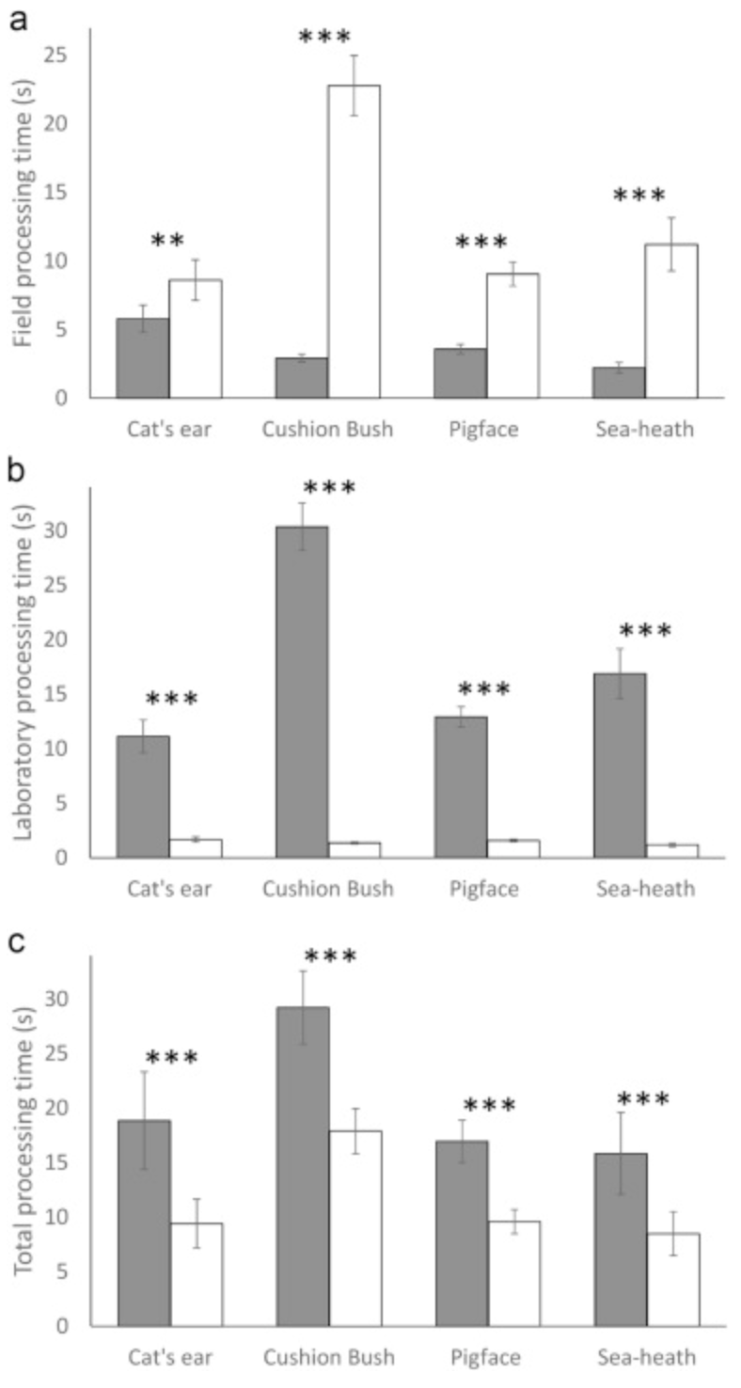

*Figure 3: A) Field processing time, B) Laboratory processing time, C) Total processing time for 4 plant species using environmental (white) and photographic (gray) monitoring (Dongen et al., 2017).*

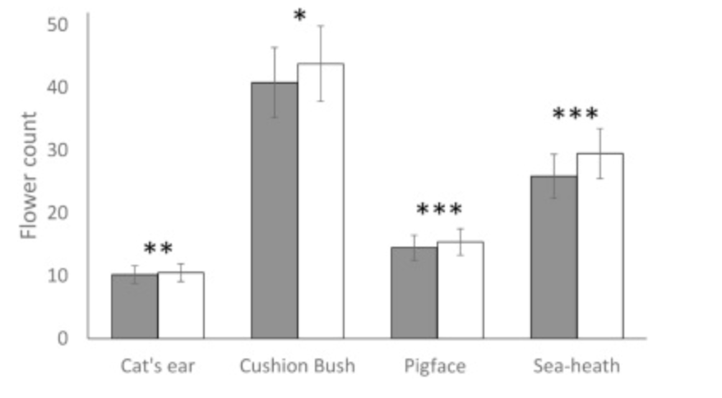

*Figure 4: Total flour counts of the four species using photographic (gray) and environmental (white) monitoring techniques (Dongen et al., 2017).*

### Critical Components Of Effective Monitoring Programs

There are three broad types of monitoring: curiosity driven, mandated monitoring, and question driven monitoring (Lindenmayer and Likens, 2010). Question driven monitoring is defined as having a rigorous study design and works closely with the adaptive management strategy to adjust monitoring needs as when needed (Lindenmayer and Likens, 2010). Our study will use a question driven monitoring plan to allow for changes to the study design and management goals.

*Table 1: Key factors when constructing a monitoring plan (Lindenmayer and Likens, 2010).*

|  |
| --- |
| Plots and study sites should be permanently  marked and identified |
| detailed descriptions of study areas and  field protocols for multiple locations with sufficient detail to allow  for site location |
| calculation replication, and method  reproduction by other investigators |
| establishment of appropriate and adequate  reference and/or control sites at the beginning of the study |
| availability of appropriate field  equipment |
| long-term security of research sites and  field equipment |
| reliable access to field sites |
| calibration of analytical results by  comparison against standardized samples |
| avoiding changes to analytical methods or  collection procedures unless fully tested for impacts on the long-term record |
| matching the scale of monitoring to the  spatial and temporal dimensions of the question |
| measurement duration should align with the  evaluated phenomenon’s frequency or organism life history |
| testing and justification required before  adopting methods or procedures developed for one location or study for  another |
| strict database management and data  storage with agility to adapt to technological changes |
| datasets stored in at least two locations  to prevent accidental loss with long-term sample storage encouraged |
| stability and competence of staff |
| resolution of intellectual property issues  at project onset |
| constant data review and updating |
| use of long-term datasets for answering  research questions |
| partnerships among scientists,  policymakers, and resource management agency staff to ensure the project’s  management relevance, availability of adequate, sustained, and reliable  funding |
| ongoing development of questions that  align with or complement the monitoring program framework |

### Case Study

In 2021, a study was conducted that observed tamarisk (*Tamarix)* using remote sensing in Grand Canyon National Park. The tamarisk is an invasive riparian shrub that can “decrease groundwater supply and alter hydrologic processes” due to its high demand for water (Bransky et al., 2021). Along with its ability to add salinity to the soil and produce high rates of seeds, the tamarisk poses a threat to the native vegetation. This research used high resolution satellite imagery titled WorldView-2 to assign each tamarisk a category of botanical fitness: healthy tamarisk, canopy dieback, or defoliated tamarisk. This was accomplished by measuring the reflectance of different wavelengths on different health stages of the tamarisk (figure 5). Using the satellite reflectiveness of plant species were measured and mapped (Figure 6). This allowed researchers to visualize the health of the tamarisk population and inform managers in real time what is working and not working.

This could be used in our study by taking the reflectance of cheatgrass and other target weed species and taking abundance measurements via the satellite before and after remediation. This would provide a broad overview of the effectiveness of goat grazing on the Bridger M trail. Ideally the satellite would do one pass before treatment, one during treatment, and another after treatment to see the change in invasive populations. Yearly passes could be conducted at the same time each year after the study is complete to show the effectiveness in management of invasives each year after the treatment. 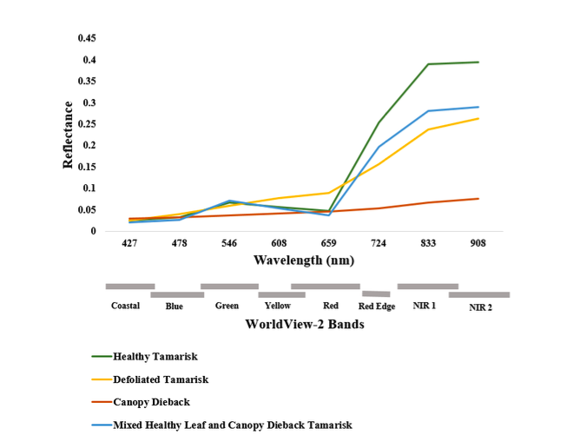

*Figure 5: Ground-based hyperspectral training spectra for the four tamarisk classes (Branskey et al., 2021).*

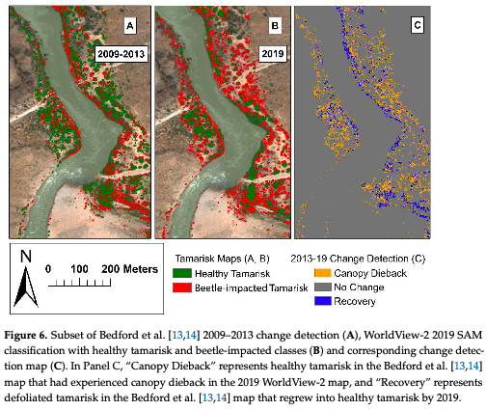

*Figure 6: Example data from the WorldView-2 satellite (Branskey et al., 2021).*

### Monitoring of Cheatgrass and Goat Grazing

To ensure successful restoration, a multi-faceted monitoring approach will be established along the Bridger M Trail, focusing on plant survival, invasive species management, and habitat stability. Initial steps include regular watering and monitoring during the first growing season, supplemented by invasive species removal to minimize competition with native plants. Adjustments such as additional planting or erosion control will be implemented as needed. Over the next 3–5 years, a monitoring schedule will assess plant health, soil stability, and invasive species presence through periodic site visits. Photographic monitoring, in partnership with a Montana State University Environmental Science class, will involve capturing consistent annual images of areas under restoration, encouraging students to develop plant identification skills and engage in hands-on restoration projects. Signage along the trail can also encourage hikers to submit photos, enabling researchers to analyze seasonal and annual variations in plant health and distribution.

The monitoring plan will follow a question-driven approach, incorporating adaptive management to adjust study design and goals as needed (Lindenmayer & Likens, 2010). Key components include the permanent marking of study plots, detailed descriptions of methods and study areas, secure field sites, standardized data collection protocols, and thorough data management with storage in multiple locations. This structured design will support data accuracy, site accessibility, and study reproducibility. Remote sensing technology will provide a broad assessment of treatment efficacy, particularly for invasive species like cheatgrass. Satellite imagery before, during, and after treatments will map changes in target species' reflectance and abundance, offering a visual measure of the impact of goat grazing and other interventions. Long-term satellite monitoring can help assess the effectiveness of invasive species management annually. Additionally, monitoring of trail erosion and vegetation dynamics will identify areas vulnerable to invasive establishment, allowing for targeted interventions. By combining direct field measurements, citizen science contributions, and remote sensing, this comprehensive monitoring plan will support the sustainable restoration of the Bridger M Trail’s dynamic environment.

## Conclusion

Restoring the M trail is a large project that requires a comprehensive approach in order to succeed. Addressing the spread of invasive plant species and restoring native species on this trail would protect biodiversity, increase fauna habitat, and maximize recreational use of the M. The strategies outlined in this proposal include invasive plant surveys, public education initiatives, targeted management techniques, native species reintroduction, and long-term monitoring from a holistic framework to restore and maintain the health of the M Trail. Each of these components is essential, working together to create a resilient ecosystem that can withstand environmental disturbances and human activity. The proposed revegetation plan will create a vibrant, sustainable, and biodiverse landscape around the M trailhead, promoting the long-term environmental resilience of one of Bozeman’s most iconic landmarks.

Our monitoring plan emphasizes a multifaceted approach that integrates adaptive management and citizen science to support the restoration of the Bridger M Trail. By leveraging both field observations and remote sensing technologies, we will gather comprehensive data on plant survival, invasive species dynamics, and habitat stability. The combination of direct measurements, annual photographic documentation, and the involvement of local students will create a robust framework for evaluating the effectiveness of our restoration efforts. Ultimately, this approach aims to foster a resilient ecosystem, enhance biodiversity, and ensure sustainable management of invasive species in the Bridger Mountains.

### References

Hopper, C. (2014). Nature’s Weed Eater. *Outside Bozeman*.

https://outsidebozeman.com/culture/conservation/natures-weed-eater

Lacey, J. (1990). Effects of Spotted Knapweed on Soil Erosion. *TechLine*. <https://www.enlist.com/content/dam/dpagco/techlinenews/na/us/en/files/TLJanuary1990.pdf>

Launchbaugh K. (2006). Retrieved October 21, 2024, from

https://www.webpages.uidaho.edu/rxgrazing/handbook/Chapter_1_Targeted_Grazin

g.pdf

Mosley, J. (2018). *Targeted Livestock Grazing to Suppress Cheatgrass*. https://www.montana.edu/extension/sanders/Prescription%20for%20Cheatgrass%20November%2025%202018.pdf

Orbán, I., Szitár, K., Kalapos, T., & Körel-Dulay, G. (2021). The role of disturbance in invasive plant establishment in a changing climate: Insights from a drought experiment. *Biological Invasions*, *23*(6), 1877–1890. https://doi.org/10.1007/s10530-021-02478-8

Thrift, B. D., Mosley, J. C., Brewer, T. K., Roeder, B. L., Olson, B. E., & Kott, R. W. (2008). Prescribed Sheep Grazing to Suppress Spotted Knapweed on Foothill Rangeland. *Rangeland Ecology & Management*, *61*(1), 18–25. https://doi.org/10.2111/05-199R2.1

Williams, S., & Prather, T. (2006). Goats: A Tool for Controlling Spotted Knapweed. *The Journal of Extension*, *44*(5). https://open.clemson.edu/joe/vol44/iss5/15