

Wildfire Analysis of the College M
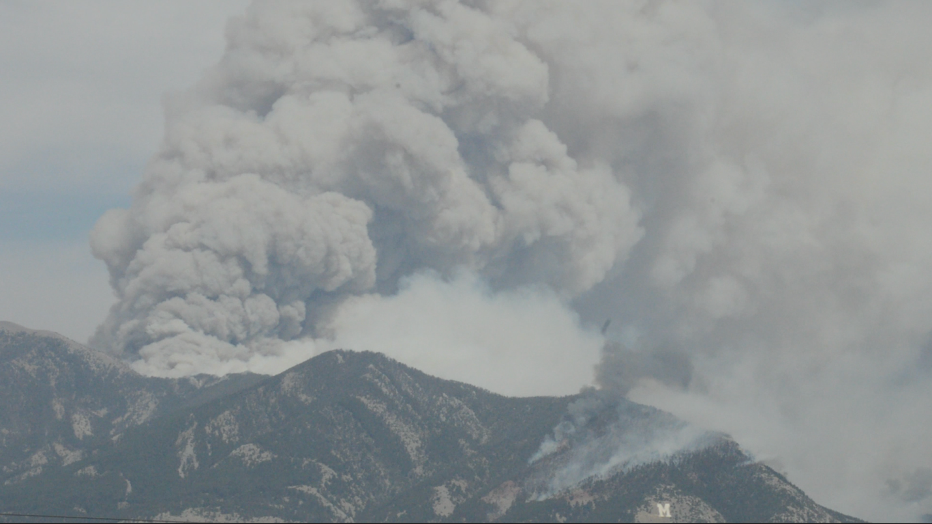

Karolyn Hilquist, Lindsey Webb, Mason Knighton, and Zachary Moore
ENSC 449R

Contents
Page
Introduction.................................................................................................................................... 3
Wildfire History........................................................................................................................... 3-7
Pre-Fire Conditions.........................................................................................................................7
Assessing Current Conditions................................................................................................... 8-12
Post-Fire Conditions................................................................................................................ 14-18
Management Recommendations.............................................................................................. 19-23
Conclusion.................................................................................................................................... 24
References .............................................................................................................................. 25-28

Abstract
The 2020 Bridger Foothills Fire provides a recent example of the risks and consequences of wildfire in the wildland-urban interface. This LRES capstone project focuses on fire management strategies for the Bozeman M Trail area, using the Bridger Foothills Fire as a case study to illustrate potential challenges and ecological impacts. The project begins with an analysis of pre-fire conditions, including vegetation dynamics, climatic trends, and fuel accumulation in the region. A field vegetation assessment evaluates the current composition and abundance of grasses, forbs, and woody vegetation, with particular attention to invasive species that can alter fire behavior and hinder post-fire recovery. Post-fire analysis of the Bridger Foothills Fire examines burn severity, vegetation recovery, soil erosion, and shifts in plant communities, offering insights into vulnerabilities that may exist in the M Trail area. By connecting lessons from the Bridger Foothills Fire to localized management planning, this project provides a comprehensive framework for addressing wildfire risk in the Bozeman region.
Introduction
The College M is an important symbol for not only Montana State University but also the community of Bozeman. In fact, the trail to the M landmark is one of the busiest on the Main Street to the Mountains system (GVLT, 2016). The current state of the M trail area makes it prone to wildfires which would devastate this important recreational area and community symbol. Therefore, due to its local significance, restorative action as a means of wildfire prevention in the region needs to be done not only for recreational value, but human and wildlife safety as well.
Public interest and support for fire prevention within the M trail area is high due to the 2020 Bridger Foothills fire’s far –reaching impacts on the local community. In fact, Corey Lewellen, the Bozeman District Ranger for Custer Gallatin National Forest said in an interview “The Bridger Foothills fire is just an excellent reminder that we live, and we work in fire-driven ecosystems. If we wait to do that type of mitigation work when we have a fire, we’ve waited too long. The time to do that is now” (Dore, 2021). Therefore, we analyzed the area surrounding the College M and determined ecosystem health and wildfire risk to produce the following report of recommendations.
Wildfire History
Historical and evolving wildfire behavior in this area is a key component to understanding both the pre and post fire erosion risks, as well as causes of current vegetation patterns to make informed management suggestions. Fire behavior has changed dramatically over the last century primarily due to shifting management practices and climate change. Fire has historically been a natural part of the landscape, benefiting ecosystems and even serving as a tool for land management by Native American peoples (Pausas, 2009). Following European colonization, however, fires were increasingly seen as destructive, ushering in a period of widespread fire suppression. As a result, fire regimes—the patterns of wildfire occurrence in an area—began to shift, a change further intensified by climate change. Shifts in fire intensity, occurrence, and severity have influenced both the likelihood of areas like the College M trail to burn, and what vegetation now exists there (Wasserman & Mueller, 2023). Vegetation in highly visited areas is increasingly dominated by invasive plants, which have an effect on the frequency and behavior of fire. Cheatgrass, an annual grass, dries out earlier than native plants, creating dry fuel for fires in a way native plants typically would not (Randall, 2022). Human use on the College M trails also has had an influence on the trail stability causing more erosion and influencing which species of vegetation are present.
The Bridger Foothills Fire is crucial to help better understand the study site and manage the M trail area because we can look at what caused it and the factors that primarily contributed to its spread. In 2020 the fire grew to be over 8000 acres in size, burning a large area primarily on the east side of the Bridger Mountain range but first began near the College M trail (Bridger Foothills Fire Information, 2020). In addition to the factors pertaining to the cause of fire and spread, the area within the burn scar provides somewhere to study the post fire conditions including what erosion occurred, which plants are recolonizing after disturbance, and what mitigation practices land managers need to focus on.
To implement successful management policies, taking into consideration the evolution of wildfire management policies is important in addition to the changing fire behavior discussed above. Indigenous practices that utilized fire to promote a healthy environment and sustain their lifestyle were widespread (USNPS, n.d.). The purpose of these practices was to sustain soil health, promote healthy vegetation, and maintain a balanced ecosystem, providing essential resources for various needs, including food, shelter, medicine, and basketry, among others (USNPS, n.d.). Settlers initially used a pretty “hands off” method toward fire, but 1910 marked the beginning of a new age of fire suppression management and attitudes toward wildfires. A number of small fires in a very dry summer merged together to burn over 3 million acres in two days leading to a negative perception of fire (National Forest Foundation, 2022). The 10 a.m. policy was implemented which meant every fire needed to be extinguished by 10 a.m. the next day, beginning an era of complete suppression. The “full stop” suppression tactics resulted in increased fuel loads, leading to fires that often burn at much higher intensities than what the ecosystem was historically adapted to and thrived with (National Forest Foundation, 2022). The year 1988 marked a significant milestone in wildfire management in the West, as natural fires were initially permitted to burn based on predictions of the previous year's precipitation and fire behavior. However, by July 15, this policy was suspended, and by July 21, all fires were aggressively suppressed due to a rapidly spreading series of destructive fires in Yellowstone National Park (USNPS, n.d.). It wasn't until October 1st that all these fires were finally brought under control. Over the recent decades land managers have begun to implement better forest management with the goal of allowing wildfires to burn as they should without annihilating everything in their path and using it to maintain forest health as Indigenous Peoples once did (Himanshu et al., 2024).
Climate change has had a large effect on the changing fire behavior and the area surrounding the College M Trail is no exception. To begin, there are increasingly more days at the highest temperatures resulting in heat stress on the environment, including lower snowpack which subsequently amplifies lack of water resources (National Climate Assessment, n.d.). Droughts are worsening, as shown below in Figure 1; looking at the destruction done in 2020 and taking into account the drought wasn’t as severe it is easy to imagine how much fire risk could get worse as the years progress. Fire season is longer, hotter, and more extreme, as far as intensity and severity are concerned (Union of Concerned Scientists, n.d.). Along with the danger comes high costs associated with management and postfire rehabilitation. Tens of millions of trees have died in Montana due to heat stress, drought, and amplified wildfire behavior and occurrence. Many issues are posed to humans as a result of global warming issues, but air quality in particular is threatened along with the likelihood of physical exposure. As the wildland-urban interface (WUI) expands, the likelihood of fires occurring in these areas increases, leading to the production of more toxic smoke, which poses greater risks for firefighters and affects their firefighting strategies. The WUI is anywhere wildland mixes with human development, and 60-82% of homes in Montana are in this zone. Specifically, it can worsen lung diseases and amplify asthma. The proximity to the Bridger Foothills Fire was a good example as homes were scattered closely in the valley on the mountain edge very near to where the burn was. 62 structures were lost, including 30 residences, and 11 were damaged (Montana Right Now, 2020). In addition to a dryer climate and drought, less water in this region results in more flammable vegetation which means not only are they more easily ignited but very easy to spread from plant to plant (US EPA, 2024).
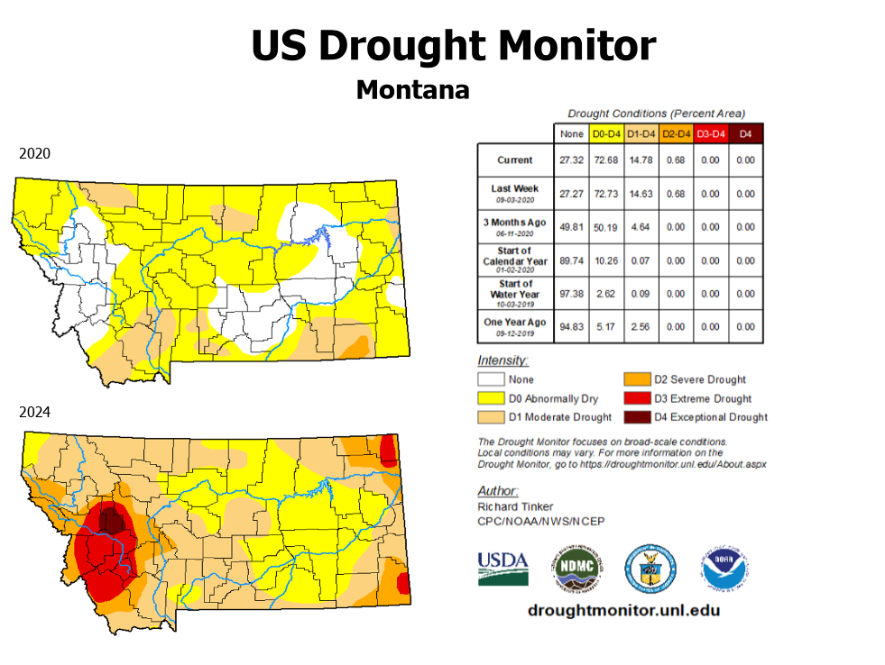
Figure 1: Comparison between the drought conditions in 2020 (when the Bridger Foothills Fire occurred) and now in 2024.
To understand fire risk and behavior there are a couple important recurring concepts: fire regimes and return intervals. The nonnative species being studied in our analysis such as cheat grass have a very different return interval than the native plants. Fire regimes are the pattern of behavior of a fire over a long period of time including characteristics such as intensity, severity, how often they occur, seasons in which they occur, and typical size (Oregon State University, n.d.). Severity of a fire is the measure of its impact on the area, while the intensity is the heat energy released (Keeley 2009). There are five Fire Regimes from class 1-5 respectively (Landfire, 2024): Fire Regimes 1 and 2 range from 0 to 35 years, but Fire Regime 1 burns at a low severity level while Fire Regime 2 burns at a stand replacing level of impact. Fire Regime 3 has a 35-to-200-year frequency, low to mixed severity, Fire Regime 4 is 35-to-200-year frequency with a stand replacement severity, and Fire Regime 5 has a 200+ year frequency. The concept was adopted in the US in 1960 when opinions about wildland fires and their positive role in ecosystems started to become more prevalent (Krebs et. al). In addition to the numbered fire regimes, there are classifying characteristics often taken into account in addition to the time span. First, an understory fire is mostly smaller vegetation that doesn’t climb into crowns of fires and most of vegetation survives (80%) which is healthy for the forest (Oregon Explorer, n.d.). On the opposite end of the spectrum in stand-replacement fires 80%+ of vegetation die. A mixed severity regime is different, changing on an individual basis from fire to fire and vegetation burning depends on different factors such as weather and topography. (Oregon Explorer, n.d). Figure 3 below discusses the four fire regimes the College M Trail is found in.
Historically there are four vegetation classification groups found at the College M Trail: Inter-Mountain Basins Montane Sagebrush Steppe, Middle Rocky Mountain Montane Douglas-fir Forest and Woodland, Northern Rocky Mountain Lower Montane-Foothill-Valley Grassland, and Northern Rocky Mountain Montane-Foothill Deciduous Shrubland, with the first two making up the majority of the study area (LANDFIRE Map Viewer, n.d.) (Figure 1 and Figure 2). Historically vegetation in this area had different return intervals than what now exists. Depending on whether in the shrub stepland, grassland, or woodland areas with return intervals ranging from 50-200 years, now the invasive cheatgrass with a different return interval covers the majority of parts of the landscape - one that is more easy to burn, and more likely to carry it to poorly managed surrounding areas which could lead to high severity fires like the Bridger Foothills Fire (NatureServe Explorer 2.0, n.d.). As discussed above, this is one of those vegetation that are drier and carry the fire quicker.
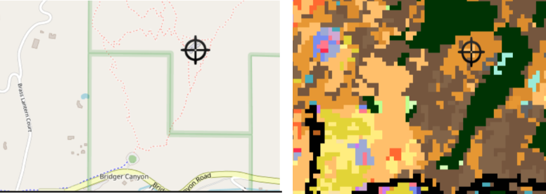Figure 2: The left image tick mark designates where the “M” at the top of the trail is located for reference on the right map showing the colors associated with each ecosystem classification from LandFire with details shown below in Figure 3.

Ecosystem Type | Map Color | Fire Regime | Historical Return Interval (years)
Inter-Mountain Basins Montane Sagebrush Steppe | Tan | 5 | 200-240
Middle Rocky Mountain Montane Douglas-fir Forest and Woodland | Green | 3 | 30-100
Northern Rocky Mountain Lower Montane-Foothill-Valley Grassland | Light Tan | 1 | 10-30
Northern Rocky Mountain Montane-Foothill Deciduous Shrubland | Brown | 3 | 50-100
Figure 3: Different Ecosystem classification information.

Study System:
The study system for our data collection to perform the analysis was focused solely within the southwestern region of the Bridger Range with a focus around the College M trail and the Bridger Foothill fire burn zone. The area of interest is roughly 115 acres and ranges from 4,960-6,200 feet elevation, as this includes both the unburned M trail and a portion of the southwest facing burn zone. By observing both burned and unburned sites, a better understanding of the regions current fire risk and post-fire recovery can be derived. An additional purpose for restricting the sampled burn zone to the west facing slopes of the Bridger range is that recovering plant communities will face similar conditions, thus removing additional variables.

Assessing Pre-Fire Conditions
The College M trail is a high-risk area for burning and erosion due to its steep topography and vegetation. With the improvement of management practices unique to this area, wildfire-caused erosion can be lowered significantly to protect the area so greatly valued by the community. The College M trail presents unique difficulties when it comes to managing this area because it is not a good place for many commonly used successful fire prevention management practices. For example, the steep terrain makes controlled burning impractical, and manual fuel removal like thinning is challenging due to limited vegetation. To assess fire risk and evaluate management strategies, it is essential to explore current factors that contribute to increased fire risks, such as drought conditions and forest service fire risk rankings. Numerous online resources are available that focus on changing fire environments and predictions, which will be valuable for this analysis. In addition, many of these websites and applications will help to make wise decisions when it comes to recreation and safe outdoor choices. The vegetation and topography in this area create significant fire risks, as the steep slopes can rapidly carry fire through easily ignitable plants like cheatgrass. Websites like the National Interagency Fire Center and many other interactive maps online help to keep track of current fires and fire risk.

Assessing Current Conditions
To understand the potential impact of increased foot traffic on the fire regime at the College M trail, a baseline must be established to monitor the current vegetation both on and off the trails. While it is important for more aggressive actions to be taken with trail maintenance, parking lot expansion, and vegetation control these actions will be creating a variety of disturbances and introducing more invasive species through increased foot traffic of both workers and day hikers. Establishing a baseline for the current vegetation on the hillside will assist managers in predicting and adapting trail conditions in the future to better accommodate the evolving challenges posed by heavy foot traffic.
To ensure that a baseline is effective for monitoring an area of this size, several essential elements must be in place. Data collection points need to be repeatable, meaning that the same locations must be identifiable and recorded using consistent methods for the data to be meaningful and representative of changing conditions. To achieve this repeatability, a high-accuracy GPS unit should be employed to document the exact coordinates of each data point. Additionally, plant data must be collected within designated vegetation plots that adhere to a predetermined size.
Having a baseline for the vegetation present at the M is important for the overall fire ecology of the area because it will allow managers to monitor for vegetation characteristics such as invasive species and conifer encroachment. Invasive species are important to manage because they have natural fire regimes that do not match the succession stage that the native plants are in. On the south-facing side of the College M trail, conifer encroachment is occurring as evident by increasing numbers of Rocky Mountain juniper and Abies lasiocarpa (sub alpine fir) (Taylor, 2017). The establishment of conifers in areas where they would not naturally occur can also lead to higher intensity fires, which may sterilize the soil and potentially destroy the existing seed bank (Taylor, 2017).
The M trail is situated on a southern facing slope of the Bridger range meaning that it is mostly dominated by grasses and shrubs. While not exactly invasive, this slope is undergoing conifer encroachment by Pinus contorta (lodge pole pine) as well as subalpine fir. Conifer encroachment acts to shade out and outcompetes the plant species that are already there, and when pine forests burn, they will burn at a higher temperature sterilizing the soil of any of the local native plants. Another invasive plant Bromus tectorum (Cheatgrass), which is found in high-density on the College M trail, has a fire regime of 2 -5 years depending on density (Zouhar, 2003). Cheatgrass is promoted by fire, which leads to a positive feedback loop that results in more frequent and higher intensity fires (Zouhar, 2003). Cheatgrass is an early season annual that is aggressively promoted through fire and will outcompete the most native grasses if left on its own (Zouhar, 2003).

Methods: Field maps
In order to collect the spatial and vegetative data that was high accuracy and easy to work with, a medium for this data had to be devised. In ArcGIS Online, using the application field maps designer, a form and geo database was created. Within the form, four-point objects were created for grasses, forbs, woody vegetation, and invasive and non-native species. Within each point the fields that are available are “number of plants observed”, “species observed” and “notes”. The offline map of the M trail and its surrounding areas was then created and downloaded onto the tablet that was to be used for the data collection.
Methods: Daubenmire frame
To collect data from a uniform area in the field and minimize inaccuracies that can arise from using tape measures, rulers, or yardsticks, a frame should be constructed to maintain a fixed shape and area. The solution for this frame is a Daubenmire frame, which would be constructed using two 10-foot, ½-inch schedule 40 PVC pipes. PVC was selected for its affordability and ease of construction. The pipes are cut into four 39 3/8-inch pieces (1 meter and connected with four 90-degree couplers. This assembly creates a 1 meter by 1 meter frame that can be placed on the ground to count the number of plants within the frame.
Methods: Data collection
Data was collected on the College M trail using the Ridge Trail and M Trail as boundaries for the study. An Emlid Reach RS2 GPS receiver was paired via bluetooth with a tablet that had the field mapping form downloaded. 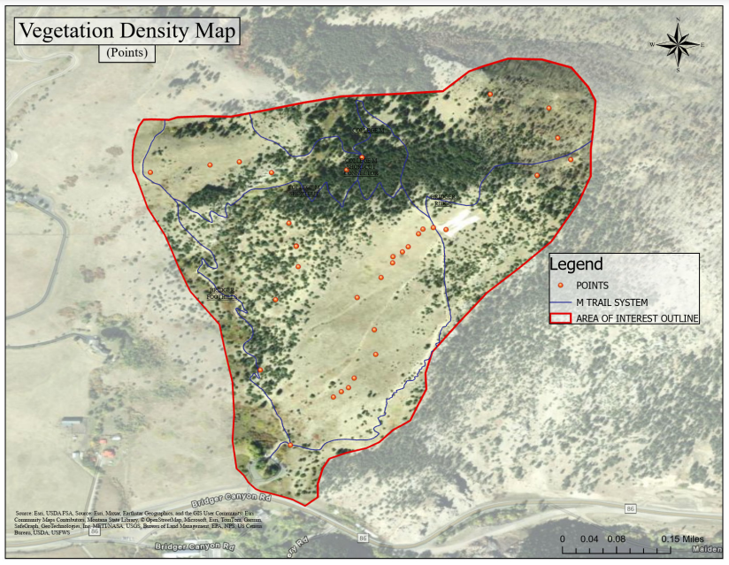
Figure 4: Points where the data used to create the density maps was collected.
The team started from the parking lot, placing points along the bottom of the M trail and making their way to the M itself, marking points both on and off the trail. At one location, four points were established, and data on grass, forbs, woody vegetation, and invasive species was recorded. To ensure that the data collection was not biased by what the team could see, the Daubenmire frame was thrown at random distances and angles(figure 4). Where the frame landed, the Emlid Reach RS2 GPS receiver was positioned in the center, while one team member filled out the data and other members identified and counted individual plants. The same data collection methods were employed as the team ascended to the burned area above the M and then descended back toward the parking lot.
Analysis
After the data was collected, in ArcGIS Online the file geo database was downloaded onto a laptop that had ArcGIS Pro installed onto it. From here the data was opened inside a new project and the data points were loaded into the map. Using the Create Feature Class tool, a layer was established to delineate the perimeter of the study area. The Edit tool was then utilized to draw the perimeter based on the area's topography, with the symbology of the outline set to red. In the Geostatistical Wizard found in the Georeferencing tab, grass points served as the input, while plant count data was processed, with the extent set to the outline. The settings for the Geostatistical Wizard were configured to run kernels, producing a density map of the entire hillslope. This process was subsequently repeated for forbs, woody vegetation, and invasive/nonnative species, resulting in four density maps that illustrated the distribution of vegetation on the hillslope. A trail shapefile was clipped to match the extent of the study area, and this trail system was then overlaid on the density layers to explore potential connections between foot traffic and plant density.
Results
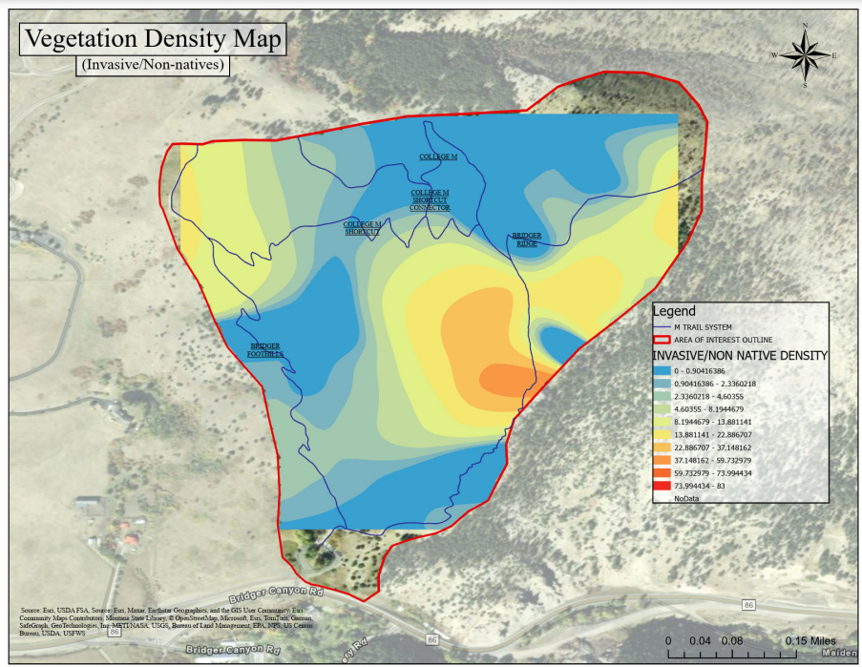
Figure 5: Invasive/non-native species density map showing the locations with the highest density of invasive species. Density on the M trail systems.
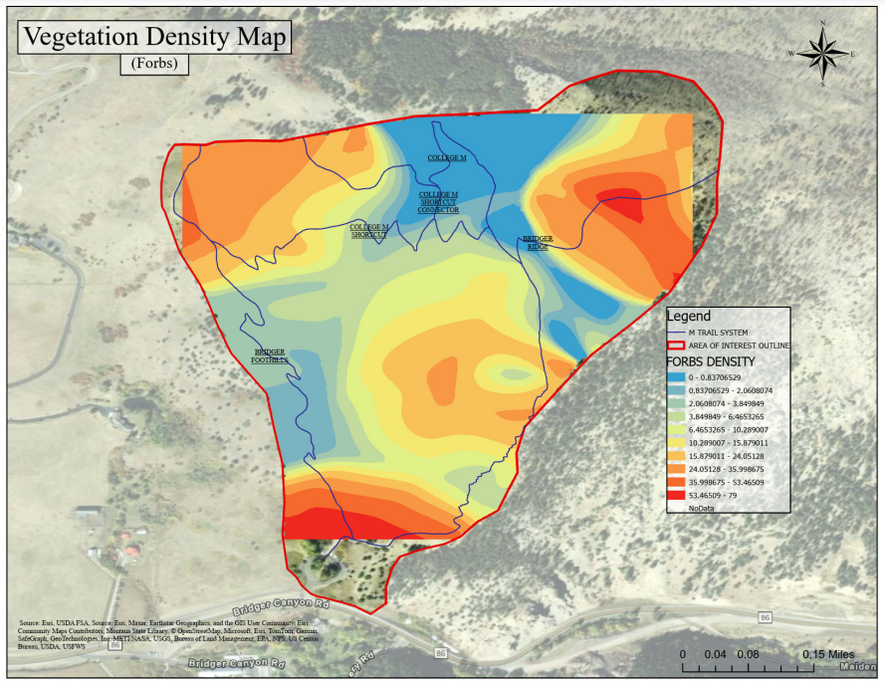
Figure 6: Forbs density on the M trail systems.
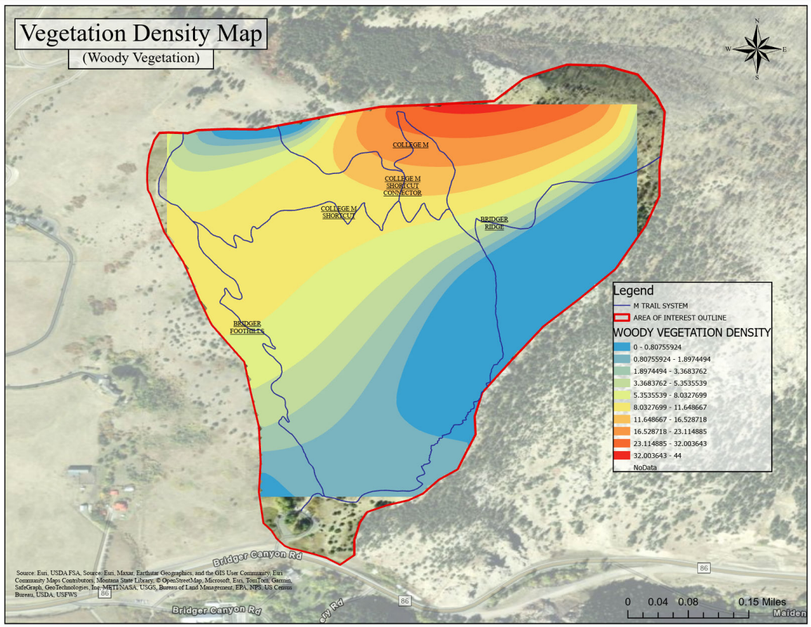
Figure 7: Woody vegetation density on the M trail systems.
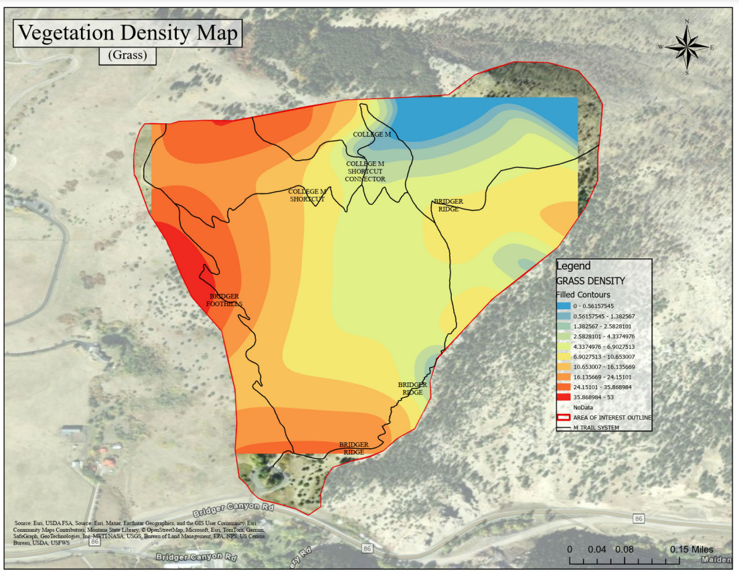
Figure 8: Grass density on the M trail systems.
It was found that the areas that have the most invasives present are areas that see the most human traffic and disturbance like the top of the trail by the M, the burned area on the trail and the bottom of the “easy” trail where other trails converge. There is conifer encroachment occurring on the southern slopes. Forbs density shows that in areas that are not dominated by woody vegetation there are a higher density of forbs. Grasses have a higher density in areas with a lower slope.

Discussion
The data reflects that there is a higher density of invasive plants especially cheatgrass and spotted knap weed in high disturbance areas such as right by the trail in the burned areas, at the M and at the lower elevations on the M trail (Figure 4). While the more aggressive management methods being proposed are beneficial for recreation, all of them will create some amount of disturbance as well as an increase in foot traffic, this is creating the perfect scenario for an explosion of invasive plants. These outbreaks of invasive plants have the potential to change the fire regimes of the hillside. Changes in fire regimes can significantly impact fire-prone areas, posing risks to human health and safety, especially given the recent housing developments on the front side of the hillslope.
Managers can use this data and baseline in order to focus their efforts of weed management in areas that are in disturbance prone areas. The weed management group can portable hot wire fencing to concentrate their goat grazing in the areas that have a higher density of invasive species.
Although the data collected is representative of the hillslope, the locations of the recorded points reflect the bias of the terrain. To remain within the constraints of this class and adhere to available funds and time, the team focused on areas accessible by foot, excluding some of the rocky faces and extremely steep sections.

Predicting Post-Fire Conditions
Wildfires have various effects on the landscape, both positive and negative, as they are a crucial process in many ecosystems. However, anthropogenic management decisions and recreational activities have significantly altered the landscape, impacting fire behavior. For example, as mentioned in a previous section, vegetation has changed in many areas due to high recreational use, which causes disturbance (Figure 4). This disturbance leads to the spread of non-native and invasive plants that outcompete native vegetation. Since fire is a natural part of our ecosystems, we must understand its role and the dangers it poses when shifting from its natural course. Some key impacts that wildfires have on ecosystems are loss and changes in vegetation, soil health degradation, wildlife displacement and mortality, water cycle disruption, effects on nutrient cycling, and changes in air quality. Specifically, at the M trail areas, direct observations have led to concerns about vegetation and erosion due to the high use of the areas and the steep slope of the terrain.
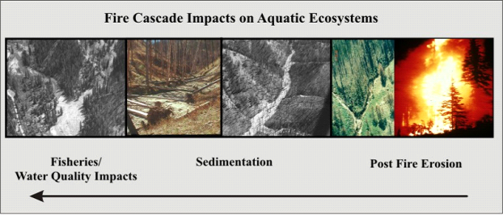
Figure 9: A “fire cascade” of post fire impacts related to hydrology (Miller, MacDonald, Robichaud, & Elliot, 2011)
Additionally, the nearby Fish and Wildlife Service fish hatchery and Lyman Creek are at risk of cascading impacts from fire. A high-severity fire leads to accelerated erosion, which increases channel sedimentation and significantly impacts fisheries and water quality (Figure 9). Lyman Creek provides twenty percent of the drinking water for the city of Bozeman (Bishop, 2021). Therefore, wildfires along the M trail and in the surrounding areas of the Bridger Mountain Range are a significant concern due to their potential impact on water supply quality, private homes, ranches, and outdoor recreational areas such as Bridger Bowl.
To understand the potential effects of wildfires on the M trail area, it is helpful to analyze information from past fires to gain insights into their varying behaviors, severities, and intensities and how these factors contribute to different levels of post-fire impacts. A recent example in this area is the Bridger Foothills Fire in 2020, which burned areas above the M trail. To understand post-fire conditions, it is essential to understand the slope, soil type, land cover, and climate (Miller et al., 2016). These conditions are crucial in understanding and predicting soil erosion, debris flows, and flooding that can occur after a wildfire event. Specifically, debris flows are events of moving flows that are greater than 50% sedimentation and pick up fallen vegetation, trees, and rocks that are triggered by intense rainfall events in burned areas of a fire that lack vegetation and often have hydrophobic layers on top of the soils. This hydrophobic layer results from waxy substances derived from plant material that burned during a fire and cooled around soil particles (Brooks, n.d.).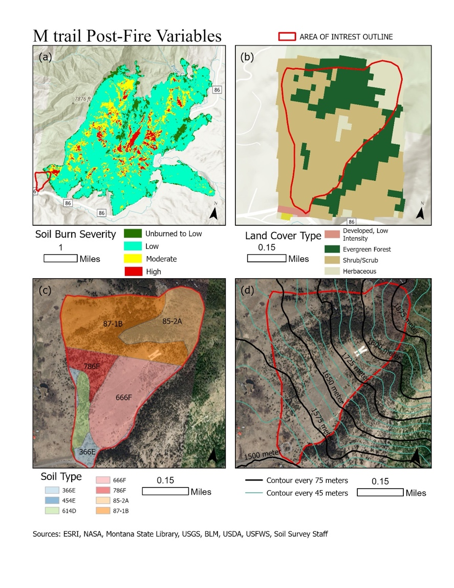
Figure 10: Maps of the (a) Bridger Foothills Fire soil burn severity and other post fire variables directly in the M trail area including (b) land cover type, (c) soil type, and (d) slope.

For the slope, the area spans from about 1,500 meters to above 1,875 meters, a change of 375 meters, which is considered a steep slope. Then, the land cover is mainly comprised of shrubs, some evergreen forest, and a little herbaceous cover. Additionally, information from the Bridger Foothills fire provides insight into the M trail area, as the areas just above it had low to moderate soil burn severity (Figure 10). Finally, there are the soil types, which combine different soil units, mainly loams. A loam is a type of soil that is an even mix of sand, silt, and clay; the smallest particles are clay, and the biggest are sand, and silt falls in between. Larger particles have less capacity to hold water than smaller particles because there is more tension between the particles to hold the water between the soil's pores. Because these soils are loams, they have a moderate capability to retain water and, therefore, have a decent amount of runoff and erosion.
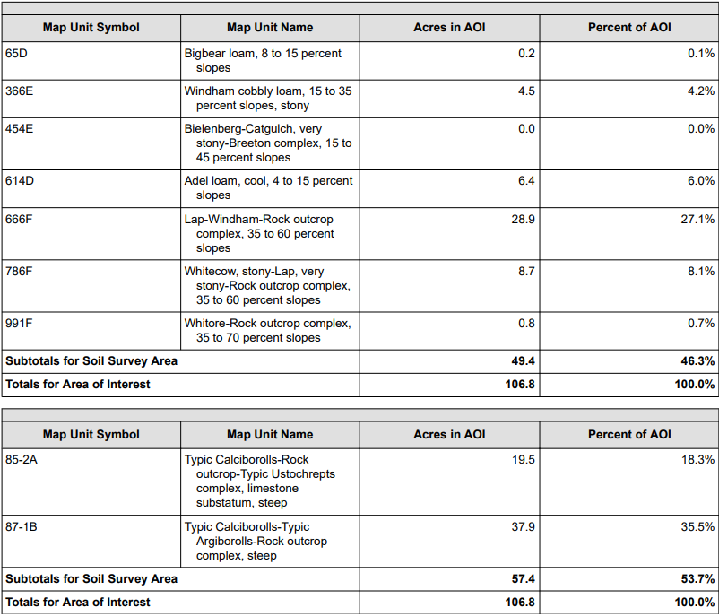
Figure 11: Screenshot of Custom Soil Resource Report M Trail Area soil units (Soil Survey Staff, 2010) https://websoilsurvey.sc.egov.usda.gov/WssProduct/sjdrkg5ebx2x1nuitkhbq5ff/GN_00000/20241027_15060003231_1_Soil_Report.pdf
Some of the notable soils that make up the upper 54% of the M trail area are Typic Calciborolls, an obsolete term. However, the description implies that they are well-drained soils found on slopes from 45 to 70 percent and, as a result, have no flooding or ponding since all the water is usually runoff as it quickly drains through the soil (Figure 11). Then, just below the ‘M’ in the middle area of the slope between the trails, the dominant soil is the Lap-Windham-Rock outcrop complex, found on 35 to 60 percent slopes. The soil is found on hills and is from a parent material that is a loamy residuum weathered from limestone. Due to the steep slope, the soil is relatively shallow, as bedrock reaches between 16 and 20 inches, and there is a usual amount of soil erosion each year. However, these areas are susceptible to landslides or more significant erosion events that could result from wildfires and rainfall events.
One way to attempt to predict soil erosion after a wildfire is the Water Erosion Prediction Project (WEPP) computer simulation, which calculates erosion and sediment delivery potential. (Elliot & Robichaud, 2014) Specifically, the WEPPcloud-disturbed model incorporates infiltration and runoff, soil detachment, transport and deposition, and plant growth. The model also allows users to upload a burn severity map from a past fire to be considered in the model. The model can also run without soil burn severity data since it uses SSURGO to create 7778 soils and NLCD to parameterize land use for unburned conditions (Elliot, 2014). Therefore, the model inputs climate, such as rainfall amounts, intensity, temperature, and management, which includes land cover type, soil properties, and topography, such as slope length, steepness, width, and orientation. For climate, the CLIGEN model is used to produce estimates of precipitation, temperature, dewpoint, wind, and solar radiation and then averages those values over 100 years. The model output is a geospatial delineation of a stream channel outlet hillslopes and the predicted soil lost in each hillslope section.
For this example, at the M trail using the Bridger Foothills fire, standard inputs were used in the WEPPcloud - disturbed model, uploaded data of the soil burn severity from the Bridger Foothills fire, channel delineation of a minimum channel length of 330 feet and a critical source area of 25 acres, the outlet was determined using the cursor, subcatchment delineation was created. The generation of the land use for each hillslope from the 2019 national land cover database, soil for each hillslope, and climate from the closest station, the BOZEMAN AGR COL MT 241044, with the PRISM climate method for a single climate ran over a stochastic climate generation of a 100-year simulation. All of these generated variables were input into the WEPP, which creates an output of multiple result summaries, reports, and resources in a geodatabase to upload into ArcGIS Pro.
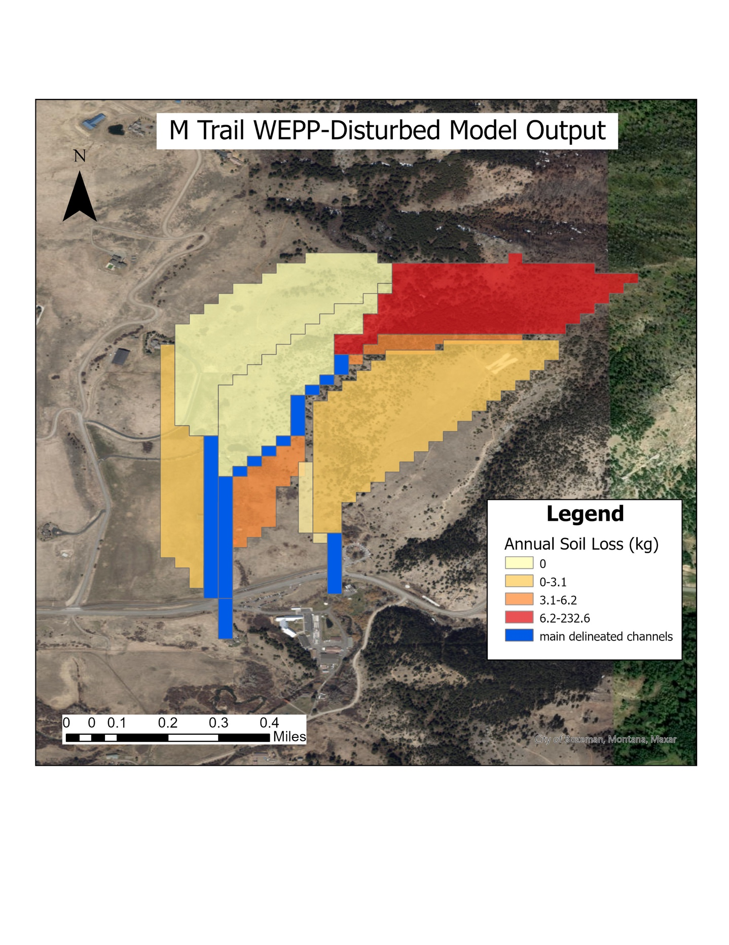
Figure 12: Output of the calculated soil loss (kg) annually from the WEPP-disturbed model for the M trail area
The initial results from the WEBB-disturbed model show relatively low amounts of erosion, between zero and six kilograms of soil loss annually. However, there is a significant increase in the amount of soil loss in the area where the Bridger Foothills fire burned, as it was predicted that there were 232 kilograms of soil loss annually (Figure 12). This outcome was expected due to the decrease in vegetation. After the fire burned a lot of vegetation, nothing held the soil in place, which allowed for increased erosion and loss of that soil. This information shows that if a fire were to burn around the M trail area, the region would be suspectable to have large quantities of soil loss based on what occurred after the Bridger Foothills fire. Understanding that there is a considerable risk of erosion in this area that could be destructive towards the M trail, precautions before, during, and after a fire event should be taken to prevent a level of erosion that could completely wipe out parts of the trail.
Management Recommendations
The history of wildfire management has evolved from a suppression-focused approach in the early 1900s to a more holistic understanding of fire and its ecological role. In response to this shift in awareness and the expectation that critical wildfires will worsen in frequency, size, and severity, the United States Congress took bipartisan action to establish the Wildland Fire Mitigation and Management Commission in 2021. The Commission was tasked with creating a report of recommendations to address wildfire mitigation, management, and post-fire rehabilitation and recovery (USFA, 2023). This report includes 148 policy recommendations with seven key themes, including - urgent new approaches to address the wildfire crisis, supporting collaboration, shifting from reactive to proactive management, enabling beneficial fire, supporting and expanding the workforce, using new tools for informed decision-making, and investing in resilience (USDA, 2023). These proposed strategies directly apply to the M trail and its burn zone. Therefore, these policies could increase the region's wildfire resilience and ecosystem health if applied.

Urgent New Approaches to Address the Wildfire Crisis
The first recommendation of utilizing new approaches to address wildfire mitigation applies to the College M area due to its proven susceptibility to fire. The report mentions several practices for reducing wildfire severity in natural environments, such as prescribed burning, mechanical treatments, grazing mitigation, and all land actions (Adams, 2023). While wildfire mitigation must occur at the M trail area, it must also be acknowledged that not all of these recommended practices are as straightforward as they may seem. For example, prescribed burning may not be a practical preventive measure due to the topography and location of the College M area. This is because fire spreads with a higher rate of spread in up-slope directions, meaning a prescribed burn, if not done tactfully, could spread out of control (Abouali, 2021). For example, a prescribed burn conducted on rugged terrain similar to that of the College M led to the largest and most destructive wildfire in the history of New Mexico, known as the Calf Canyon/Hermits Peak fire (USFS, 2022). In addition to the topographic challenges, the location of the M makes prescribed burning a higher-risk activity due to its proximity to Lyman Creek, a stream from which Bozeman derives a portion of its drinking water. However, this can be circumvented, as it has been found that the effects of a prescribed burn on water quality can be minimized if unburnt patches >10m wide are retained within prescribed burns. This was found to reduce runoff and erosion into down-slope streams; however, rainfall intensity is an uncontrollable variable that had a significant impact on the results of this study (Cawson, 2013). Despite these potential drawbacks, prescribed burning is proven via computer simulation, case studies, and fire regime analysis to reduce wildfires' intensity, size, and damage (Fernandes, 2003). Therefore, while a multifaceted decision, prescribed burning should be seriously considered to address wildfire mitigation across the M trail area.
Additionally complex but viable wildfire mitigation approaches include mechanical treatments and grazing practices. Using mechanical treatments as a means of fuel reduction throughout the M trails area would be beneficial for fire resilience, as it would lead to a healthier ecosystem through the removal of invasives (Figure 1). However, a drawback of this method is that it involves high financial costs that would be vulnerable to the government's appropriations processes (Adams, 2023). The alternative practice of wildfire mitigation through grazing as a means of fuel load reduction could be a beneficial byproduct of the goats whose introduction to the M trail area is recommended to control invasive plant species. In fact, grazing practices can change the dynamic of rangeland impacted by invasive grasses and have been found to improve native bunch grass survival when a wildfire does occur (Ratcliff, 2022).
The final yet most crucial approach to wildfire mitigation introduced by the Wildland Fire Mitigation and Management Commission is that of all-lands action. This proposes a cross-boundary approach to prioritization, planning, and implementation of risk reduction treatments (Adams, 2023). This is highly relevant to the M trail area as several pertinent landowners and stakeholders are involved. Therefore, open communication is vital, as wildfire mitigation must be done on all lands around the M trail area for these strategies to work effectively.

Supporting Collaboration
To accomplish cross-boundary work and support collaboration, fire mitigation needs to be a discussion that involves all relevant landowners, stakeholders, and administrators, including state, local, and tribal agencies, private landowners, the public, and non-government organizations. This is incredibly relevant to the College M because the land is owned by two government organizations: the United States Forest Service and the United States Fish and Wildlife Service. These two organizations are not the only ones involved, however, because the College M also has stakeholders such as Montana State University and the community of Bozeman. In fact, a survey with over 300 participants found that 60% of the respondents considered the M to be very important to Bozeman’s identity. Therefore, this project is the first step in initiating a conversation between stakeholders and government organizations regarding increasing the College M’s fire resilience. One way to further involve the public could be by installing a “photo stop” along the ridgeline trail where those recreating could place their phone on a stand to photograph the burn zone and submit their images. The stand would ensure all the photos are taken at the same height and angle, allowing for imagery of the burn zone recovery through time. To accompany this interactive activity, an educational sign could be installed to inform visitors of the 2020 Bridger Foothills fire and discuss how action toward greater fire resilience is being taken (Figure 13).
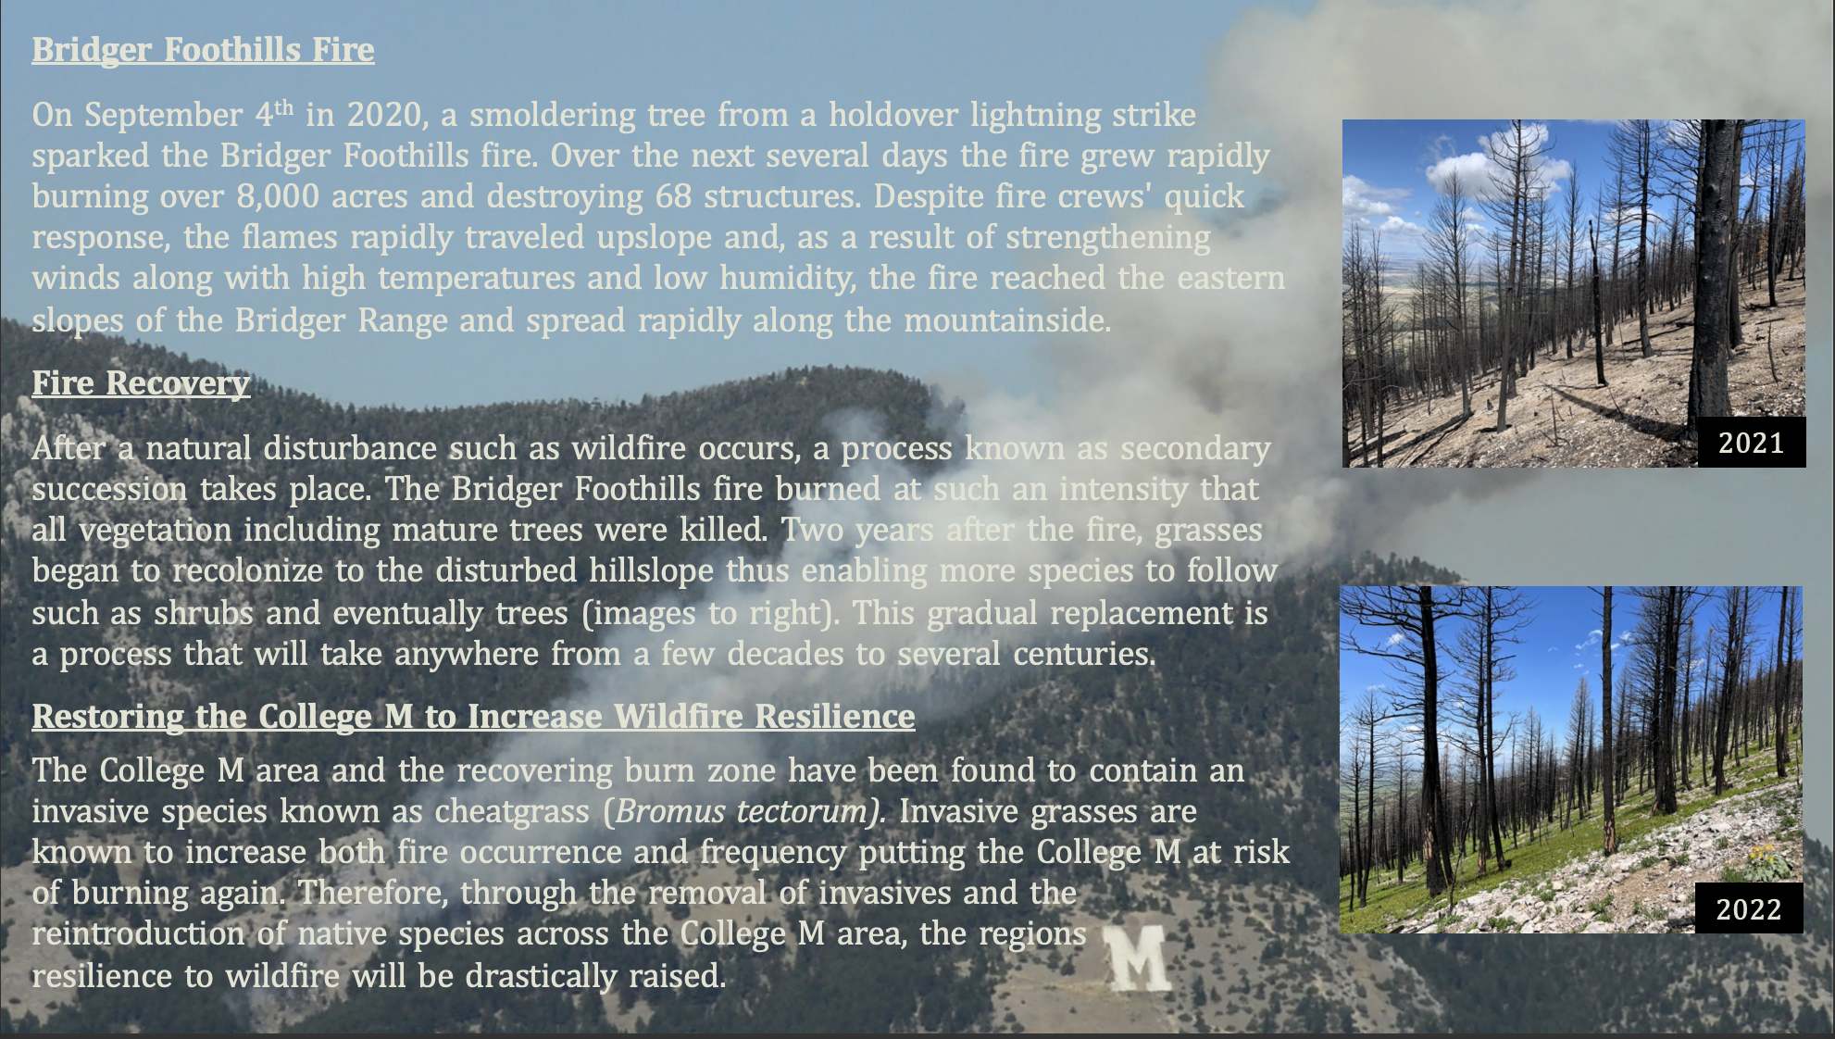
Figure 13: A sample of the sign that will be placed at the Bridger Foothills fire burn zone.

Shifting from Reactive to Proactive Management
It is known that historical suppression-based management has drastically increased fuel loads of forests and, as a result, contributed to the rise in wildfire severity. Despite this understanding, most forest fire response and legislation are reactive to large wildfires (Mourao, 2019). While the M trail area is not a large enough scale project to call attention to this error in management, it could serve as an example of how wildfire management can be improved. By using methods outlined in the “New Approaches” section of the Wildland Fire Mitigation and Management Commissions report, potential action such as prescribed burning, mitigation through mechanical and grazing treatments, and all lands action could prove to reduce the severity of future wildfires and result in the protection of structures, drinking water, and the College M itself. These new approaches, however, are not the only way for fire management to take on a proactive role. In fact, the most crucial action to increasing wildfire resilience may be through ecological restoration.
An emerging movement to remove invasives and restore ecosystems to their natural order has been a growing practice in the pre-fire management of wildfires. For example, in northwestern forests and arid grasslands, restoration has become a common tactic employed by fire managers to reduce the impacts and spread of severe wildfires. This is done by preventing invasive plants and restoring wetlands, beaver ponds, and other natural fuel breaks (CNW, 2021). While a relatively new practice, restoring ecosystems as a preventative measure against large-scale wildfires is becoming more widespread. In fact, California has incorporated forest restoration into its fuel management plan alongside thinning and fuel reduction practices in an attempt to slow the frequency and scale of wildfires the state has been facing (CNRA, n.d.). Evidence to back up these management practices can be found in a research paper by Northern Arizona University titled “Potential fire behavior is reduced following forest restoration treatments”. A table in this paper shows an evident change in fire behavior due to restoration treatments; however, managers were still advised to remove slash fuels via prescribed burning to prevent crown fires (Fule, 2001). Overall, the currently available scientific information indicates that restoring the College M’s ecosystem could enormously benefit the region’s wildfire resistance.
Additional support for proactive restoration-based wildfire management comes from data collected across the M trail area (Figure 5). Using the data gathered, a density map of invasive and non-native plants was made, indicating that the clearing down-slope of the College M contains a high density of invasive species such as cheatgrass (Figure 1). These invasive plants likely spread from hikers taking the steep and easy trails, as there was consistently a higher concentration of invasives along the trailside. Additional evidence for this distribution of invasives was found upslope of the M along the Bridger Ridge Trail within the burn zone. Here, invasive plants were only found adjacent to the trail, while the remainder of the burn area contained native plants. The presence of these invasive and non-native species is alarming because local-scale studies done across varying US ecoregions and vegetation types found that invasive grasses increased fire occurrence by up to 230% and fire frequency by up to 150% (Fusco, 2019). From this evidence and the known presence of invasive grasses, it can be determined that restoring the College M area has the potential to improve the region’s wildfire resilience drastically. In turn, this would also protect recreational opportunities, structures, and Bozeman’s drinking water. The primary challenge that comes with proactive ecosystem restoration is that without cross-boundary collaboration and proper funding, it can be extremely challenging to take preventative measures.

Enabling Beneficial Fire
Beneficial fire includes a multitude of proactive actions such as prescribed burning, cultural burning, and managed fire. These practices are beneficial in ecosystems such as ponderosa pine forests, where low-intensity surface fires once occurred. Today, these forests often experience fires of size and severity much greater than the ecosystem's historical fire regime due to suppression-focused fire management practices (POLIS, 2024). According to the Commission, by restoring these ecosystems to their natural species and historical fuel loads, the practice of beneficial burning, whether it be prescribed, cultural, or managed, can resume and reduce the severity of wildfires. While the College M area does not explicitly need this management practice, the push by the Wildland Fire Mitigation and Management Commission for the restoration and beneficial burning of at-risk ecosystems serves as additional support for the restoration of the M trail areas.

Supporting and Expanding the Workforce
In its report, the Wildland Fire Mitigation and Management Commission advised that increasing workforce capacity is essential for sustaining fire response, risk reduction, and recovery. Despite this claim, the 2020 Bridger Foothills fire received support from crews across the county with a force sufficient to stop the spread of the fire. Therefore, instead of pursuing a larger wildfire response workforce, it would be beneficial to continue involving Montana State University students in the wildfire mitigation process. This can be done by having relevant courses such as Biodiversity Surveying and Monitoring Methods (ENSC 410) and Identification of Seed Plants (BIOO 230) visit the M trail area each fall and spring. An additional course that could aid in fire mitigation at the College M ecosystem is Fire Ecology and Management (NRSM 330), as this course focuses on using prescribed fire to accomplish habitat management goals. Therefore, students taking these courses could follow the methods used for this initial analysis and collect data on native, non-native, and invasive plant species, further increasing the data available for analysis while simultaneously reducing potential identification errors. From this, a robust plan could be made to increase the College M area’s wildfire resilience.

Using New Tools for Informed Decision Making
A partnership with Montana State University for the wildfire mitigation process could be beneficial beyond the ability to collect more data. In fact, the Wildland Fire Mitigation and Management Commission states in its report that the current fire management system and its fire behavior models are not designed for the rapid change ecosystems are undergoing in response to climate change. Therefore, students at Montana State University could utilize the school's scientific resources and technology to conduct research in the M area and fill gaps in knowledge, thus guiding changing management practices. This would foster improved coordination, communication, and collaboration across science and management organizations (Adams, 2023).

Investing in Resilience
Investing in resilience is the final key theme in the Wildland Fire Mitigation and Management Commissions’ 148 policy recommendations. The report states that restoring federal lands to increase wildfire resilience would likely cost over $100 billion. However, an economic analysis of wildfire and its impacts noted that the costs and losses associated with wildfire are tens to hundreds of billions of dollars per year (Crowley, 2023). From this, the Commission states its belief that “the wildfire crisis must be acknowledged as an issue of national security and a public health crisis” (Adams, 2023). Therefore, it is not only cost-effective but also crucial to the health and protection of the Bozeman community that restoration of the College M ecosystem be considered seriously to increase wildfire resilience.

Conclusion/Next Steps
In this report, we conducted a comprehensive fire analysis of the M trail area. We recommended several mitigation practices to prevent future wildfires and reduce the negative consequences of a fire should one occur. These management recommendations include utilizing new approaches to address the wildfire crisis, supporting collaboration, shifting from reactive to proactive management, enabling beneficial fire, supporting and expanding the workforce, using new tools for informed decision-making, and investing in resilience. The primary actions advised in tandem with these broad goals involve prescribed burning, mitigation through mechanical treatments, mitigation through grazing, all lands action, and restoring the College M ecosystem. Each of these proactive measures is advised primarily because cheatgrass is found throughout the M trail area, along with other invasives and non-native plants, which increase the risk of fire in the area while reducing its recurrence window. By acting now, the College M region will be more resilient to fire protecting not only the ecosystem but also Bozeman’s drinking water and an important place to the community.
As this project moves forward, significant work still needs to be done. Additional surveys can be conducted to better understand fire risk and mitigation across the M trail area through collaboration with Montana State University. One way this can be accomplished is via a screening system for predicting wildfire risk of non-native plants. Literature-based assessment scores had a high predictive ability, correctly identifying 90% of plants considered to be at high risk of fire (Faccenda, 2022). An additional method of understanding the region’s broader fire risk would be through NSF’s Established Program to Stimulate Competitive Research. Montana State University received a 20 million dollar grant for prescribed fire research through EPSCoR, where drones with sensors can map the burnable fuels in forests and monitor fire behavior and smoke (MSU, 2023). With this information, educated fire mitigation action can be accomplished to reduce the College M area’s wildfire risk. In addition to collecting this data, increased plant identification can significantly aid restoration efforts working to improve the wildfire resilience of the ecosystem. In conclusion, while this report is the first step to increasing the College M ecosystem's wildfire resilience, there is still much more data collection and management to be done.

Literature Cited
Abouali, A., Viegas, D. X., & Raposo, J. R. (2021). Analysis of the wind flow and fire spread dynamics over a sloped–ridgeline hill. Combustion and Flame, 234, 111724. https://doi.org/10.1016/j.combustflame.2021.111724
Adams, Jamiah, et al. (2023, September). ON FIRE: The Report of the Wildland Fire Mitigation and Management Commission. Wildland Fire Mitigation and Management Commission, www.usda.gov/sites/default/files/documents/wfmmc-final-report-09-2023.pdf.
Bishop, J. (2021, March 11). From peak to faucet: Bozeman's water. The MSU Exponent. Montana State University. https://www.msuexponent.com/outdoors/from-peak-to-faucet-bozemans-water/article_d648befa-8285-11eb-8430-0ffc95f9b72b.html
Bramwell, L. (2024). Smokejumping and Science: Montana's Role in Wildfire Management History. Montana: The Magazine of Western History 74(2), 66-77. https://dx.doi.org/10.1353/mnt.2024.a934813.
Brooks, R. (n.d.). After the fires: Hydrophobic soils. University of Idaho Extension. https://www.uidaho.edu/-/media/UIdaho-Responsive/Files/Extension/topic/forestry/F5-After-the-Fires-Hydrophobic-Soils.pdf
Cawson, J. G., Sheridan, G. J., Smith, H. G., & Lane, P. N. J. (2013). Effects of fire severity and burn patchiness on hillslope-scale surface runoff, erosion and hydrologic connectivity in a prescribed burn. Forest Ecology and Management, 310, 219–233. https://doi.org/10.1016/j.foreco.2013.08.016
CNRA. (n.d) Restoring Forest Health for Wildfire and Climate Resilience. California Natural Resources Agency, resources.ca.gov/Initiatives/Forest-Stewardship
CNW. (2021). Fire, Forests and Communities: Conservation Northwest. Conservation Northwest - Protecting, Connecting and Restoring Wildlands and Wildlife, conservationnw.org/our-work/wildlands/fire
Crowley, C., Miller, A., Richardson, R., & Malcom, J. (2023, May 25). Increasing damages from wildfires warrant investment in wildland fire management. United States Department of the Interior, https://www.doi. gov/sites/doi.gov/files/ppa-report-wildland-fire-econ-review-2023-05-25.pdf
Dewitz, J. (2023). Products: U.S. Geological Survey data release. National Land Cover Database (NLCD)., https://doi.org/10.5066/P9JZ7AO3.
Dore, Helena. (2021, Septeber 3). One Year Later, Bridger Foothills Fire Stirs Feelings of Loss, Appreciation. Bozeman Daily Chronicle, www.bozemandailychronicle.com/news/county/one-year-later-bridger-foothills-fire-stirs-feelings-of-loss-appreciation/article_47c21952-4bd7-55cf-9b0c-692ccc347d20.html
Elliot, W. J., & Robichaud, P. R. (2014, August 5). Water Erosion Prediction Project (WEPP). USDA Forest Service, https://research.fs.usda.gov/rmrs/products/dataandtools/tools/water-erosion-prediction-project-wepp
Fusco, E. J., Finn, J. T., Balch, J. K., Nagy, R. C., & Bradley, B. A. (2019). Invasive grasses increase fire occurrence and frequency across US ecoregions. Proceedings of the National Academy of Sciences, 116(47), 23594–23599. https://doi.org/10.1073/pnas.1908253116
Fernandes Paulo M. Botelho Hermínio S. (2003). A review of prescribed burning effectiveness in fire hazard reduction. International Journal of Wildland Fire 12, 117-128, https://doi.org/10.1071/WF02042
Fire Tower - Helena Historic District. (n.d.). Historic Montana. https://historicmt.org/items/show/704
Fule, P.Z. and McHugh, C. and Heinlein, T.A. and Covington, W.W. (2001). Potential fire behavior is reduced following forest restoration treatments. In: Ponderosa pine ecosystems restoration and conservation: steps toward stewardship (RMRS-P-22).
Fusco, E. J., Finn, J. T., Balch, J. K., Nagy, R. C., & Bradley, B. A. (2019). Invasive grasses increase fire occurrence and frequency across US ecoregions. Proceedings of the National Academy of Sciences, 116(47), 23594–23599. https://doi.org/10.1073/pnas.1908253116
Global warming in the Western United States. (2015, September 15). Union of Concerned Scientists, https://www.ucsusa.org/resources/global-warming-western-united-states
GVLT. (2016). College ‘m’ Trail - Gallatin Valley Land Trust. Gallatin Valley Land Trust - Trails & Conservation, gvlt.org/featured-trails/college-m-trail
Himanshu, B., Pandey, A., Bhatt, D., Sundriyal, R. C., & Uniyal, V. P. (2024). Forest fire management, funding dynamics, and research in the burning frontier: A comprehensive review. Trees, Forests and People, 16, 100526. https://doi.org/10.1016/j.tfp.2024.100526
Krebs, P., Pezzatti, G.B., Mazzoleni, S. et al. (2010). Fire regime: history and definition of a key concept in disturbance ecology. Theory Biosci. 129, 53–69, https://doi.org/10.1007/s12064-010-0082-z
Life. (2009, July). BioScience, Volume 59, Issue 7, Pages 593–601, https://doi.org/10.1525/bio.2009.59.7.10
Miller, M. E. et. al. (2016). Rapid-response tools and datasets for post-fire remediation: Linking remote sensing and process-based hydrological models (Gen. Tech. Rep. RMRS-GTR-355). USDA Forest Service, Rocky Mountain Research Station. https://www.fs.usda.gov/rm/pubs_journals/2016/rmrs_2016_miller_m002.pdf
Miller, M. E., MacDonald, L. H., Robichaud, P. R., & Elliot, W. J. (2011). Post-fire erosion. NetMap Tools. https://www.netmaptools.org/Pages/Watershed_assessment/post_fire_erosion.htm
Mourao, P. R., & Martinho, V. D. (2019). Forest fire legislation: Reactive or proactive? Ecological Indicators, 104, 137–144. https://doi.org/10.1016/j.ecolind.2019.04.080
MSU. (2023). Montana State-Led Project Receives $20 Million for Prescribed Fire Research. Montana State University, www.montana.edu/news/22928/montana-state-led-project-receives-20-million-for-prescribed-fire-research.
National Climate Assessment. (n.d.). National Climate Assessment. https://nca2014.globalchange.gov/report/regions/great-plains
National Forest Foundation. (2022, April 19). Blazing Battles: The 1910 Fire and its legacy. https://www.nationalforests.org/our-forests/light-and-seed-magazine/blazing-battles-the-1910-fire-and-its-legacy
Oregon State University. (n.d.). Oregon Explorer Topics, https://oregonexplorer.info/content/what-fire-regime?topic=95&ptopic=2#:~:text=A%20'fire%20regime'%20is%20the,pattern%2C%20season%2C%20and%20severity.

Pausas, Juli G, Keeley, Jon E. (2009, July). A Burning Story: The Role of Fire in the History of Life, BioScience, Volume 59, Issue 7, Pages 593–601, https://doi.org/10.1525/bio.2009.59.7.10
POLIS. (2024). Beneficial Fire versus Catastrophic Wildfire. The POLIS Wildfire Resilience Project, poliswildfireproject.org/beneficial-fire-versus-catastrophic-wildfire/.
Randall, B. (2022, November 17). Why is Cheatgrass bad? Working Lands for Wildlife. https://www.wlfw.org/why-is-cheatgrass-bad/
Ratcliff, F. et.al. (2022). Cattle grazing reduces fuel and leads to more manageable fire behavior. California Agriculture, 76(2-3). https://bof.fire.ca.gov/media/xraftixn/ratcliff-et-al-2022_ada.pdf
Soil Survey Staff. (2010) Keys to soil taxonomy. 11th edition. U.S. Department of Agriculture, Natural Resources Conservation Service. http:// www.nrcs.usda.gov/wps/portal/nrcs/detail/national/soils/?cid=nrcs142p2_053580
Soil Survey Staff (2023). The Gridded National Soil Survey Geographic (gNATSGO) Database for Montana. United States Department of Agriculture, Natural Resources Conservation Service. https://nrcs.app.box.com/v/soils
Taylor, K. T., Maxwell, B. D., McWethy, D. B., Pauchard, A., Nuñez, M. A., & Whitlock, C. (2017). Pinus contorta invasions increase wildfire fuel loads and may create a positive feedback with fire. Ecology (Durham), 98(3), 678–687. https://doi.org/10.1002/ecy.1673
US EPA. (2024, July 23). Climate change indicators: Wildfires. US EPA, https://www.epa.gov/climate-indicators/climate-change-indicators-wildfires#:~:text=Multiple%20studies%20have%20found%20that,wildfire%20frequency%2C%20and%20burned%20area.&text=The%20wildfire%20season%20has%20lengthened,and%20drier%20soils%20and%20vegetation
U.S. National Park Service. (n.d.).1988 Fires - Yellowstone National Park https://www.nps.gov/yell/learn/nature/1988-fires.html

U.S. National Park Service (n.d.). Indigenous Fire Practices Shape our Land - Fire. https://www.nps.gov/subjects/fire/indigenous-fire-practices-shape-our-land.htm#:~:text=Throughout%20California%2C%20Indigenous%20nations%20have,began%20living%20in%20Yosemite%20Valley

USDA. (2023). Wildland Fire Mitigation and Management Commission. U.S. Department of Agriculture https://www.usda.gov/topics/disaster-resource-center/wildland-fire/commission
USDA Forest Service, Geospatial Technology and Applications Center, BAER Imagery Support Program. (2020, November 13). Soil Burn Severity Dataset for the BRIDGER FOOTHILLS Fire occurring on the none National Forest [raster digital data]. USDA Forest Service. Salt Lake City, Utah, USA. https://fsapps.nwcg.gov/afm/baer/download.php
U.S. Fire Administration. (2023). Wildland Fire Mitigation and Management Commission. U.S. Department of Homeland Security. https://www.usfa.fema.gov/wui/wildland-fire-mitigation-management-commission.html
USFS. (2022). “Single Incident Information.” InciWeb. inciweb.wildfire.gov/incident-information/nmsnf-hermits-peak-fire.
United States Geological Survey (2021). United States Geological Survey 3D Elevation Program 1 arc-second Digital Elevation Model. https://doi.org/10.5069/G98K778D.
Wasserman, T. N., & Mueller, S. E. (2023). Climate Influences on Future Fire Severity: A Synthesis of Climate-fire Interactions and Impacts on Fire Regimes, High-severity Fire, and Forests in the Western United States. Fire Ecology, 19(1).
Zouhar, Kris. “Bromus Tectorum.” Usda.gov, 2003, www.fs.usda.gov/database/feis/plants/graminoid/brotec/all.html. Accessed 13 Nov. 2024.

