Trail Maintenance Group
ENSC 499 LRES Capstone
Dr. Will Wetzel
11 December 2024

Strategic Trail Maintenance and Monitoring at the Bozeman M For a Sustainable Use Future
Written by Paige Gardner, Ryan Lawson, Alex Ferland, Azzio Simontacchi, Mya Dube, Matt Honiker, and Nichols Barrett

Abstract
There is an ever-increasing number of users opting to travel along the College M trail for either an easy day hike or to access the more extensive Bridger Range. The path leading up to the M and its surrounding environment have endured extensive damage and disturbances related to said overuse, leading to the degradation of ecosystem functions and overall trail aesthetics. To foster an environment that echoes Bozeman’s passion for outdoor recreation and preservation, our group crafted a proposed restoration plan to promote future sustainable use at the College M Trail by implementing best management practices. As a tool to guide our restoration plans, we used geographic information systems (GIS) to create a base map that depicts the current trail conditions. This map highlights any existing trail erosion, signs of off-trail use, and drainage discrepancies that we aim to alleviate and mitigate within our proposal. Finally, the suggestion of incorporating informational signage and a future monitoring program is discussed. These components are included to educate users, record current trail conditions, and ensure potential solutions serve their desired purpose.

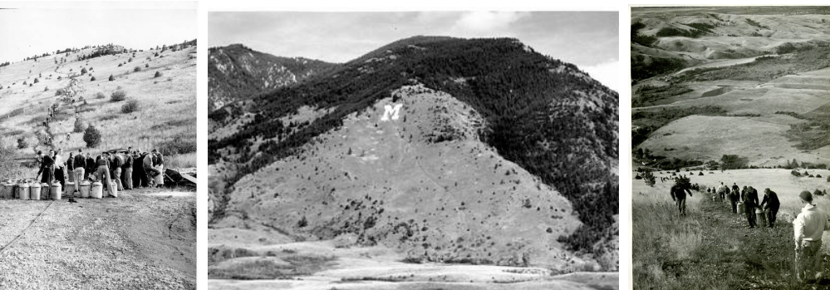
Figure 1. Bozeman's M trail.
Introduction
Since its creation in 1915, the college “M” has been a centerpiece of the Bozeman community. Located on the southern edge of the Bridger Range, the trail leading up to the College M is one of the most popular hikes in the Bozeman area, with up to 1500 users annually (Cite?). The user group is projected to increase as the population of Bozeman continues to grow. With the rise in use comes the challenge of addressing an already stressed trail system to accommodate more traffic in a sustainable and environmentally friendly fashion. We propose tackling these issues through three main management recommendations: alleviating switchback cutting, erosion control, and implementing drainage systems throughout the trail.
The switchback portion proposes reclaiming social trails and degraded switchbacks through soil decompaction and native grass seeding, along with implementing rose bushes within trail ‘elbows’ to act as a natural deterrent to ‘trail-cutting’ hikers. The result is a more simplified, aesthetic trail system with a less extensive impact on the surrounding environment. Erosion control and drainage will consider the potential of redesigning portions of the trail as well as banning high erosion activities, such as mountain biking, from utilizing the trail. The use of water bars, retaining walls, and revegetation of barren areas are also discussed. Geographic information systems (GIS) will be applied throughout the entire project to create a base map that highlights areas in need of remediation. This map will not only be implemented during the remediation process but can help create a baseline for monitoring efforts and be used in public outreach.
Informational signage and a proposed future monitoring class are also included in this project. The purpose of these latter two components is to amend the trail condition from overuse and excess traffic by educating the public to prevent future disruption and track if solutions are serving their desired purpose. Through the application of GIS mapping, Erosion control, Switchback revegetation, Informational signage, Drainage implementation, and future monitoring, we believe that the quality of the trail and its neighboring ecosystem will become enriched, leading to a better experience for hikers and less disruption to native wildlife.

Part I: GIS
To aid in the management plans of the later section, we conducted an extensive survey to better understand the current conditions of the M’s easy trail. We focused on this trail specifically due to it having the highest amount of traffic. 23.75% of trail users claimed that they use the easy route to get to the M, which is over 6% higher than the next most popular route (M Area Intercept Survey, 2024). Figure 1 shows this path up towards the landmark in red alongside its sister trails in yellow. This survey was done by leveraging our access to an Emlid Reach RS2 GNSS Receiver, tablet, Arc software, a measuring tape, and a survey rod. We then constructed a survey form on Arc Online for Field Maps that considered erosion, trail widening, desired trails, switchbacks, depressions in the trail, and points of interest.
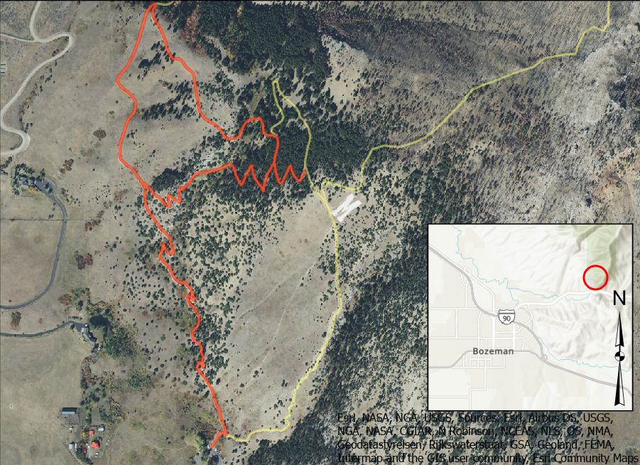
Figure 2: M "easy" route
The data collected was projected in NAD 83 UTM zone 12 for the least amount of distortion for the study area. The maximum acceptable horizontal accuracy was 50 cm (63-68% confidence) to make sure the point was in the ~1 m wide trail.
For consistency in data collection, attributes were created for each feature type, and some attributes had a domain. The classifications for erosion and depression were pulled from the US Forest Service’s Forest Soil Disturbance Monitoring Protocol (FSDMP). The protocol is commonly used for projects within national forest land when making NEPA assessments; therefore, we deemed their definitions appropriate for our use.
Erosion has been a scale to measure many trial conditions due to it being directly correlated with human use. Erosion also has significant ecological implications, especially in xeric habitats that recover slowly, like the ‘M’ slope. In FSDMP, the four classes of erosion are as follows: (0) none, (1) Slight erosion evident (i.e., sheet erosion), (2) a moderate amount of erosion evident (i.e., sheet and rill erosion), and (3) a substantial amount of erosion evident with gullies, pedestals, and rills noticeable (Page-Dumroese et al., 2009).
Depressions in the trail catch water and are usually a source of erosion. As the water continues to build, the side of the trail may have a blowout, leading to gully creation and trail incision. Beyond the ecological damage, depressions tend to create areas of mud, which may upset many trail users. Similar to erosion classifications, the USFS classifies depressions into four categories: (0) None, (1) slight depressions evident (<5 cm deep), (2) depressions are >5 cm deep, and (3) depressions highly evident with a depth being >10 cm. We recorded the locations of depressions and measured their depths by laying a survey rod flat on the ground so that the deepest point could be measured. The diameter of the depression was also recorded for additional information.
Desire trails (cut-throughs) were the only line feature in this survey. This feature had six different classes that were pulled from the study Guidance for Managing Informal Trails by Marion. The classes are: (0) none, (1) trail distinguishable; slight loss of vegetation cover and/or minimal disturbance of organic litter, (2) trail obvious; vegetation cover lost and/or organic litter pulverized in primary use areas, (3) vegetation cover lost and/or organic litter pulverized within the center of the tread, (4) nearly complete or total loss of vegetation cover and organic litter within the tread, bare soil widespread, and (5) soil erosion obvious, as indicated by exposed roots and rocks and/or gullying (Marion, 2019).
Switchbacks and trail widening were documented to examine their relationship with specific disturbances, such as cut-through paths. The attributes associated with trail widening were the length of the widened section and the width of the section. Points of interest were extra points that were not accounted for before going into the field. Some of these points were seating areas, offshoot trails, springs, and other noteworthy features. Each feature had a notes section and an optional photo attachment. The notes section was primarily used for highly disturbed points, providing a description explaining the reason for the assigned score, along with an accompanying photo.

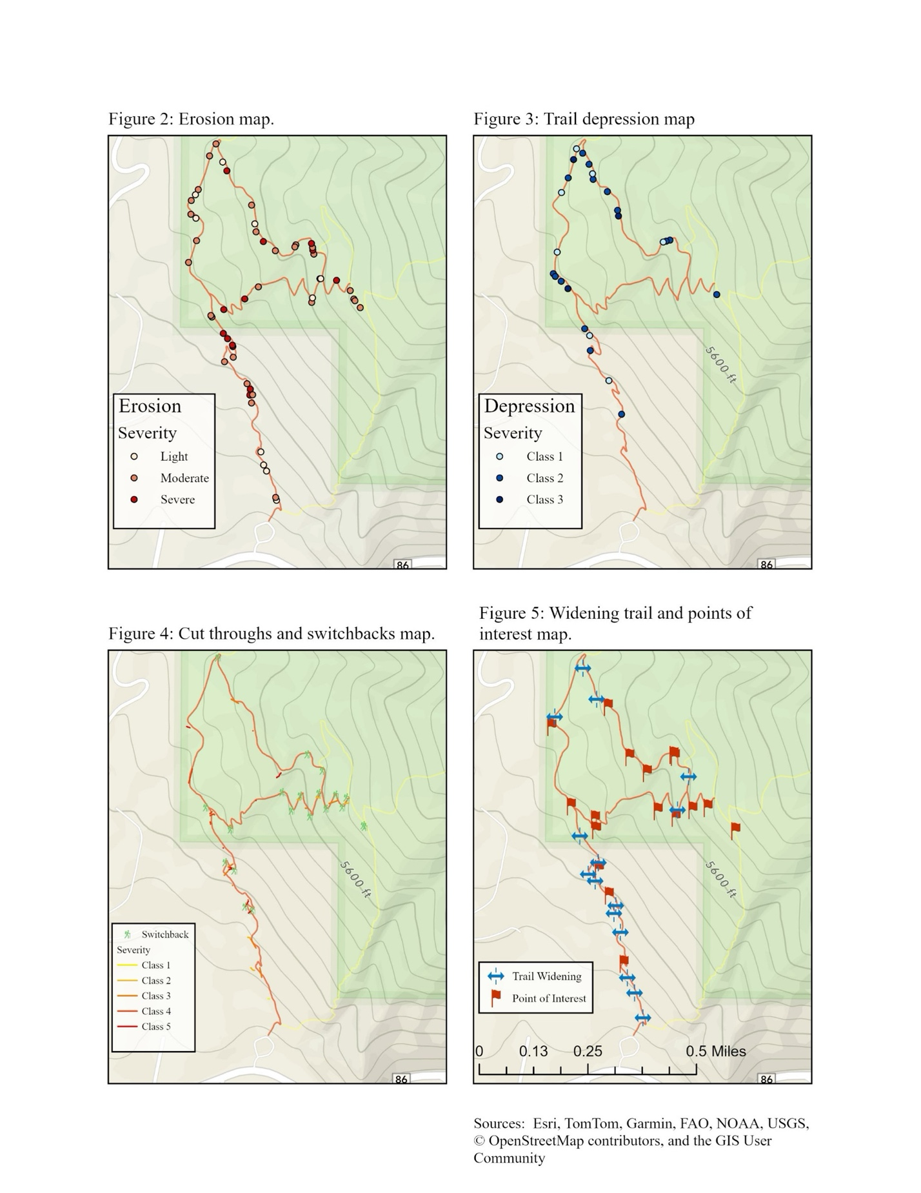
Figure 3: ArcGIS data sampling of the M

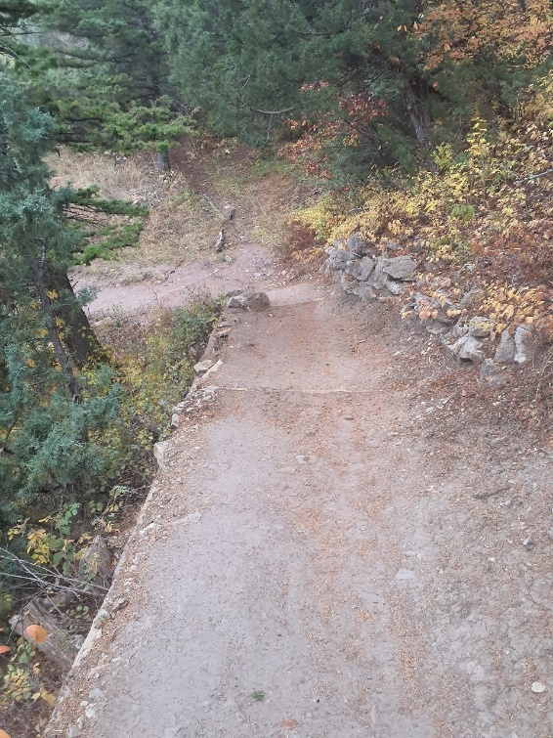
Looking at Figure 3, the densest area of moderate-severe erosion was at the beginning, which might be expected. The nature of the ‘M’ trails may explain this phenomenon. Most of the ‘M’ trails start with this section before breaking off; consequently, this short section is the most heavily trafficked. The increased human traffic can cause more disturbance in this area. Looking at these maps, there is another section of dense erosion near the top of the long route. This area is a gully, which is a natural waterway. Water erosion, coupled with human traffic, has led to a considerable amount of slumping. There have been improvements to this portion of the trail, with the installation of rock walls and wood for the trail to prevent further slumping.
Figure 4: Trail improvements at the gully such as wood to support the trail and a rock wall to support the hill side have been installed.
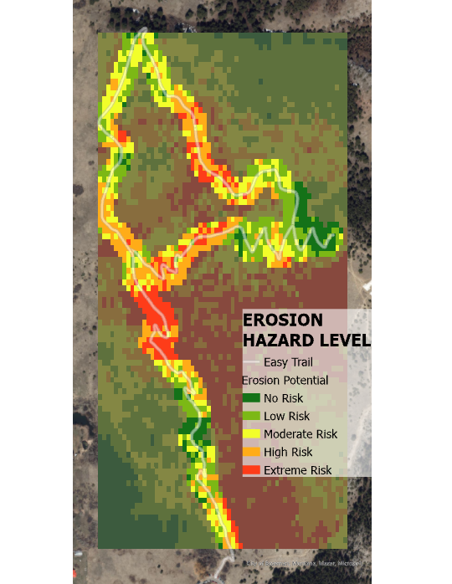
We can then export the data from Arc Field Maps and import them into ArcGIS Pro. For further analysis, we needed some additional data. Firstly, the trail layer of the area was pulled from the USFS and then reprojected to match the CRS of collected data. A digital elevation model (DEM) was collected from the USGS National Map. Soil types were pulled from the USGS Web Soil Survey, and ortho imagery was collected from USDA-SPAC-BC. This data was put together specifically so we could see soil type, vegetation cover, hill aspect, and hill slope, along with the current spots of erosion. These five layers were then weighted in ArcGIS to create a single weighted overlay raster that portrays the erosion potential within 15m of the trail.
Figure 5 Erosion potential of the 'M' easy trail
Maps like these can help stakeholders implement features we will later propose by showing how detrimental certain features, like erosion, are to the M’s trail. Showing the variables spatially will also help immensely in using the management’s resources more effectively, such as concentrating erosion mitigation in the areas of extreme risk in Figure 5.

Part II: Erosion Control
Soil erosion and improper water drainage are key issues with unsustainable trails. Increased recreational use of the College M trail has led to declining trail quality, with problems such as soil erosion and muddiness becoming more prominent. As muddiness increases in some areas, this can cause rutting, exposing roots and rocks while also increasing the overall trail roughness. Rutting and trail roughness because of soil erosion can increase the difficulty of the trail, diminish the aesthetics, impede maintenance, and incur additional maintenance costs (Wimpey & Marion, 2016). While the M is primarily used by hikers, it is a multi-use trail also used by bikers and horseback riders, which causes increased trail degradation. Addressing these concerns is critical to the safety of users, accessibility, and environmental sustainability. This section of trail maintenance focuses on the impacts of trail erosion, widening, drainage, and recommended maintenance of the M trail.

Causes of soil erosion
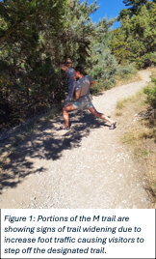
Degradation of trails depends on the usage of the trail, usage frequency, and managerial factors (Wimpey & Marion, 2016). Soil erosion, caused by trail widening, steep topography, and heavy foot traffic, is the most significant form of environmental degradation because it decreases vegetation cover and impacts water quality. The causes of trail widening are generally due to the idea of visitors that “vote with their feet,” especially depending on the “fall line” of a trail. The “fall line” of a trail is the parallel of the trail with the direction of water flowing down, which are often trails that are steep grades. When visitors vote with their feet, this results in informal trails (social trails) and trail widening. Trail widening occurs while avoiding obstacles such as mud, rocks, steeper inclines, and cutting switchbacks. It can be exacerbated by a lack of borders and heavier foot traffic that result in increased soil erosion, water runoff, and vegetation loss. Trail widening can double or triple the environmental impact (Wimpey & Marion, 2010). Trail-side vegetation and the organic layer of soil are pulverized, causing a reduction in vegetation cover and compositional changes over time by the reduction of native species and the introduction of nonnative species. This can even be within a meter of the trail borders due to off-trail traffic and reduction of cover. Figure 6 is one of the many points wider than most of the trail along the trail. Overall, the M trail maintains an average trail tread stretching 1 meter across, however, points like Figure 1 show exceedance of the average trail width. According to a study that had 12 resultant types of recreational trail conditions based on their analysis, each was grouped into four groups of degradation level. Level 1 starts with an acceptable amount of degradation, while level 4 is described as heavily damaged trails (Tomczyk et al., 2017). Based on observations, the college M trail would be within level 2. Level 2, threatened trails, are described as having a trail between 1.1 to 2.1 meters wide and an incision (trail depth between either border) of up to 0.6 meters with dominant hiking of small or medium amount of use on steep slopes (8-20%). With projected foot traffic in future years expected to increase, foot traffic will cause more trail degradation, resulting in the College M trail reaching a level described as heavily damaged. If the trail degrades to this extent, it
Figure 6. M widening
could incur more maintenance costs than proactively preparing for the predicted volume of visitors.
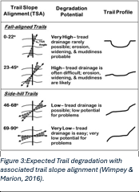
Figure 7. Trail Classification Rankings
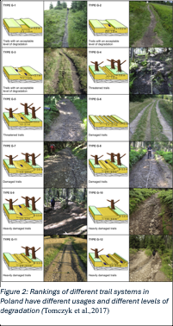
Additionally, it is important to consider slope percentage limitations and trail slope alignment when assessing the maintenance of sustainable recreational trails. Trails that exceed a trail slope of 10% exponentially increase soil erosion because of the increased velocity of water traveling downslope (Wimpey & Marion, 2016). Though many organizations, such as the International Mountain Bike Association (IMBA), have a general rule of recreational trails not exceeding an average of 10% to prevent excessive soil erosion, this is discounting ascending and descending slopes that still experience excessive soil erosion. The average slope percentage of the College M trail sits at 8% when considering the miles over the total elevational gain. Trail slope alignment (TSA) is an often-overlooked component when assessing the maintenance of recreational trails (Figure 3; Wimpey & Marion, 2016). TSA is the difference in the trail bearing to the prevailing landform. TSA of 0-22° is nearly lined up with the landform and is more prone to soil erosion because of incisions and can result in exposure of rocks and roots. These fall-aligned trails can also result in further degradation by trail widening due to hazard exposures.
Figure 8: Trail degradation and slope alignment
Native soil texture has a significant impact on sustainability when considering heavy foot traffic or water drainage. Soil texture, defined by the percentage of sand, silt, clay, and rock, has differing properties when considering compaction (Wimpey & Marion, 2016). Sandier soils will drain more easily due to the coarse texture, and finer soils contain higher percentages of clay and silt while retaining more water and puddles. Finer texture soil will compact and resist erosion better, however, when wet, it can create a slick surface. Rockier native treads eroded less and could sustain heavier traffic on the M trail Furthermore, tread drainage features also help how well water can drain off the tread without eroding most of the trail. Water bars can be effective in some areas, however, with decreasing slopes, they can be an ineffective measure to properly guide drainage.

Solutions for soil erosion
To effectively mitigate soil erosion from the College M trail, sustainable alignment will require some redesigning to minimize erosion-prone areas. Trails should follow the contour line of the Baldy Peak landform to prevent erosion by water following fall-aligned trails. However, if realignment is not feasible, an additional switchback can prevent fall-aligned trails and reduce overall slope percentage and, therefore, reduce soil displacement. Rolling contours can improve overall water movement and create natural contours that can improve the aesthetic of the trail. For sections that are subject to more intense erosion, or even along the entire trail, additional tread substrates that range in particle size can improve resistance to displacement and erosion, with sand promoting drainage, clay binding, and rocks to support heavy foot traffic. Trails with high rock or gravel content are better able to sustain heavier foot traffic and have less soil erosion overall. Crushed gravel can also be another amendment because, when mixed with native soil, it can harden the trail tread and preserve the aesthetics of the trail. A more extreme method to combat heavier foot traffic and soil erosion would be well-anchored rockwork, stone pitching, and rock steps to deter erosion on steeper grades or depressions on the trail.
Drainage is essential to prevent further soil erosion and trail widening. Installation of water bars and grade dips at regular intervals can effectively direct water off the trail surface. Lower trail grades are constructed with out-sloped treads; however, a drainage feature is still necessary due to the accumulation of soil deposition. Leading back to the conclusion of rolling contours with several grade reversal features. However, areas having a TSA over 46% will not require water bars or other drainage features due to the natural resistance to muddiness, soil loss, and widening. To discourage users from trampling vegetation, the establishment of logs or boulders and larger rocks can encourage visitors to stay on the trail. Additionally, revegetation of long trail edges can enhance the barrier and encourage soil stability to slow erosion. Planting native grasses and shrubs can promote regrowth and trail resiliency. Overall, to ensure long-term sustainability, monitoring and maintenance schedules can address areas of erosion before they worsen and incur more maintenance costs.

Changing the Dedicated Use of the Trail:
Currently, the M trail is a multi-use trail people use for running, hiking, biking, and horseback riding. Given the size of the M trail and the amount of use this trail has, there is a lot of activity that is causing excess erosion of the trail. A study in Tennessee analyzed how the use of recreational trails influenced soil loss and found that horseback riding caused 8 times more erosion than hiking trails (Olive, 2009). Therefore, horseback riding should be prohibited on the M trail, given the amount of stress horses cause on trails. Looking into mountain biking, studies have seen similar trail degradation in mountain biking and hiking unless the area is wet or has poor drainage (Evju, 2021). In terms of the M, other than the spring, this area is relatively dry. This research suggests that in terms of trail degradation, mountain biking is not causing any more harm than hikers. However, given the popularity of the M and the width of the trail, prohibiting mountain biking would allow hikers and runners to enjoy the trail more. A survey done at the M trail shows that most people (80%) use the M for hiking, running, and exercise, while the use of biking and horseback riding is limited (Church’s GPHY 401-501 Fall 2024 Student Survey 10/8/2024). There are many other mountain biking trails around Bozeman where mountain bikers can enjoy the outdoors. Limiting the activities on the M will not solve the parking problem, but it will create a few more spaces with fewer trail uses. Overall, given that horses heavily erode trails and there is not a big enough trail for mountain bikers, the M trail should be a hiking trail only.

Part III: Switchback Control


Trail Management is an integral principle of sustainable trail use and design. The challenge for steep terrain is creating routes the perceived user(s) would naturally take on their own accord. The recommended USFS is a 1:8 ratio for up to 10 feet of trail length, as this represents the maximum grade scale for mountainous trails. If this ratio is broken, users are inclined to “cut” the predetermined path to find either the easiest (least resistance) or most direct path to their desired location. Note that most cut trails link back with the intended trails at some point, but not always. While grade can be a determinant of whether one strays from the beaten path, many hikers do so regardless. To combat improper use and cutting in trail systems, physical barriers that impede movement along potential trail diversion points prove the most effective. These obstacles should provide either a physical or mental signal that delineates the established trails. This not only makes it physically more difficult for hikers to stray from trail boundaries but also makes their decision to disregard trail rules a more conscious one.
Figure 9. USDA Forest Service slope alignment grade calculation
The “easy” path on the M trail in Bozeman constitutes eight switchback style turns from the trailhead to the M itself, with most switchbacks occurring on the last ½ mile of the trail tread surface. Unfortunately, the combination of overuse, lack of education, and outright disregard for trail etiquette is apparent along this path, as nearly all addressed switchbacks are severely trampled and barren. To return these areas to the surrounding ecosystem as well as increase overall trail aesthetics, we propose a native revegetation project along the affected switchbacks with the incorporation of vegetative buffers as an extra precautionary measure to dissuade users from leaving desired boundaries. This method of addressing social trails will provide a more financially feasible and relatively quick alternative to a full trail regrading project. Due to their hardiness and well-suitability in Montana soils and climate conditions (Moore-Gough, 2024), we propose using either Fireglow (Rosa ‘Morden Fireglow’) or Morden Blush (Rosa ‘Morden Blush’) as the vegetative buffer species. These plants would act as a Goldilocks barrier by including physical elements of trail deviation management through sharp, prickly spines to deter switchback cutting. Both varieties are non-native to the area, and mature bushes measure approximately 3x3ft in size. While the introduction of non-native is typically frowned upon, we suspect that implementing these species would limit spread outside of the intentionally introduced locations. These species would also provide a visually appealing element to the trail as both exhibit repeat blooms and low fragrance. An alternative plan to nonnative revegetation would be vegetation with woodland rose (Rosa woodsii). This rose type is a native plant to Montana and thrives in most soil conditions. However, because this rose is native, it may spread beyond the target sites within the impaired switchbacks.
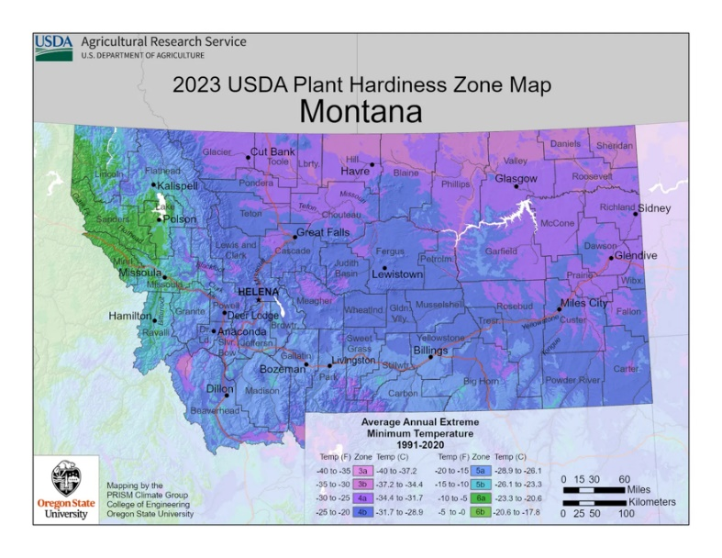
Morden Fireglow is a compact, low-spread species with little to no flowering petals. Due to its low flowering and spreading characteristics, this species would be an excellent option to consider as an herbivory defense. The other option would be Morden Blush - a vigorously spreading bush with many flowering petals. The Morden Blush would be beneficial in providing a potentially visually stimulating species to the M trail, which we suspect will give users a reason not to trample them. Due to their spreading nature, a downside would be that ongoing maintenance would have to occur to prevent movement into non-target areas of the trail.
Figure 10. USDA Plant Zone Map for Montana, 2023

To put our restoration plan into action, we propose a two-day trail closure, which will allow for the preparation of affected switchbacks and the establishment of rose bush seedlings. Ideally, this project would occur in early June, which will avoid the influx of tourist traffic experienced in July. The early spring introduction will also allow for seedlings to be established before the arrival of summertime heat (Moore-Gough, 2024). Some light preparation of the affected areas will take place before revegetation to foster ideal conditions for the re-establishment of vegetation and ensure complete remediation of affected areas. First, the social paths themselves will be de-compacted using hand tools, such as pulaskis and shovels, to a depth of approximately 8 inches. Soil decompaction will help restore soils to a healthier state, enhancing soil biota, porosity, and nutrient availability, all key players in creating conditions that are viable for plant growth.
Figure 11. Morden Blush rose, courtesy of PlantSpark
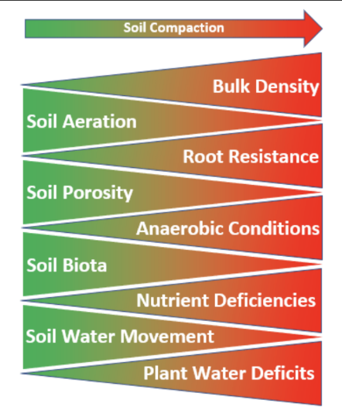
The next step will be to plant the rose bushes in the target switchback elbows. To allow for adequate growth and ensure the prevention of trail encroachment, we suggest planting a singular bush in the center of each switchback elbow. We recommend sourcing both varieties of rose bush from High Country Roses. This online retailer charges $191.60 for eight individual units of either rose species. The final task to be completed in the revegetation process will be to spread a native grass mix over the rest of the disrupted switchback cuts. Grasses act as a fast-establishing cover crop that will help prevent weed establishment and runoff. Since these grasses coexist with native forbs and shrubs, we expect seeding these areas with grass mixes will also act as the first step towards native recolonization. Rocks bordering the desired trail and additional project signage are recommended as further steps to funnel people on the main trail and away from seedlings. These signs should display text along the lines of “Keep on trail, restoration in progress” and should be secured with stakes or to trees adjacent to the switchback (Reference Information Signage). Signage can be removed at the end of the summer following initial planting or be kept up indefinitely as another management tool to help mitigate switchback cutting.

Note while this entire project could be feasibly accomplished within a two-day timeframe, project management should include an ongoing monitoring phase, which consists of both passive and active monitoring, to determine the effectiveness of the applied trail management practices. Active monitoring of switchbacks is recommended to occur twice annually, ideally in the early spring and middle of summer. During each of these sessions, the proper function of the rose bushes should be ensured, and any changes in the structure of cuts along the switchbacks should be noted. Passive monitoring can occur throughout the year via eight-game camera traps (One per switchback). Game cameras should be set up in such a way that the field of view of the cameras captures the entirety of the switchback. This will provide insight into whether trail users are cutting switchbacks even with soft barriers in place and where social trails are forming so that trail management parties can further address any flaws within this style of management practice. We recommend using the Reconyx Hyperfire 2 Cellular Trail Cameras because these units are cellular network compatible and allow wireless photo transmission to the stakeholders and project management team. Eight of these units, one per switchback, would cost $4799.92.
Figure 12: Morden Fireglow Courtesy of Denver Botanic Gardens

Part IV: Educational Signage
To ensure maximum effectiveness, the switchback methods detailed above will be accompanied by a series of signs to further prevent off-trail use and excessive erosion. As previously discussed, we will focus our efforts on the “easy” part of the M trail and will revamp the current signage present on that part of the trail. This will begin with a series of signs at the trailhead detailing the need for restoration and erosion mitigation that our project will undertake. Concentrating most of the signage efforts on the trailhead will increase the chances that someone reads them, as people are likely to read signs here, whereas they might not notice them if they’re partway through the hike. The current signage at the trailhead consists of a large wooden sign with a trail map, warnings about bear country, and other hiking-related posters. There is a small section on the trail etiquette poster that mentions staying on the trail even if it’s muddy, a suggestion made to reduce off-trail erosion, but this isn’t emphasized enough. In the large blank space at the bottom of this sign, right above “Custer Gallatin National Forest,” another poster saying, “Stay on trails, don't cut switchbacks, reduce erosion!” will be placed. It will be on a white backdrop with black font. This will help enforce the message to stay on the trail, and the text size being larger than the rest of the writing on the sign will help it stand out further.

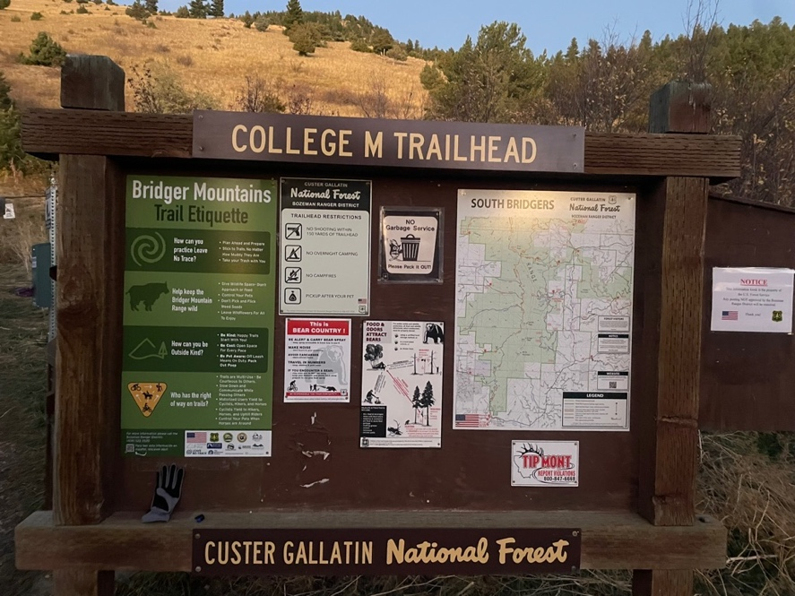
There is currently a sign at the trailhead titled “The ‘M’ Improvement Project.” This sign explains that MSU has a long history of maintaining the M and has several pictures showing students painting rocks and building the retaining wall that sits at the bottom of the M. Another sign as large as this one will be placed next to it after the restoration project is completed and detail the steps taken through our project. It makes more sense to place the sign once the project has been completed in case there were any unforeseen obstacles or funding-related issues that led to the initial project proposal not being completed. This sign would briefly mention all the different sections, such as GIS, erosion control, switchback control, drainage, monitoring, etc, and explain the timeline for our project and the need for restoration. This sign might be more detailed than others, but simply reading the headings will effectively convey the main message of our project to the public.
Figure 13. College M trailhead sign.
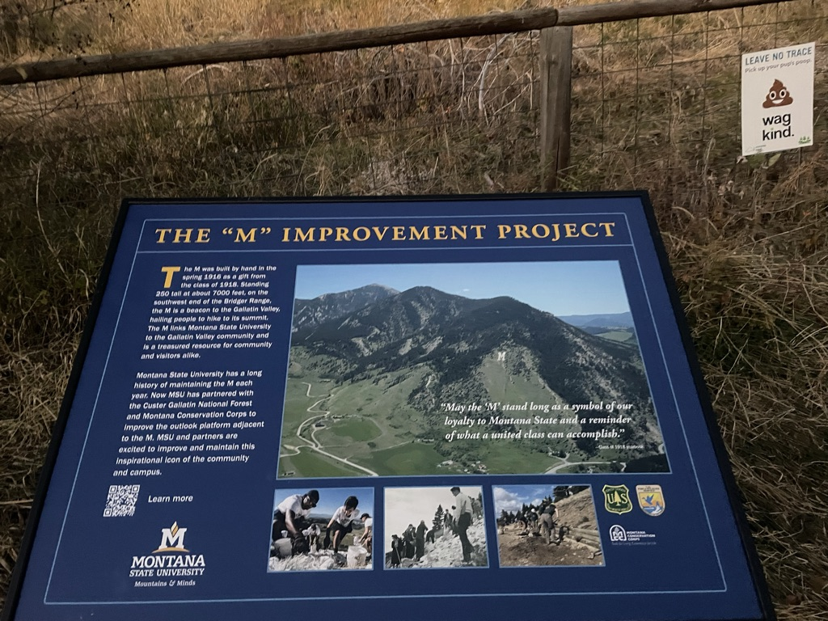
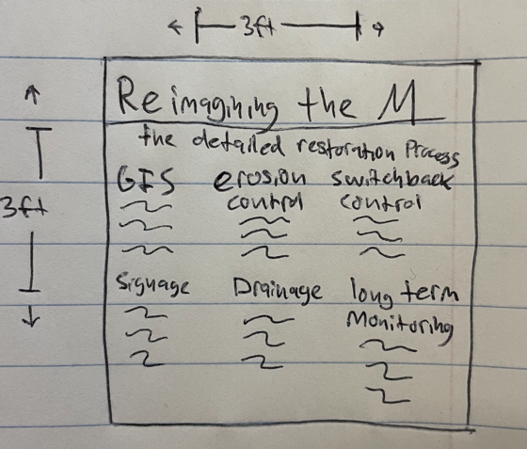
We found a well-put-together sign that the Forest Service uses to warn against switchback cutting and will make our signs identical to this (figure 15). The main message of “Do not cut switchbacks” is prominent, so it can be seen at a glance, but there is also text beneath it that briefly explains why. As previously explained, the M trail is frequented by a wide variety of hikers, many of which may not understand the consequences that switchback cutting and the erosion it causes can have on areas adjacent to the trail. If these hikers are curious as to why they shouldn't cut the switchbacks, they’ll learn that the vegetation is being restored when they read the subtext of the sign. There are eight switchbacks on the trail, and two of these signs will be made. One sign will be placed in a convenient location just before the first switchback, so hikers going up the trail can see it before they start any of the switchbacks. Another sign will be placed in a convenient location just above the eighth switchback, facing toward hikers who are descending the trail. This will ensure hikers get the message since some may come up the “steep” trail and down the “easy” trail, where they otherwise wouldn’t know to not cut the switchbacks.
Figure 14. The “M” Improvement Project and proposed educational sign about our project.

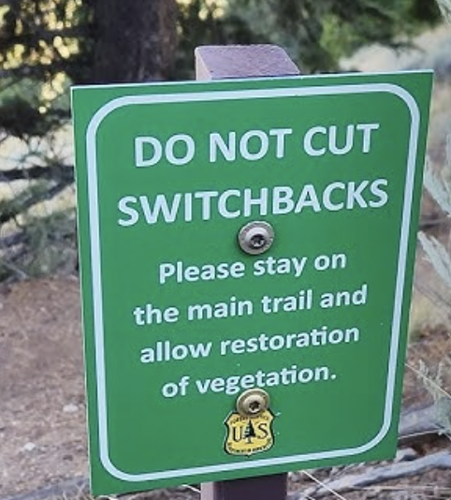
While the restoration is in progress and the rose bushes are in their beginning stages of growth, they may not be as visible to hikers, and there could be issues with trampling. To prevent this, we will make small, temporary signs. These temporary signs will read “Keep on the trail, restoration in progress” and will be placed in a suitable location in front of the growing rose bushes. These signs will be a necessary supplement as the rose bushes may not be large enough to provide a sufficient barrier to deter off-trail use and switchback cutting in the early phases of the restoration. These signs will be removed once growth is sufficient enough to deter the trampling of the rose bushes. As discussed earlier, hikers may only be heading down the “easy” trail if they take the steep trail up, so if applicable, signs will be put on both the uphill and downhill sides of the restoration area along the switchbacks.
Figure 15: reference signage for impaired switchbacks

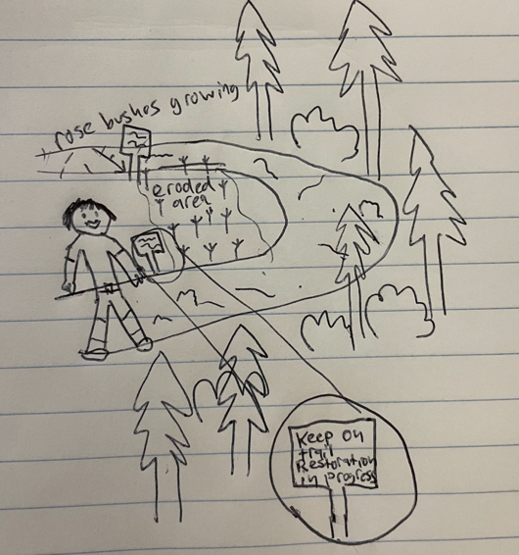
Figure 16: potential rose bush signage schematic

Part V: Drainage
The College M trail is a staple attraction of Bozeman and has been put under the spotlight for renovation to make it more accessible to the ever-growing population. Although the trail is going to be going through renovations meant to improve accessibility to the trail, the renovations have been looking past the issue of trail erosion and the poor drainage around the western side of the mountain. We see this as trails are being washed out, and the potential for mudslides or rockfall on the mountain is increasing due to the loose sediment and rocks falling from higher up along the trail onto the lower trail. When we took the time to go out and see the M trail, we noticed that there were multiple areas along the trail where there were loose rocks, a divide in the trail, as well as poor irrigation around the mountain, causing trails to be cut out and loose. I want to focus on this issue as it is a main attraction for the town when people come here as they are looking for places to hike and connect with nature and the M trail is an easily accessible trail for most people as well as a way for the school to promote its activities. As the renovations of the M trail are being done, we are suggesting the addition of proper drainage within the trails as well as adding retaining walls to prevent the sides of the mountain from crumbling on themselves and blocking people from going off trail.
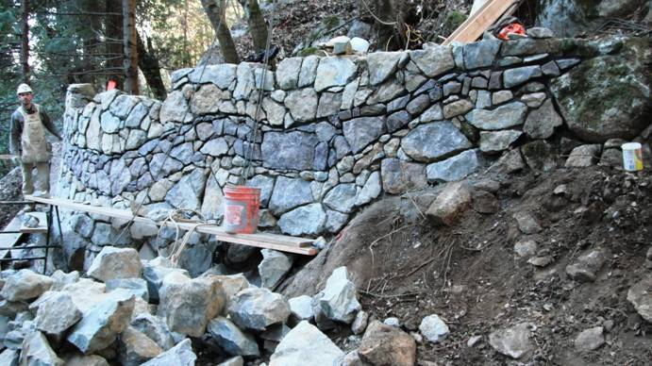
The reason that erosion is an issue on the trail is because trail erosion can lead to disturbance of the aquatic systems. It brings more sediment into these systems, and this could be harmful, especially as there is a fishery across from the trail. Trails will become muddy, which is already seen in areas where the water is flowing through, which is potentially dangerous to people as the mud is slippery, causing someone to fall and harm themselves with no easy way for rescue operations to reach them or for them to reach the bottom of the trails themselves. It can also widen the trails, which could cause the trail to split as water flows through it and exposes the roots and rocks, creating a rougher trail experience. This could create undesired trails that people could take and get lost on, which is not a main issue on this trial as erosion has not made any new trails. A vast majority of the trail erosion I had seen on the M trail was located along the western side of the mountain, with many of the issues that were described. A lot of the trails had split down the middle, cuts on the side of the trails where water flows, very fine sediment being brought into the trails causing widening, as well as still water pooling in certain areas. With those issues in mind, a potential solution would be a retaining wall around steeper curves, steep walls, and switchbacks.
Figure 17: Example Retaining Wall (Credit: Trailism)
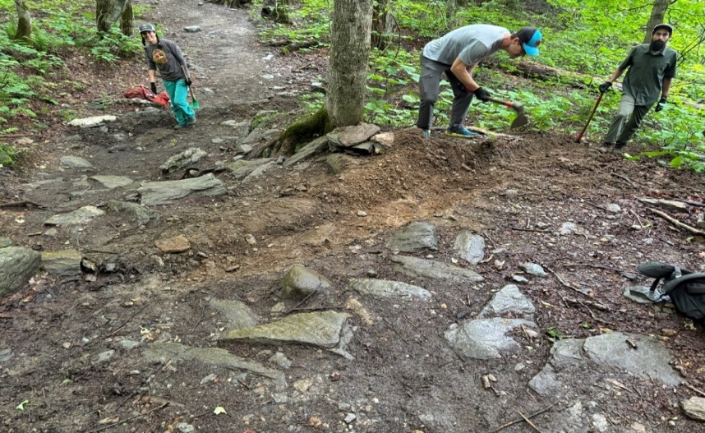
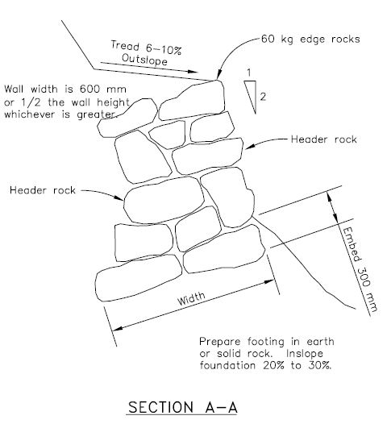
The retaining wall can be made of either stone or wood and would help improve the stability of the trail at certain points when trying to create a winding trail upwards like it is near the peak of the trail within the wooded areas. Near the peak of the trail, there were zones of the winding trail that had been eroding, cut through, and had water flowing through it. Implementing the retaining wall would be a benefit of maintaining the existing trail alignment. The structure would help keep the trail as it is, with little to no trail meandering, as people would no longer be able to cut across the steep grade to make a shortcut. The trail would remain with its designated trail grade as well. The grade is influenced by the sustainability of the trail tread, so placing the retaining wall is a long-term solution to stay within its sustainable grade and not lose the design and layout along the mapped-out trail over time. As well as keeping its current slope, it stays accessible to the public even if they have movement impairments, they can see if the slope and grade are within their abilities before going. The wall would help protect resources around the trail sides as well as reduce the impacts on the trail. As the trails are along soft dirt and many trees around the trails, the wall would help keep the rises in the trails inaccessible to people, so they aren’t trampling the plants or exposing tree roots. And finally, it can reduce the debris that falls on trails below. When going into the starting area of the trail, there are plenty of large rocks that have fallen from the top parts of the trails and create tripping hazards around the trails until you are high enough along the trail, but having the retaining wall can act as a buffering system catching larger rocks that could fall onto someone while hiking.
Figure 19: digging out small drainage ditches. (credit: Green Mountain Club)
Figure 18. USFS Wall Example
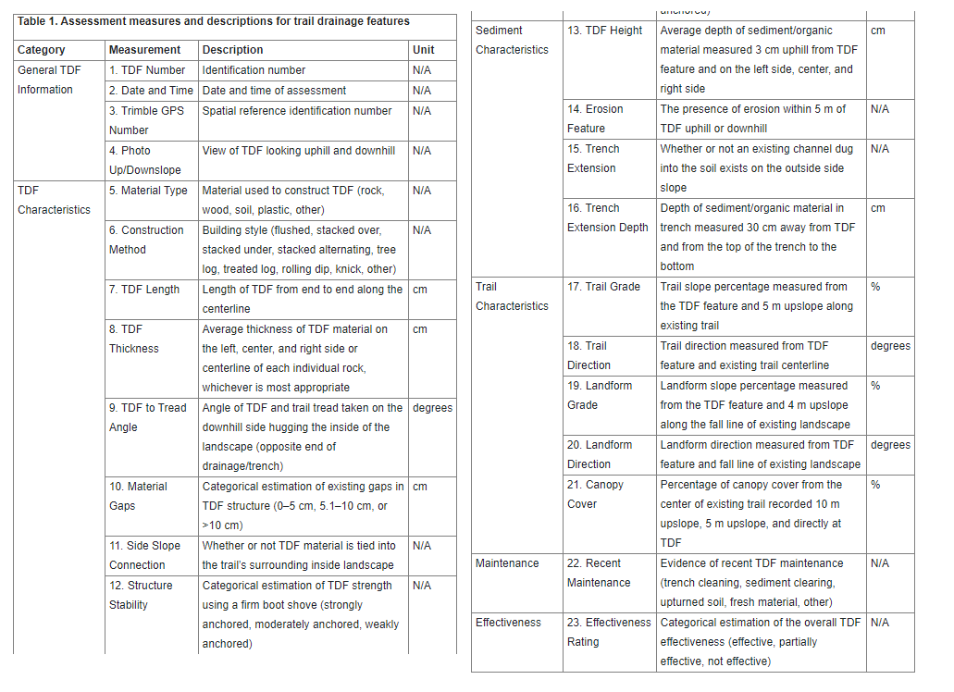
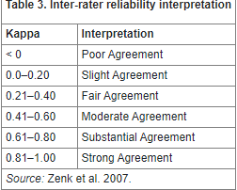
The second option for maintaining the trail quality around the M trail would be to improve the trail drainage by creating paths for the water to flow down without touching the actual trail. The National Park Service says that a trail that is designed sustainably and is well maintained will allow visitors better access to natural areas as well as reduce their impacts on the resources by focusing the usage to a limited amount of linear pathing. The occurrence of running water on or next to the trails causes problems like muddiness, widening, root exposure, soil erosion, and the trampling of non-trail areas. If the problems become too much for the trails to handle, it will be too harsh on the surrounding environment as well as the recreational experiences as it causes people to stray off the main path and, in a way, forge their trails to go around zones that are already too damaged. The easiest solution to these problems is to create trail drainage features. A drainage feature is an arrangement or installation of any material, such as rocks, wood, or soils, on a separate path near a trail that would catch surface runoff and divert the water away from the actual trail surfaces. Something I would recommend for creating the trail drainage is to follow the field assessment tool that the National Park Service has tested around for a research proposal. The design aims to provide a quantitative approach to creating trail drainage features similar to those implemented by parks nationwide. Although initially developed as a test tool to establish a foundation, it has potential for improvement but already contributes to building more resilient trail foundations. For management, the tool is meant to provide a catalog of the trail’s current conditions as well as the qualities that it has. With the trail tool, it can highlight the unwanted qualities that lead to poor performance, such as the trench depth or the tread levels left on the trails for the angles for the trail drainage features that were previously implemented but became unusable so that the agency could fix the issues or make new features to help the drainage. It can also help the land managers justify that they need to work on these areas and how much money, time, and the amount of resources are needed to fix everything.
The tables are what are used to assess how to scale the trail quality and, eventually, what needs to be fixed. By using these tables and tools, identifying, locating, and addressing areas of poor quality will become easier, leading to improved trail quality and sustainability in the long term. This will also enhance visitor enjoyment and help maintain the surrounding environment. For the M trail, I think that adding inside channels that are dug out and filled with a sturdy material like a concrete channel will prevent the soil from cutting out further and draining it off to a connection or drain down the sides of the mountain into a waterway. The drainage needs to be reinforced as if it’s just a simple cut out along the trail it could be expected to overflow, erode faster, as well as take away the sediment that is stable around the trails. It does not need to travel across the whole mountain trail, but it does need to be around the western side of the trail as that is where most of the erosion, water flow, and loose sediment is.

Part VI: Future Long-Term Monitoring

Importance of Monitoring
To ensure that the trail we improve stays maintained, it is critical that we monitor it. Our recommended trail maintenance would greatly improve the trail; however, it is important to keep in mind that once these projects are “completed,” they are never really finished, monitoring is a critical part of the restoration of a landscape. Over time, with the use of the trail, modifications will be needed, so having a team assessing the trail is essential to know how to best modify the trail. For a heavily damaged and used trail like the M, it is suggested that it gets monitored at least once a year (Tomczyk, 2017). According to the US Forest Service trail maintenance manual, it is common for trails to be maintained based on the type or amount of use they are currently getting without considering the future trends and needs of the trail, which eventually leads to bad trail design (USDA Forest Service, 2016). This situation directly applies to the M today, and to avoid this from occurring in the future, there must be a list of trail management objectives that are constantly being monitored. This being said, we have compiled a list of monitoring objectives from each environmental aspect at the M to create a solution that utilizes our resources at MSU to consistently monitor the M.

Long-Term Monitoring Objectives

Wildlife:
In terms of wildlife, this team would like to have trail cameras implemented in more wooded areas, away from vehicle and foot traffic, to be monitored over time. This should be checked three times a year to ensure it is working and has battery power. The bat houses, including bat cameras and acoustic surveys, will be used to monitor bats and engage the community. The pollinator garden is a great way to have students monitor the insect diversity of the area over time, which would include a variety of trapping methods for different insect orders.

Water Quality:
Water quality in this area is a big concern with the growing popularity of the area and the lack of riparian areas around the stream. To monitor this area, a riparian assessment should be conducted at least twice a year downstream; this includes water quality testing, macroinvertebrate and geomorphology assessments, etc. This area should also monitor discharge, which can be done by implementing a stream gauge downstream to monitor flow.

Parking Lot:
In terms of the parking lot, there should be a physical assessment of the surface for wear and tear because permeable asphalt tends to wear faster than traditional pavement. The bioswales located right by the parking lot should also be monitored to ensure that they are effective in filtering out toxins. Stormwater management is important in this area, which would require a team to go up during a heavy rain event to ensure that the permeable asphalt is allowing water to percolate through the surface. If it is not, this would require a group to go up and vacuum out the fine sediments that are trapped in the asphalt. Expanding the bus system allows more accessibility to the M with less parking. This could be a very effective solution if students were to monitor the busy use times of the trail and the overall usage of the bus as transportation to determine the best way to incorporate a route to the M.

Plants:
The plants section includes the removal of invasive as well as the addition of native plants to the area. For the removal of invasive species, this will be monitored by prevention and detection. This involves having students practice their plant ID while also creating more space for native species at the M trail. If major construction were to be done on the trail, it is important that extra monitoring take place because it spreads invasive plant seeds. It is also important to look at where the trail is expanding or eroding for detection because there is a higher potential for invasive species. In terms of native plants and understanding the overall plant biodiversity, permeant plots will be established on both the South and West aspects of the trail. With these plots, percent cover and species richness should be recorded twice each year.

Fire Ecology:
To understand the impact and risk of wildfire in the M trail area, it is important to understand a variety of climate and topographical factors, which can be monitored using online datasets. This will be done by modifying the GIS fire maps created this semester. In the field, native vegetation can also provide insight into the fuel loads and potential likelihood and response of a wildfire if it were to occur in this area. With this being said, a permeant plot will be established at the top of the trail to record percent cover and species richness, which will be recorded every year for reference points on biodiversity differences with and without fire.

Trail Maintenance:
The long-term goals of trail maintenance include erosion, drainage, and switchbacks. Monitoring erosion and drainage during the spring with snow runoff is crucial to understanding how the water is running off the hill and making sure that this isn’t degrading the trail. This is also critical in the late summer, with lots of visitors having high use of the trail. In terms of switchbacks, monitoring the reestablished native plants to make sure they aren’t being trampled. Long-term new switchbacks could be created over time, so it’s important to consistently monitor the trail to make sure no new paths are being made. A GIS map has been made of the trail with the major points of erosion and major switchback and drainage areas. This map should be updated as the trail develops.

Utilizing Our Resources at MSU

These monitoring methods proposed above can be conducted by students at MSU. These students would monitor the M trail as well as the area surrounding the M. We see two options for achieving this, and we discuss them below.

Monitoring Plans:
Option 1: Creating an environmental science class specifically designed to monitor the M

Given the goals and objectives needed to monitor the M, creating an elective environmental science class focusing on monitoring methods is critical. Throughout my education as an environmental science student, I constantly heard the importance of monitoring, but no classes focused on long-term monitoring methods. This gap in the curriculum could be filled with a class designed to monitor the M. This also creates a team of people every semester that is in charge of monitoring the M and understanding what improvements need to be made. Given the diverse types of monitoring we are suggesting, from plants and wildlife to fires and maintenance, there will be a lot of opportunities for students to work in areas they are interested in while exposing them to different aspects of monitoring they might not be as familiar with. This option would require the setup of a new class and a professor in charge of leading the class. Overall, creating this class would make it an efficient way to keep the M trail consistently monitored.

Option 2: Utilizing classes currently at MSU to monitor the M

While accumulating the objectives from the different groups in the class, many of these monitoring aspects fall well in line with a lot of the classes that are currently offered at MSU. This would allow us to keep the M monitored without creating a whole new class. This being said, if multiple classes were to divide the monitoring up, this would require one professor to be in charge of overseeing everything to make sure everything is working together and running smoothly. On top of that, this plan would have to work with multiple professors and class schedules.
Aside from those few setbacks, the M could be a great hands-on example for many different environmental science classes. With the wildlife objectives, this monitoring could go great with the principles of fish and wildlife management (WILD 301). With the pollinator garden, the insects could be incorporated into entomology ecology (ENTO 510). When monitoring water quality, this could go great with riparian ecology (NRSM 455). In terms of the parking lot, I think this could align very well with a section in ecological responses to climate change (BIOE 375) that will demonstrate how using more environmentally friendly resources has an impact on our local climate. With the invasive and native plants, this could be a great place for weed ecology (ENSC 443) to understand the importance of invasive species monitoring. If goats were to be implemented and monitored, this could be covered by range and pasture monitoring (NRSM 235). Looking at how fire has impacted the area, this could go great with the fire ecology and management class (NRSM 330). For overall trail maintenance and the function of the trail, it could be incorporated into restoration ecology (ENSC 461) to understand how well this area is being maintained. Overall, while there are a lot of different monitoring components to the M trail, there is a wide variety of classes at MSU that could utilize the M to solidify the concepts taught in the classroom.
All these ideas above are the broad objectives that future students at MSU will use as a guide to monitor the M trail. This list must be ongoing with the development and needs of the trail. Below is a breakdown of the objectives by term, starting in the fall of 2025, to give some time for the construction of the trail and development of the class.

Monitoring Goals by Semester:

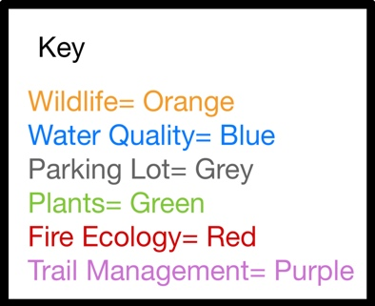
The outline shows the monitoring methods based on the time of year they should be conducted. This outline could be applied to both class options of creating a new class or adding these monitoring methods to current courses.
Fall 2025:
- Trail cam monitoring~ 1 time a week
- Bat acoustic surveys ~1 time a week
- Trapping Insects: use various trapping methods 3 times a semester (once a month at the beginning until November)
- Stream gauge implemented and tracking discharge: look at trends of total discharge at the end of the semester
- Riparian Assessment: macroinvertebrate, geomorphology, and water quality assessment twice a semester (1 beginning, one at end)
- Monitor bioswales by taking a soil sample once a semester
- Physical assessment of wear and tear
- Stormwater management, if the pavement isn’t percolating→ Vacuum out fine sediment
- Monitor bus busy use times and overall usage of bus
- Prevention and detection of invasives: done early in the semester
- Manage goats if implemented
- Establish two permanent plots (South and West aspects of the trail) and record percent cover and species richness twice a semester (1 at the beginning, one at the end)
- Original satellite pass to find baseline reflectance of grass species
- Update ArcGIS online map that groups plants by grasses, Forbes, woody vegetation, and invasive and non-native species with several plant species observed, species observed, and notes.
- Establish a permanent plot at the top of the M and record species richness percent cover, as well as take soil samples once a semester.
  - Species richness and percent cover done at the beginning of the semester
- Monitor drainage points to ensure they are working properly
- Compare high erosion areas with a GIS map from 2024, mark new high erosion areas
- Monitor switchback regrowth and citizen usage (staying on the trail/ off trail)
  - Look for new switchbacks

Spring 2026:
- Trail cam monitoring~ 1 time a week
- Bat acoustic surveys ~1 time a week
- Trapping Insects: use various trapping methods twice a semester (1 in late March and one in late April)
- Stream gauge implemented and tracking discharge: look at trends of total discharge at the end of the semester
- Riparian Assessment: macroinvertebrate, geomorphology, and water quality assessment twice a semester (1 beginning, one at end)
- Monitor bioswales by taking a soil sample once a semester
  - If excess nutrients/pollutants are cut, discarded, and replant
- Physical assessment of wear and tear
- Stormwater management, if the pavement isn’t percolating→ Vacuum out fine sediment
- Plan possible routes where a bus stop can be implemented, plan location for bus stop
- Use permanent plots and record species richness and percent cover at the end of the semester (early spring)
- Begin photo monitoring to look at photos and identify species
- Establish a permanent plot at the top of the M and record species richness percent cover, as well as take soil samples once a semester.
  - Species richness and percent cover were done once at the very end of the semester.
- Update ArcGIS online map that groups plants by grasses, forbs, woody vegetation, and invasive and non-native species with several plant species observed, species observed, and notes.
- Monitor drainage points to ensure they are working properly
- Monitor pools alongside the trail and ensure that they are draining properly
- Compare high erosion areas with a GIS map from fall 2025, mark new high erosion areas
- Monitor switchback regrowth and citizen usage (staying on the trail/ off trail)
  - Look for new switchbacks
- Go up during peak snow runoff and monitor the drainage of the trail
Summer 2026:
- Trail cam monitoring~ 1 time a week
- Bat acoustic surveys ~1 time a week
- Trapping Insects: use various trapping methods twice a semester (at one beginning, one at the end)
- Stream gauge implemented and tracking discharge: look at trends of total discharge at the end of the semester
- Riparian Assessment: macroinvertebrate, geomorphology, and water quality assessment twice a semester (1 beginning, one at end)
- Monitor bioswales by taking a soil sample once a semester
- Physical assessment of wear and tear
- Stormwater management, if the pavement isn’t percolating→ Vacuum out fine sediment
- Incorporate route to the M and monitor bus use
- Prevention and detection of invasives
- Use permanent plots and record species richness and percent cover twice (beginning and end)
- Continue taking photos and recording species present
- Second satellite pass to see a change in reflectance throughout the season
- Establish a permanent plot at the top of the M and record species richness percent cover, as well as take soil samples twice a semester because of the dry season.
  - Species richness/percent cover done in late June and July
- Update ArcGIS online map that groups plants by grasses, forbs, woody vegetation, and invasive and non-native species with several plant species observed, species observed, and notes.
  - Species richness/percent cover done in late June and July
- Monitor drainage points to ensure they are working properly
- Monitor pools alongside the trail and ensure that they are draining properly
- Compare high erosion areas with a GIS map from 2025, mark new high erosion areas
- Monitor switchback regrowth and citizen usage (staying on the trail/ off trail)
  - Look for new switchbacks

Conclusion
The restoration project of the “M” trail combines GIS technology, erosion control processes, switchback control efforts, the use of educational signage, drainage improvements, and long-term monitoring programs into a scientific, multifaceted approach to restore the “M” trail. GIS technology was used to map the trail and identify areas with excess erosion or switchback cutting and provide a baseline for future monitoring programs. Erosion control will include potentially redesigning parts of the trail, altering the dedicated use of the trail to limit high erosion activities such as mountain biking, and revegetation of barren areas to prevent further soil disruption. Water bars will be installed to improve drainage on the trial, and retaining walls will be placed in certain areas to reduce slope erosion and encourage drainage in ways that limit erosion. The current switchback situation has led to hikers cutting the trail and eroding areas adjacent to the switchbacks. To prevent this, revegetation of these impaired off-trail areas will be done with the planting of thorned vegetation. These bushes will provide a physical and mental barrier to prevent future switchback cutting. In addition, educational signage about our project will be placed at the trailhead, and signs warning against cutting switchbacks and informing hikers of the revegetation will be posted along the trail. Organizing monitoring efforts, using classes at MSU and trail cameras, will help gauge the future success of our project. In conclusion, the “M” trail is heavily trafficked, and our multi-faceted approach aims to restore the “M” trail and make it more suitable to handle heavy recreational usage in the coming years.

References

0623-2801-MTDC: Accessibility Guidebook for Outdoor Recreation and Trails. (n.d.). Retrieved October 24, 2024, from https://www.fs.usda.gov/t-d/pubs/htmlpubs/htm06232801/page24.htm

Assessing soil erosion on trails. (n.d.). https://www.fs.usda.gov/rm/pubs/rmrs_p015_5/rmrs_p015_5_133_140.pdf

Accession Number: 980921*1—Rosa Parkland Series “Morden Fireglow.” (n.d.). Retrieved October 24, 2024, from http://navigate.botanicgardens.org/weboi/oecgi2.exe/INET_ECM_DisplayPlant?ACCNUM=980921*1

Church’s GPHY 401-501 Fall 2024 Student Survey from 10/8/2024

Evju, Marianne, et al. "Effects of mountain biking versus hiking on trails under different environmental conditions." Journal of Environmental Management 278 (2021): 111554.
https://www.sciencedirect.com/science/article/pii/S0301479720314791

Features, G. K. H. last updated in. (2004, October 15). Montana Planting Zones—USDA Map Of Montana Growing Zones. Gardeningknowhow. https://www.gardeningknowhow.com/planting-zones/montana-planting-zones.htm

Marion, J. L. (2023, April 21). Trail Sustainability: A state-of-knowledge review of trail impacts, influential factors, sustainability ratings, and Planning and Management guidance. Journal of Environmental Management. https://www.sciencedirect.com/science/article/pii/S0301479723006564?casa_token=zwPuUxEMFuwAAAAA%3A8uHMU9iSLMCqOQq6C4jzVQ6uJepjjR9NlJujaKSw2KEpwqUCV1Dfzaw4pQSOzCTjC8-o_v85tA#fig5
Marion, J. (2019, August). Guidance for managing informal trails. Guidance for Managing Informal Trails - American Trails. https://www.americantrails.org/resources/guidance-for-managing-informal-trails
Morden Blush. (2020, September 24). High Country Roses. https://www.highcountryroses.com/shop/modern-roses/hardy-canadian-roses/morden-blush/
Morden Blush Rose. (n.d.). Plantspark Nurseries. Retrieved October 24, 2024, from https://www.plantspark.ca/product-page/morden-blush-rose
Morden Fireglow. (2023, November 13). High Country Roses. https://www.highcountryroses.com/shop/modern-roses/hardy-canadian-roses/morden-fireglow/
MSU Extension | Montana State University. (n.d.). Retrieved October 24, 2024, from https://apps.msuextension.org/montguide/guide.html?sku=MT199603AG
MT150_HS.png 1,650×1,275 pixels. (n.d.). Retrieved October 24, 2024, from https://planthardiness.ars.usda.gov/system/files/MT150_HS.png

Olive, Nathaniel D., and Jeffrey L. Marion. "The influence of use-related, environmental, and managerial factors on soil loss from recreational trails." Journal of Environmental Management 90.3 (2009): 1483-1493.
https://www.sciencedirect.com/science/article/abs/pii/S0301479708002867#fig1
Page-Dumroese, D. S., Abbott, A. M., & Rice, T. M., Forest Soil Disturbance Monitoring Protocol (2009). Washington, D.C; United States Dept. of Agriculture, Forest Service.
Surveying Hub B.V. (2023a, May 15). Overcoming signal interference in GPS land surveying. Global GPS Systems. https://globalgpssystems.com/gnss/overcoming-signal-interference-in-gps-land-surveying/
Simontacchi, A. (2024). 'M' Easy Trail Disturbance Monitoring. Bozeman, MT
Reconyx Hyperfire 2 Cellular Trail Camera. (2024a, September 18). Scheels. https://www.scheels.com/p/85841400153
Tomczyk, Aleksandra M., et al. "A new framework for prioritizing decisions on recreational trail management." Landscape and Urban Planning 167 (2017): 1-13. https://www.sciencedirect.com/science/article/pii/S0169204617301135?casa_token=r-8I5ZSevOkAAAAA:KJUb-3wZOcLU89fdbsoUayq-5NZPd-brLhGhH6BYvTr-8uACNKAQWWdC9wB51AQmQKBpRqXnKA
Trail Fundamentals and Trail Management Objectives.” US Forest Service, USDA Forest Service, 2016, www.fs.usda.gov/recreation/programs/trail-management/documents/trailfundamentals/1623-3801_TrailFdml+TMO_Sec508_11-14-16_150dpi.pdf
Tomczyk, A. M., Ewertowski, M. W., White, P. C., & Kasprzak, L. (2017). A new framework for prioritizing decisions on recreational trail management. Landscape and Urban Planning, 167, 1-13.
U.S. Department of the Interior. (n.d.). Trail drainage features: Development and testing of an assessment tool (U.S. National Park Service). National Parks Service. https://www.nps.gov/articles/parkscience33-1_42-49_burroughs_et_al_3854.htm
USDA. (2024). Soil Survey MT622 and MT623. soildb_MT_2003.
USDA-FPAC-BCc Farm Production and Conservation Business Center. (2021). Montana 2021 NAIP Orthophotos.
USFS. (2024). National Forest System Trails (Feature Layer)
USGS. (2001). Montana Land Cover Data. Washington, D.C.
USGS. (2023) USGS 1/3 Arc Second n46w111 20230119: U.S. Geological Survey.
Wimpey, J. F., & Marion, J. L. (2010, June 11). The influence of use, environmental, and managerial factors on the width of recreational trails. Journal of Environmental Management. https://www.sciencedirect.com/science/article/pii/S0301479710001465?casa_token=xq36C8PzyPkAAAAA%3A2tb-w4vGGguFufMj6Q47rreIl_kOZ7Jo5bl2MoX61NYIVgk-uy137kRVIFj-iqoKj7GP7oWTWg

Wimpey, J. F., & Marion, J. L. (2016, December 19). Assessing the influence of sustainable trail design and maintenance on soil loss. Journal of Environmental Management. https://www.sciencedirect.com/science/article/pii/S0301479716309665

While our two-day time frame is based off of the assumption that a trained trail maintenance team would be available and that the eight affected switchbacks would be focal points, the time frame is contingent to change with alterations in these two variables.

