Discussion of Effective Channels in Protecting Fauna Habitat Pre- Through Post- M Revitalization and the Implementation of Native Biota Education to the Public
Mia DeGarmo, McKinley Leslie, Frances Zoloth, Tristan Burlingame

The M trail revitalization project has many opportunities to better the Bozeman community in health, education, recreation, culture, and environment. This project requires extensive construction and changes around the M trailhead and parking lot. A main environmental concern is how the ecological system will bounce back, especially in an area that has an opportunity to thrive with the help of MSU. The university has a unique situation where LRES students will ideally restore and continue to conserve prime habitat ranges for plants, wildlife, and macroinvertebrates native to the Bridger range.
Main ecological systems in the project range include Inter-Mountain Basins Big Sagebrush Steppe and Northern Rocky Mountain Lower Montane-Foothill-Valley Grassland. Identifying key wildlife, macroinvertebrate, and plant species to promote will determine the success of revitalizing and maintaining these systems. Implementing a pollinator garden, bat boxes, and safe construction practices with extensive public signage will promote biodiversity at the M with the goal of getting the community involved and excited about our native biota. It is also incredibly relevant in protecting this land during the rapid development of Bozeman and the surrounding Gallatin Valley. The goal is to create a healthy and sustainable habitat that biota can consistently rely on at the M revitalization site.
Modified Construction Practices
Montana State University’s planned alterations at the reimagined M trail require substantial construction that will impact animal life and habitat in an otherwise protected natural area. The last thing this project should do is damage existing plants and animals on protected land. There is considerable development throughout Bozeman and the surrounding area so protected land like around the M trail should be prime targets in proactive and retroactive strategies throughout development and construction. Working to diminish much of the human-biota interactions during this project should be a priority for maintaining the natural ecological systems: Inter-Mountain Basins Big Sagebrush Steppe and Northern Rocky Mountain Lower Montane-Foothill-Valley Grassland and the animals implicated with the affected land. The table below outlines proposed construction and pre-development practices and examples in anticipation of dampening harm to fauna during the project carry-through.
Table 1: (Gleeson and Gleeson). A breakdown of proposed practices to limit fauna and habitat harm through protocol during and prior to construction on and around the M trailhead.
Construction/Pre-Development Practice | Benefit | Example
Daylight schedule | Nocturnal fauna won’t be as attracted/affected with less noise and light from machinery and materials | Lights at night will attract and change activities for animals such as Neuroptera or Coleoptera insects (Wakefield et al.)
Off-site staging lot | Less habitat range used for machinery storage – more habitat unaffected from construction | Any fauna living around the M trail  - Insects, birds, mammals (carnivores, herbivores)
Fauna rescue and reintroduction | Removing active fauna from site prior to construction and moving to unaffected sites; catch and release practices | - Removing inactive nests to deter birds from nesting on-site  - Waiting to remove nests and continue construction nearby until young have left
Flora rescue and revegetation | Removing and planting flora elsewhere for fauna to continue to utilize | Removal of perennials and revegetating for the M trail or a separate project for fauna habitat health  - Hesperostipa comata  - Balsamorhiza sagittata (NatureServe Explorer)
Exclusion fences | Physically keeps fauna from entering construction zone and getting harmed | - Squirrels kept from access to active construction through fencing
Deterrents | Visuals or audio that scare animals away | - Stationary owls to deter smaller birds from nesting in construction zone  - Predator calls to scare prey fauna
These practices can all be adopted once development starts, or the university may choose one of a few to follow. It is important to be aware of how disruptive activities affect natural systems and how efforts in mitigating damage are vital to the success of promoting a healthy system. Exclusion fences and deterrents, whether visual or auditory, are lower cost and easy to implement with little involvement necessary after the initial addition. Fencing is common in construction zones, so ensuring there are minimal holes for wildlife to enter and exit through would be beneficial in an exclusion feature. Visual predator deterrents must be placed somewhere visible for potential prey to react and avoid accordingly, and otherwise it requires little effort to install. Unfortunately, these deterrents might only work for small mammals or birds, depending on what visual or auditory variable is used. Exclusion fencing works to keep out animals, but cannot restrict birds, small rodents, or macroinvertebrates from frequenting the fenced off area. A combination of both fencing and deterrents will optimize protection from construction. Limiting work to a daylight schedule may already be commonplace with construction crews, while there should still be insurance that machinery and facility lights remain off during these nocturnal hours. An altered schedule with ‘blackout’ times will limit exposure to nocturnal fauna but may cost more money in decreasing the time a crew can work each day.
Pre-development rescue and reintroduction requires identification of individuals, removal, finding reintroduction sites, and actual re-establishment of flora and fauna. This will take more effort than fencing or deterrents but preserves present individuals and gene pools of current populations. Revegetation will include cultivars or seed mixes that may not represent the genetic material at the M, so maintaining as much native genetic material is important in preservation. Removing fauna also minimizes human-biota interactions throughout the entire development process where additional fencing and deterrents will exclude any remaining organisms from harm. In addition, implementing off-site staging for materials (machinery, building supplies, offices) will make a substantial difference in the amount of current habitat lost. Revegetating an on-site staging lot means habitat lost is temporary, but gene pools will still be impacted. Like biota rescue, an off-site staging lot means current individuals and populations remain relatively undisturbed at the site and will continue to contribute to a natural ecological system compared to revegetation that increases the possibility of nonnative plants to invade post-construction and removal of materials (Abella et al.).
Once the M trail has been developed, there are some ways to promote fauna choosing to repopulate the area, both artificially and naturally. Proposed building plans require tree removal around the parking lot which will in turn remove protected niches for birds, small mammals, and insects. Planting trees post-construction with wildlife in mind can provide food and homes while contributing to an aesthetic and shaded recreational area for the public to better enjoy. Gleeson and Gleeson provide other ideas to promote biota in a post-development environment like constructing other artificial forms of refuge habitat: rock piles, woody debris, riparian zones, and bat boxes (later examined). Like flora/fauna rescue and reintroduction, temporarily moving roosts or already occupied refuge to less harmful areas can mean continued available habitat for fauna throughout construction with less risk of fauna rejecting artificial refuge.
Revegetating for Animals
After construction is completed, there should be additional retroactive efforts to restore animal habitat surrounding and within the site. Revegetating the site is vital in restoring food and niche requirements of wildlife along with expanding available habitat space around the M trail for fauna use. Focusing on restoration of animal populations includes the identification of ecological and trophic interactions between flora and fauna. These interactions provide insight into what plants best restore this prime habitat range for animals. Simplified food webs can exemplify what flora to implement and prioritize in M trail projects that can support different groups of fauna such as macroinvertebrates, reptiles, birds, and mammals. These primary consumers are preyed on by predators, thus higher trophic levels are also supported through revegetation. Plants for insects and small critters produce food for birds, fish, or large mammals like bobcats.
Post-construction revegetation provides a great opportunity to identify and utilize fundamental plant species that are a culmination of erosion control, reflection of natural landscape, easy to establish, and, importantly, effective animal habitat source. The table below breaks fauna down into groups with specific examples then identifies flora that provides habitat or food. Example predators on these groups are provided for a fuller scope of the trophic cascade that will occur due to revegetating with animals as the significant variable impacted.
Table 2: (Webmaster, (Phylum) Vertebrates - Montana Field Guide), (USDA Plants Database), (NatureServe Explorer), (Webmaster, (Family) Grasses - Montana Field Guide). Fauna have been split into groups based on size, classification, and niche, exemplified in the second column. Plant species are recommended to each group for revegetation, and some predators supported by these groupings or example animals through tropic cascades.
Target Animal Group | Examples | Plant Species | Predators Supported
Macroinvertebrate
- Pollinators | Hymenoptera, Lepidoptera, Coleoptera, hummingbirds | Showy flowers (Lolo National Forest): Rosa woodsii, Castilleja minor, Prunus virginiana, Monarda fistulosa, Achillea millefolium, Phacelia linearis, Clematis Columbiana, Elymus spicatus | Squirrels, songbirds, black and grizzly bears
- Aquatics | Odonata, Ephemeroptera, Plecoptera, Trichoptera | Carex aquatilis, other sedges, REFERENCE WITH PLANT AND RIPARIAN GROUPS | Longnose dace, longnose/mountain sucker, Westslope or Yellowstone cutthroat trout (Bozeman Fish Technology Center), Columbia spotted frog, northern leopard frog, western toad, painted turtle
- Other herbivores, ground macro-invertebrates | Hemiptera, Coleoptera, Orthoptera,  Ground Hymenoptera,  spiders | R. woodsii, grasses (Hesperostipa comata, E. spicatus, Bromus carinatus, Oryzopsis hymenoides, Elymus albicans, Poa arida, Poa secunda), forbs (Goodyera oblongifolia, Balsamorhiza sagittata, Spiraea betufolia), Populus tremuloides, Physocarpus malvaceus | Squirrels, spiders, Songbirds, occasionally cougars, coyotes
Bird | Songbirds: thrushes, warblers, robins, wrens, chickadees, finches, larks, etc. | Berries (P. virginiana, Symphoricarpos albus), seeds (native grasses, forbs, annuals: C. minor, Crepis occidentalis, P. linearis) | Raptors, garter snakes, coyotes, red foxes, skunks
Amphibian | Frogs, toads | n/a | Raptors, snakes, carnivorous mammals
Reptile | Painted turtle | Riparian vegetation, similar to aquatic invertebrate plants | Raptors, Hemiptera, snakes, frogs, weasels, minks, skunks
Mammalian herbivore/omnivore
- Small | Rabbits, chipmunks, ground/flying squirrels, marmots, porcupines, skunks | Artemisia tridentata, grass, forbs, showy flowers, Pinus contorta | Rubber boa, garter snakes, rattlesnakes, some songbirds (crows, jays), bobcats, red foxes, weasels, minks, racoons
- Large | Mule and whitetail deer, elk, antelope, black bears, beavers, grizzlies, coyotes | P. tremuloides, forbs, A. tridentata, Purshia tridentata, some grasses, berries (P. virginiana, S. albus), P. malvaceus, some riparian vegetation | Grizzlies, cougars, coyotes, wolves
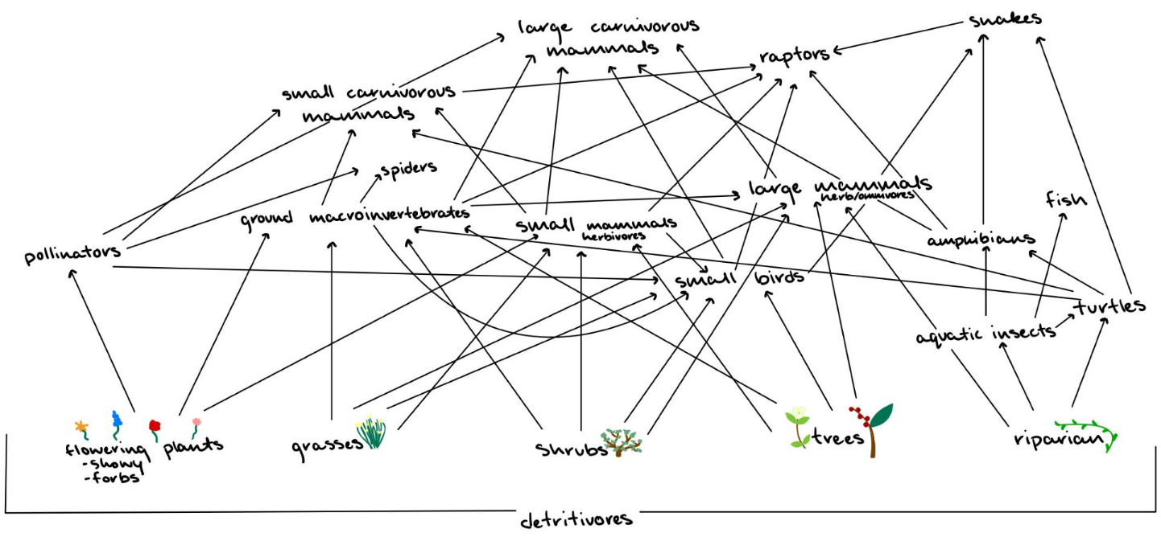
Figure 1: A schematic of the trophic food web expected around the M, based on Table 2 exemplifying the complex biota relationships in the expected ecological systems.
Two main ecological systems are identified at this site: Inter-Mountain Basins Big Sagebrush Steppe and Northern Rocky Mountain Lower Montane-Foothill-Valley Grassland. Native plants in these systems were referenced with food types that support regional fauna to compile a list of optimal revegetation and cultivar options for land managers to choose from for a post-construction revitalization plan. The above food web uses the information presented in Table 2 to display a comprehendible model of the intricate interactions between flora and fauna around the M trail. Producers play a vital role in feeding all other biota, directly or indirectly, so forming a strong basis through proper revegetation ensures a healthy community structure will flourish. For example, carnivores like bobcats rely on populations of small mammals like chipmunks and rabbits that must be supported with native shrubs (big sagebrush) or grasses (Indian ricegrass). Besides trees providing homes for various biota, they can also provide food like bark, cones, and berries to large mammals like black bears down to macroinvertebrates like ground beetles.
The above Figure 1 explores the vast complexities of a single community structure. The revegetation of suggested plant species will support ecosystem function with generalist species. More work must be done with pollinator gardens and monitoring to identify specialists on plants that could later be conserved on a university driven project at the M trail. Providing general native plants maintains many parts of the trophic web, such as bluebunch wheatgrass being a niche for both elk and pollinators in Inter-Mountain Basins Big Sagebrush Steppe and Northern Rocky Mountain Lower Montane-Foothill-Valley Grassland systems, which should be the priority during current revegetation, along with guaranteeing habitat health is rehabilitated and conserved post-construction.
Pollinator Garden
The idea of the pollinator garden is to offset the damage done to the area during the construction phase and high traffic from the public. Habitat loss is known to be affecting pollinator species due to development destroying natural habitat, pesticide and herbicide poisoning, invasive species takeover, poor nutrition, and more. This project offers an opportunity to do our part in supporting pollinator communities by offering a pollinator friendly garden and wildlife habitat protection (USDA).
There are three plausible locations to house a pollinator garden at this site. Ideally, the garden will be around 100 square feet, starting small and expanding later. The location depends on the parking lot that is selected to be put in place. All presented options have ideal sunlight and are on a south facing slope which is preferred for a pollinator garden. The options include the northern part of the proposed parking lot, the middle of the proposed parking lot where the tree ditch appears to be going, and the last option is the middle of the loop of the already established parking lot remains These options are mapped out and listed as Northern, Tree Ditch, and Loop (Figure 2). In this pitch for the pollinator garden, the northern option is ideal, adding to the proposed parking lot. This option seems to be the least disturbed and untouched, offering the most natural environment to support the planted native vegetation.

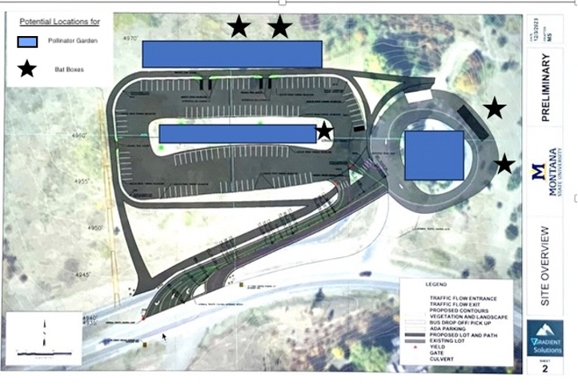
LOOP
NORTHERN
TREE DITCH
Figure 2. The 3 possible locations of interest with the proposed parking lot from the “College M Steering Committee”. This map includes bat boxes which will be discussed later in this paper.

The pollinator garden will go in after construction as a final touch. Before the overall construction happens, the 100 square foot garden plan should be flagged out and remain as untouched possible. There should be no trampling in this area and absolutely no machinery should be allowed near the area. Before planting, a soil test should be implemented in the flagged area. Based off the findings from this test, nutrients should be added, and fertilizers should be considered. Then it should be put in place in the least strenuous way, with as little machinery as possible and mostly by hand. Old vegetation should be removed, the layout should be put in place, walking paths should be added to lessen the trampling, beds should be delineated, and everything should then go in. Planting should match the time of year the respective plants go in.
With the Bozeman population increasing, this popular trail will become more trafficked in the upcoming years. This garden should be admirable and match the energy the Bozeman community holds, that of a ski town with care for the outdoor beauty that surrounds Bozeman. To create a garden with such an aesthetic, there will be pavilions, benches, picnic tables, arches, signs, and art throughout the entirety of the garden (Figure 3).

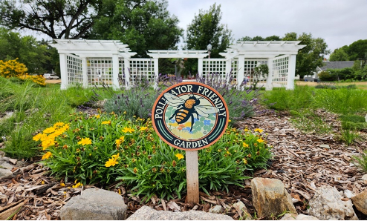
Figure 3. Example of the desired aesthetic

With the location being enroute to the Bridger Bowl ski area, a concept of a ski fence is entertained (Figure 4). The ski fence is a fun idea of posts that are shaped like a ski. There are 10 elementary and middle schools in the Bozeman area that can capitalize on this garden and educate the kids in a hands-on, fun, and entertaining way (Bozeman Real Estate Blog). It would be fun for every class that takes a field trip to the garden to be able to paint a ski showing they were there and toured the garden and learned about its contribution to the ecosystem. This would also show the community the significance of the garden. It could include the year they are meant to graduate, and they can make their own unique designs. The kids would love it and really buy in.

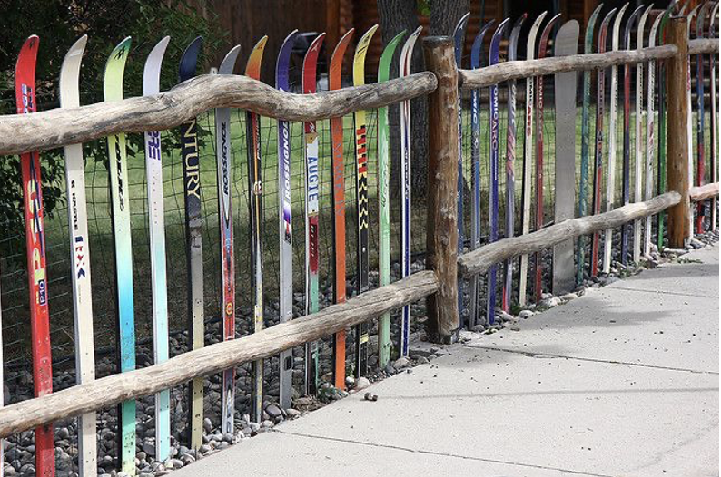
Figure 4. Example of the Ski fence

The garden beds will be in the ground rather than a raised given that the plants of interest will be native to the area and will thrive in the native soil. The flower beds will be in shapes of ovals or circles and should have enough room for species to spread and thrive, spaced out via a trail system. Mulch will be placed around the plant beds and used to reduce weeds and make weed management easier. Cedar mulch is one of the best types of wood mulch. Cedar mulch has natural oils in the wood that repel insects, which makes it the ideal choice of wood mulch (Peninsula Pavers). This mulch will also be the material used as the trail network throughout the garden (Figure 5). Avoidance of weed cloth should be a priority because natural habitat is the goal. On top of the mulch can lay either slate, rock, wood planks, or other options, to create an easier walking path for guests. Along the routes of said trail, benches will be available, arches will go over the trail, art can be seen, and signs will be in front of each garden bed. Rock piles, woody debris, fallen logs, and more will be added as buffers between, space fillers, and more complex habitat for the insects.

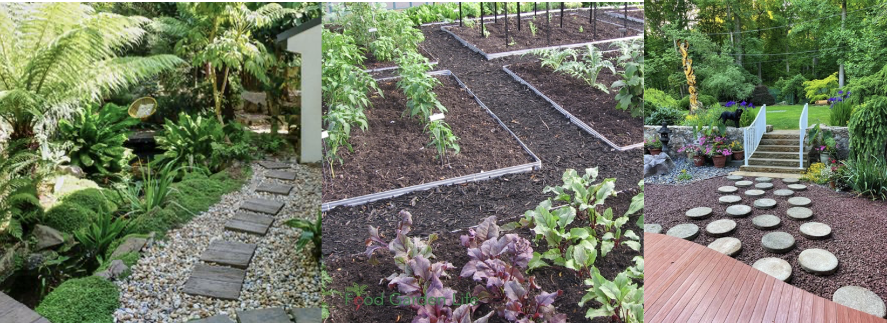
Figure 5. Possible garden ground

There is a large range of native plants that could be implemented into the garden that have proven in other gardens to benefit the pollinator populations (Table 3).
Table 3. Possible native plant possibilities to add to the garden.
Plant | Benefit
Milkweed | A native plant that provides food and habitat for Monarch butterflies, and also sequesters carbon and rainwater.
Coneflower | This plant is a favorite of bees, butterflies, and birds. It's also deer resistant. However, avoid coneflowers with double blooms, as they don't produce nectar or pollen for pollinators.
Agastache foeniculum | Attracts bees, butterflies, and hummingbirds. The leaves contain oils that make the plant unappealing to deer and insects.
Goldenrod | Source of pollen and nectar for pollinators, especially beneficial insects and natives
Aster | Attracts a wide variety of bees
Monarda fistulosa | This plant attracts bees, butterflies, moths, and hummingbirds. It grows best in sunny, prairie-like settings or in gardens with well-drained, sandy soil
Kobold blazing star liatris | This perennial attracts many pollinating insects, including monarchs and swallowtails.

Montana State University in Billings MT has a Welding and Metal Fabrication program. This program offers ornamental steel work along with many other disciplines. We can offer them an opportunity to get involved with the project. This art could be similar to the art in the Langhor Pollinator Garden (Figure 6). These could be informational or simply ornamental and could be throughout the walking paths.
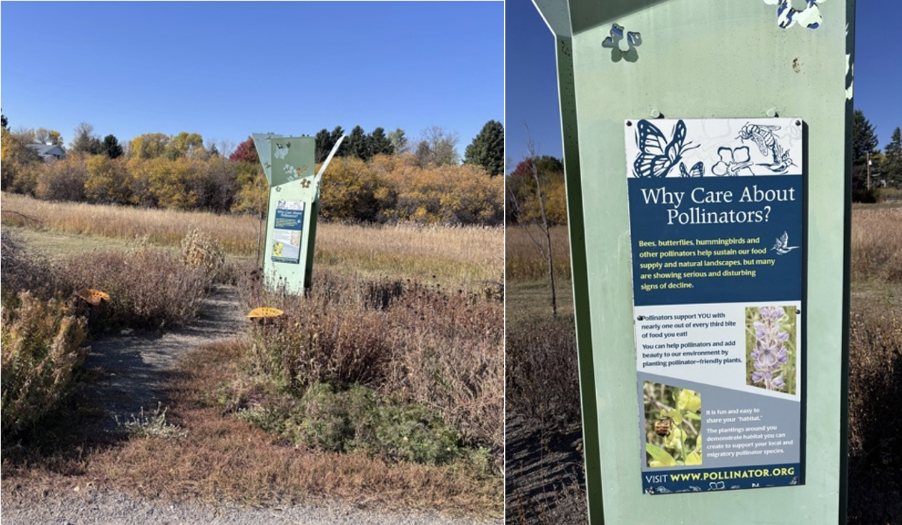
Figure 6. Langhor Pollinator Garden metal fabrication

Bat Boxes
To bolster biodiversity and help support a healthy ecosystem, the addition of bat boxes at the M trailhead alongside the pollinator garden is being proposed. Bat boxes would provide habitat and support the M ecosystems and native species after the disruptive construction project. Planting native species in the pollinator garden will encourage more insects and, hopefully, some of the native species of bats in Montana. There are 15 species of bats native to Montana, of the 15, 8 species of bat have been documented in Gallatin County: Townsend’s Big-Eared Bat, the Big Brown Bat, the Hoary Bat, the Silver Haired Bat, the Western Small-Footed Myotis, the Long-Legged Myotis, the Little Brown Myotis, and the Long-Eared Myotis (mt.gov). All these bats, except for the Big Brown Bat and the Western Small-Footed Myotis, are species of concern due to the spread of a disease called the White-Nose Syndrome. WNS is a fungal disease that essentially makes the bats sick and wakes them up from their hibernation too early, killing them, and spreading quickly and easily through the other bats that roost together. This disease has not spread to all of Montana, but it has been found in eastern Montana in the Spring of 2021(Montana FWP).
With this threat encroaching on Gallatin County, it only makes sense to do what we can in Bozeman to support the bat communities and encourage population growth through habitat and resource development. After construction is done to the M Project, revegetation will occur; I propose that native species be established, as well as the specific plants that are favored by bat species and insects that bats like to eat. These plants will encourage the bats to come to the M area to eat the insects attracted by the native species and the invasive insects, like grasshoppers and moths. With the increase in the native species bringing in bats, it would be helpful to this effort if we installed bat boxes to encourage bat habitat further. A bat box could be installed in the area to promote roosting and increase the population here in Bozeman.
Bat houses help keep bats from roosting in homes and provide them with safe alternative housing for female bats to raise young. Female bats typically have one pup per year so it's crucial for population growth and health to have access to safe roosting sites. Degradation of bat habitat and loss in Montana has been increasing with the increasing population in Bozeman due to construction and development. Bat boxes provide a solution to the arising problems of WNS and habitat loss.

Box Location and Installation:
The installation of these boxes is a simple process. The instructions vary based on location, climate, and species. The boxes should be installed on a tall pole that is at least 8 ft high to prevent access for predators. The boxes should be installed away from trees so predators can’t access the boxes. For Montana bats, they should be camouflaged and mimic the native tree species of the area. The box should be painted black to absorb the most sunlight, keeping the roosting bats warm during the day, especially in colder months. To absorb the most sunlight, it is recommended that the boxes face southeast (Byrne), the M trail is the perfect spot to add a bat box as it is southeast-facing and receives direct sunlight for many hours. The box's specific location depends on where the pollinator garden is built. The goal is to have the boat box near the garden, giving the bats access to insects from the garden and encouraging population establishment in the boxes.

Construction and Design:
The specific design of the box was recommended by the Division of Fisheries and Wildlife as a recommendation to help keep bats out of houses and roofs while providing a safe alternative to interacting with humans.
The design focuses on making the bat box/house similar to the conditions of a dead tree where most bats nest when they’re not in a cave. The dead trees that they typically roost in have narrow and rough spaces between the bark and trunk of the tree. It’s in these tight spots that bats feel most at home, so the boxes need to replicate that. The box should be made from rough, untreated wood; the rough wood makes it easier for bats to hold on and prevent slipping and falling (Byrne). The wood can also be a roughened surface, grooved or scored at 1/4 -1/2-inch intervals to give the bats a surface that is easy to latch and roost on and prevent slipping.
The use of exterior grade plywood and cedar was recommended as the best material to build with, and make sure not to use pressure-treated wood. Cedar is a very durable wood that can withstand the elements while still mimicking it as close to nature as possible. There are other options to use synthetic materials, like stapling mesh to the inside of the bat box, but it can be more difficult to install when making sure there are no snags, buckles, or curls in the mesh. Other types of mesh were described as options, as well as plastic, nylon, fiberglass, screening, or hardware cloth, but it was advised not to use metal mesh because of its abrasiveness and potential to cause injury to bats. The use of mesh may also require periodic cleaning as bat guano may collect in the mesh and need to be cleaned out or gently hosed out. Although these options work, I would prefer to keep the bat boxes as natural as possible and made from natural materials instead of synthetic ones whenever possible. The bat box should also include a landing pad at the bottom of the box where the bats will enter to facilitate easy entry and access.
Along with the dark-colored exterior for heat absorption, the box needs to be caulked and properly seated to keep the heat in and any cold weather and rain/snow out and the babies that are raised there warm (Byrne). The recommended calking was latex to use around the roof to keep the bats that inhabit the box warm and dry. It was also suggested to put shingles or galvanized metal on the roof to give the box extra protection and longevity. (Byrne).
The dimensions of the house are outlined in Figures 7 and 8; the height of the box on the 8 ft tall pole should be at least 24 inches, 36 is recommended, with the inside chambers being 20 inches tall minimum. The width needs to be at least 14 inches, and the bottom must have openings to allow the bat guano (feces) to fall out and prevent buildup. There should be four chambers, as outlined in Figure 8, that should be 1-2 inches apart. The taller and wider the house, the better.
It's also crucial that the bat boxes have proper ventilation and airflow as they could get too hot and suffocate in the boxes. There should be vents 6 inches from the bottom of the house. The vents on the front of the box should be as long as the box is wide, being 6 inches tall and ½ inch wide for the best results (Byrne). Bat boxes with 3-4 chambers are ideal and give bats plenty of room, I would propose that we build two structures of two back-to-back 4-chamber bat boxes at the M. The back-to-back installation of bat boxes can help increase thermal stability and allow for wider temperature gradients (Bat Houses). Larger bat houses offer more stability in temperatures, and bats have been observed to prefer larger structures to smaller ones. Bat boxes with more chambers allow for the bats to have variability and temperature within the box so they can find the hot spots and cooler walls, improving their ability to regulate their internal temperatures and stay at a healthy state.
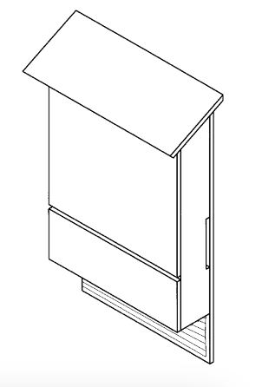
Figure 7: Completed four-chamber nursery house design. With a slanted roof to protect against rain and snow and a landing pad with grooves at the bottom of the box to aid entry. Offered by the Division of Fisheries and Wildlife. (Bat Conservation International)

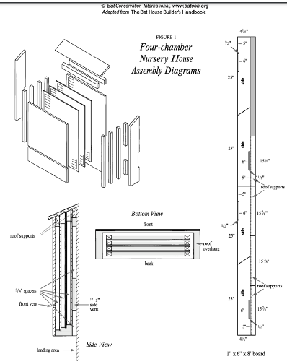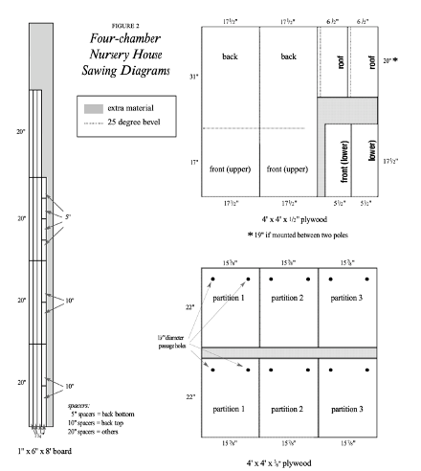

Figure 8: Assembly diagram of a four-chamber nursery bat house, showing both internal and external details. The diagram illustrates the placement of panels, dividers, and roof supports necessary for construction. Dimensions and spacing increments are provided, with views from multiple angles to guide assembly. As well as saw directions. Offered by the Division of Fisheries and Wildlife. (Bat Conservation International)
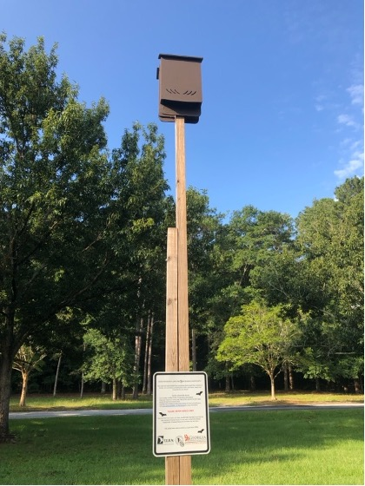
Figure 9: Completed bat box mounted on an 8-foot post, painted a dark color to retain warmth. Educational and warning signage is placed at the base to inform the public about bat conservation and safety. The installation follows recommended guidelines, ensuring the box is secure and elevated for optimal bat habitat. (Bat Houses)

Importance:
While bats in Montana do not pollinate nocturnal flora species, they do contribute to the ecosystem significantly in other ways. They consume nocturnal insects in large volumes, eating up to 100% of their body mass per night (Jones et al. 2009). Bats play a key role in regulating nocturnal incest populations and facilitating nutrient transport across landscapes, from stream corridors to tree roosts (Jones et al. 2009). Their foraging behavior not only helps to control populations of pests but also enhances the overall health of the ecosystem by promoting nutrient cycling.

Diets:
Bats eat a diverse array of insects primarily, including species from several orders, Lepidopterans (moths and butterflies), Coleopterans (beetles), Homopterans (aphids and cicadas), Hemipterans (true bugs), and Trichopterans (caddisflies) (Lacki, 2007). Their ability to consume large numbers of pests makes them valuable for agricultural ecosystems, particularly in Montana. A healthy and robust population at the M Trail could benefit farmers in Gallatin County significantly when it comes to controlling pests naturally through biocontrol. For instance, bats prey on economically important insects, including cucumber beetles, June bugs, corn earworm moths, cotton bollworm moths, tobacco budworm moths, and Jerusalem crickets, all of which are significant agricultural pests affecting crops like corn, cotton, and potatoes (Whitaker, 1995; Lee & McCracken, 2005; Jones et al., 2009). Remarkably, a single brown bat can consume 1,200 mosquitoes in just one hour, showcasing their potential to help farmers save billions of dollars annually when it comes to agricultural pest management (MFWP, 2021).

Habitat Significance:
Bats can be valuable tools in Gallatin County and at the M Trail. They are observed to be particularly sensitive to human-induced changes regarding climate and habitat quality, responding in predictable ways to environmental shifts (Jones et al. 2009). Ideal indicator species include insectivores, pollinators, or seed spreaders - roles that bats effectively fill. They are great at showing the effects of environmental degradation in predictable ways (Jones et al. 2009). Their responses to environmental degradation make them excellent bioindicators (Jones et al. 2009).
Bats’ highly diverse taxonomic group, small size, high mobility, and wide distribution enable them to serve as reliable response variables when documenting environmental impacts (Treanor). In monitoring bat populations, they can provide long-term insights into how biological communities respond to disturbances like construction and the impact of rehabilitation efforts through the M Trail and trailhead sites.
Bats can be monitored in a few ways, in very noninvasive and cost-effective ways, though camera traps and acoustic surveys. For example, these techniques are currently being used in Yellowstone National Park to monitor Townsend’s Big-Eared Bats, which are already being used as indicator species (Treanor). Additionally, hair sample collection methods have also been used in monitoring efforts (Rhode, 2022)

Attracting bats to the M:
To encourage bats to inhabit the M Trailhead, providing food, water, and shelter is essential (Bat Gardens and Houses, 2024). Adding a pollinator garden will create a buffet of insects drawn to the native species being reintroduced. Specific species such as goldenrod, common yarrow, sunflower, sage, yucca, bur oak, elderberry, and dogwood appeal to bats (Harper, 2023). Adding these to the area and garden will enhance the habitat and increase the likelihood of attracting bat populations to the boxes. It is expected that the Little Brown Myotis and the Big Brown Bat will be the only species to inhabit these boxes according to a chart from the Department of Natural Resource Conservation, they are the only species of the 15 in Montana and 7 in Gallatin County that will inhabit a bat box (DNCR).

Trail Signage
Public education is a very important part of any restoration/enhancement project, especially when the project is focused on a recreation site such as the M trail. Signs can be an effective way to connect the public with the environment around them. I propose that we design creative signs throughout the M trailhead and throughout the trail. The “M” trail is beloved by the people of Bozeman and is a symbol of Montana State University. As Bozeman continues to grow, increased traffic and improper trail-use is leading to rapid degradation of the surrounding ecosystem as well as the trail itself. The use of interpretive signs along the trail will help lessen our impact on the native flora and fauna. National Parks are famous for their use of informational/interpretive signage. The U.S. National Park Service uses signs to interact with and educate millions of people every year. Informational signs can enhance the visitors’ experience and increase public interest in an area. By introducing more informational signage throughout the “M” trail and trailhead, Montana State University could greatly increase public awareness of the impacts of ecological degradation on wildlife and hopefully increase public consideration of the native flora and fauna in the Gallatin Valley. The development of connections between the public and environmental health will help minimize further degradation of the M and enable us to implement sustainable trail maintenance infrastructure.
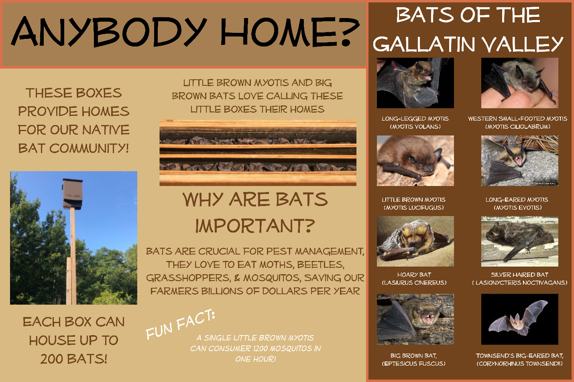
Although threats of penalty or fines are often most effective in dissuading off trail use, ecological education is also effective and would maintain a good relationship with the Bozeman public. This will allow Montana State University to spread information and awareness to the public. The proposed signs on the trail will be aimed towards ethical-based persuasion to minimize site disturbance. One study in Rainier National Park found that signs that explained negative environmental impacts to dissuade off-trail use were significantly effective, decreasing off-trail traffic by 52%. The authors also pointed out that many degrading behaviors are done unknowingly. The paper states that many rules are viewed as arbitrary because people are often unaware of the negative impacts of their actions (Johnson & Swearingen, 1988). These signs will show a variety of plant and animal species and explain the relationships between the native flora and fauna. People may feel ethically obligated to abide by trail-use rules after developing an understanding of the importance of certain plants as habitat or food sources for popular native wildlife. These signs will be focused on the identification and ecological significance of various native and non-native plant species, animal species, and native plant-pollinator relationships.
Figure 10: Draft Batbox Interpretive Sign

Suggested Monitoring
An effective monitoring plan is an essential step in any type of restoration project. A well-structured monitoring plan will let us record the project results over an extended period of time. We will measure the effectiveness of our methods via insect and plant sampling, trail cameras, and public surveys. Future monitoring around the M will be conducted annually by university students within the Land Resources and Environmental Science Department by incorporating the wildlife monitoring plan into an environmental science course.
Preliminary data collection should be conducted prior to the beginning of the project. This data will be used as the baseline for analyzing any changes over the period of the monitoring plan. Data collection will include plant species presence and percent cover, insect presence and relative abundance, and animal presence and number of sightings. (Put methods here). Students from LRES courses will conduct data collection biannually following the completion of the project. Data collection will be conducted during the fall and spring semesters, ensuring that plants and animals with different life history strategies (late and early season).
Wildlife Monitoring Techniques:
Trail cams will be set up throughout the area for monitoring wildlife presence and activity. These cameras will be located off of the actual trail to avoid areas with heavy foot traffic. There will be cameras aimed at each of the bat boxes to record bat presence. Insect data will be collected using different traps for different insect orders. Netting will be used for collecting data in the pollinator garden.
Plant Data Collection Techniques.
There will be a few permanent quadrats in areas of low native species diversity. Classes will collect data from these plots each year as well as collecting data from temporary random quadrats.
Conclusion
The “M” is a symbol of MSU and the people of Bozeman and all future projects should reflect the ideals of the communities that cherish it. Providing a healthy habitat for our wildlife should be a key component in any plans for revitalization of the “M”. Protection of biota throughout and after the “M” revitalization is paramount when structuring and budgeting this project. There are many opportunities for the university to showcase innovative methods dealing with fauna protection, habitat conservation, and public education. The proposed extensive construction will undoubtedly have adverse effects on the existing communities around the “M”. The implementation of alternative construction practices, revegetation for animals, pollinator gardens, bat boxes, and educational signage may aid in preventing and mitigating possible degradation of the ecological systems surrounding the “M” and promote quick recovery following any future development.

References
Abella, Scott R., et al. “Using a Diverse Seed Mix to Establish Native Plants on a Sonoran Desert Burn.” Native Plants Journal (Indiana University Press), vol. 10, no. 1, Spring 2009, pp. 21–31. EBSCOhost, https://doi.org/10.2979/NPJ.2009.10.1.21.
Bat Biology & Habitat Management Guide for ... Department of Natural Resource Conservation. (n.d.). https://dnrc.mt.gov/Forestry/Conservation-Nursery/BatHabitat.pdf
Bat houses. Bat Houses | Department Of Natural Resources Division. (n.d.). https://georgiawildlife.com/BatHouses#:~:text=Three%20or%20four%20chamber%20houses,stability%20and%20wider%20temperature%20gradients

Bozeman Fish Technology Center | Species | U.S. Fish & Wildlife Service. https://www.fws.gov/office/bozeman-fish-technology-center. Accessed 23 Oct. 2024.
Bozeman Real Estate Group. (2024, April 16). Everything you need to know about bozeman schools. https://bozemanrealestate.group/blog/everything-you-need-to-know-about-bozeman-schools
Byrne, B. (n.d.). Bat houses. Mass.gov. https://www.mass.gov/guides/bat-houses#:~:text=These%20artificial%20roost%20sites%20provide,chemicals%20released%20into%20the%20environment

Forest, Lolo National. Attracting Pollinators to Your Garden Using Native Plants.
Gleeson, James, and Deborah Gleeson. Reducing the Impacts of Development on Wildlife. Csiro Publishing, 2012.
Harper, R. (2023, March 7). Creating a garden for bats. Bat Conservation International. https://www.batcon.org/creating-a-garden-for-bats/
Inter-Mountain Basins Big Sagebrush Steppe | NatureServe Explorer. https://explorer.natureserve.org/Taxon/ELEMENT_GLOBAL.2.722894/Inter-Mountain_Basins_Big_Sagebrush_Steppe. Accessed 24 Oct. 2024.
Johnson, D. R., T. A. Swearingen. 1988 A Preliminary Analysis of Day Hiker Off-Trail Hiking in Response to Alternate Sign Texts at Selected Sites in the Paradise Meadows Area, Mount Rainier National Park. Cooperative Park Studies Unit, College of Forest Resources, University of Washington Seattle, WA. Technical Report NPS/CCSOUW/NRTR-98-04, NPS D-317
Jones, G., D.S. Jacobs, T.H. Kunz, M.R. Wilig, and P.A. Racey. 2009. Carpe noctem: the importance of bats as bioindicators. Endangered Species Research 8:93–115.
Lacki, M. J., Johnson, J. S., Dodd, L. E., & Baker, M. D. (2007). Prey consumption of insectivorous bats in coniferous forests of north-central Idaho. BioOne Complete. https://doi.org/10.3955/0029-344X-81.3.199
Lutz, A. (2024b, July 23). How to create a pollinator garden in 7 steps (2024 guide). Architectural Digest. https://www.architecturaldigest.com/reviews/lawn/how-to-create-a-pollinator-garden

Montana Fish, Wildlife, and Parks. (2021, April 21). Living with bats: Montana FWP. Living With Bats | Montana FWP. https://fwp.mt.gov/conservation/living-with-wildlife/bats#:~:text=They%20are%20extremely%20valuable%20in,has%2015%20species%20of%20bats

Montanas Offical State Website. (n.d.). MTNHP. Bats (Family). https://fieldguide.mt.gov/displaySpecies.aspx?family=Vespertilionidae

Northern Rocky Mountain Lower Montane, Foothill and Valley Grassland | NatureServe Explorer. https://explorer.natureserve.org/Taxon/ELEMENT_GLOBAL.2.769647/Northern_Rocky_Mountain_Lower_Montane_Foothill_and_Valley_Grassland. Accessed 24 Oct. 2024.

Reel, S., & Seiler, N., Attracting Pollinators to Your Garden Using Native Plants. Lolo National Forest, Montana.

Rhode, E. (2022, December 7). What is an indicator species? 10 key examples. Treehugger. https://www.treehugger.com/indicator-species-definition-and-examples-5183761

Treanor, J. J., Johnson , J. S., Lee, E. H., & Waag, A. G. (n.d.). Short: Yellowstone bats important indicator ecosystem health (U.S. National Park Service). National Parks Service. https://www.nps.gov/articles/yellowstone-bats-important-indicator-ecosystem-health.htm

5 types of wood mulch: Which is the best option for you?. Peninsula Pavers. (n.d.). https://www.peninsulapavers.com/blog/5-types-of-wood-mulch-which-is-the-best-option-for-you/
USDA Plants Database. https://plants.usda.gov/home/stateSearch/stateSearchResults?resultId=ab9c96d2-2136-433b-97df-7649054d3d66. Accessed 23 Oct. 2024.
Wakefield, Andrew, et al. “Quantifying the Attractiveness of Broad-Spectrum Street Lights to Aerial Nocturnal Insects.” Journal of Applied Ecology, vol. 55, no. 2, 2018, pp. 714–22. Wiley Online Library, https://doi.org/10.1111/1365-2664.13004.
Webmaster, David Ratz. (Family) Grasses - Montana Field Guide. Natural Heritage Program and Montana Fish, Wildlife & Parks, https://fieldguide.mt.gov/displaySpecies.aspx?family=Poaceae. Accessed 24 Oct. 2024.

Welding & Metal Fabrication. Montana State University Billings. (n.d.). https://www.msubillings.edu/citycollege/programs/progwelding.htm
---. (Phylum) Vertebrates - Montana Field Guide. Natural Heritage Program and Montana Fish, Wildlife & Parks, https://fieldguide.mt.gov/displayClasses.aspx?phylum=Craniata. Accessed 23 Oct. 2024.

